WE CAN CONQUER UNEMPLOYMENT!

Conall Boyle

1986

WE CAN CONQUER UNEMPLOYMENT!

Why should you read this book? Unemployment and its cure are, we are told best left to the experts: the economists, the industrialists, the civil servants, the politicians who run the country. How could an engineer turned maths teacher like me have anything useful to say about conquering unemployment?

But wait! The 'experts' have had a free hand for decades. For most of that time they seemed to succeed in maintaining Full adult male Employment, but lately they have failed. Unemployment has climbed steadily, and with has gone misery and despair. The experts have argued fiercely over the causes of this record Unemployment. What IS clear is that they have no idea how we might get back to a golden age of Full Employment.

So if the experts haven't a clue how to cure unemployment, perhaps it is time for some new thinking. Judge for yourself whether the ideas in this book provide a practical recipe for conquering unemployment, not in some distant future, but here and now. The problem is surely serious enough that all possible ideas for conquering unemployment should be examined. I invite you to see how we can do it - how we can conquer Unemployment, completely, finally and soon.

WE CAN CONQUER UNEMPLOYMENT!

CONTENTS:
1. INTRODUCTION - THE PROPOSAL
PART I: USEFUL UNEMPLOYMENT
2. SACK THE BUREAUCRATS!
3. DRIVE OUT THE MONEY CHANGERS! ............ J- ^
4. INDUSTRY: LESS SWEAT, FEWER BROWS ............
5. BASIC ENERGY: FARMERS AND MINERS ............
6. SECURITY FORCES: MORE SECURITY, LESS FORCE
7. MIND BENDING; DRUGS OF ALL KINDS
8. EDUCATION AND 'TRAINING ' ........
9. TRANSPORT, HOLIDAYS AND BUILDING
PART II: GOOD WORK FOR EVERYONE
10. THE EMPLOYED RUMP ............
11. LEARNING FOR LIFE, LIFETIME LEARNING
12. CARING AND SERVING ............
13. ART: LET A BILLION FLOWERS BLOOM!
14. DOING IT FOR YOURSELF AT HOME ....
16. FREEDOM AND EQUALITY ............
17. MEANING TO LIFE; MEETING RELIGIOUS EXPERIENCE
18. STEPS TO BASIC INCOME ............
19. FRIENDS AND ENEMIES OF BASIC INCOME
APPENDIX: BIBLIOGRAPHY

1. INTRODUCTION - THE PROPOSAL

Unemployment is a cancer which is eating the heart out of our so-called advanced industrial society. We must find some way of combating it not just a little and not sometime in the distant future. Now is the time when the vast army of the Unemployed are suffering; now is the time when we must use our imagination as never before to completely conquer Unemployment.

The solutions offered by all the main political parties are a mockery, totally inadequate to the problem at hand and they know it. The Conservatives hope that jobs will sometime somewhere spring up throughthe miracle of the micro-chip or through newly liberated private enterprise. The Labour party offers modest 'Keynesian' reflation but is honest enough to admit that at best the jobless total might go down by 25%. The Liberal/SDP Alliance has some bright ideas which nibble at the edges but nothing which comes anywhere near to tackling the biggest worry of our times - How can we get four million people out of the dole queue and into useful jobs?

Of course there was always one easy answer - WAR. Within months of the start of World War 2 the unemployment problem had vanished. Before 1939 Government was crippled by rules about borrowing money. Then there was a National Emergency which mattered more that the Treasury and the Banks. Whatever was needed to be spent to mobilise every available man and woman was spent and the money was found. Suddenly the Unemployed changed from being a burden on the State into a vital and needed asset.

You may relish the prospect of another war - the Falklands incident of 1982 showed how easy it is to whip up aggressive feelings. But Total War in the 1980's is not the same as the 1940's - the snag is that in a nuclear war you don't just wipe out unemployment you wipe out everything else as well. So war is no t really an option for conquering unemployment.

No wonder people are in a state of depression and despair about the Unemployment problem. By international standards Britain is not a poor country - we still have plenty of resources in oil, coal and even industry. There is a wealth of skills available for making things and to make money. There is no shortage of brainpower either - by winning Nobel prizes this country shows that some of the best minds in the world are in the UK. We have the resources, the skills and the brains so why have the politicians got no idea how to solve the Unemployment problem?

Perhaps what is missing is a real will to solve the problem. Perhaps the politicians are so locked into their old ideas that they are frightened of looking at the problem in a different way. Instead of asking
- "What can be done to get the four million back into jobs?"
maybe they should be saying
- "There never will be jobs for everyone again indeed there is no reason or need for jobs for everyone." By facing up to the inescapable fact of continuing high rates of unemployment the politicians can start to think about ways of making this situation tolerable of giving everyone a respected place in our society.

Once the crippling burden of old ideas is swept aside then politicians and others can start to think afresh about what needs to be done to put the economy right and serve the needs of society. Perhaps the blinding truth will dawn - that the economy is for the benefit of people and not the other way around. Perhaps they might also discover that people spend too much time in employed work either fo their own good or for the needs of society.

But these are vague generalisations. In order to convert this new thinking into an agenda for action some definite proposals are called for. So here goes:

THE PROPOSAL: BASIC INCOME

Basic Income (BI) or Guaranteed National Basic Income as it is sometimes called is a simple idea: BI is a single adequate flat rate payment made to every citizen regardless of employment or other status; the amount varies only with age. Basic Income would replace all social security payments, supplementary benefits, tax allowances and tax reliefs.

To give you a rough idea of how much the Basic Income would be think of a figure of about #30 per week (at 1986 prices) about half for children, somewhat more for the elderly. BI is not a new idea; such schemes have been suggested for more than half a century. Perhaps the simplicity of BI is misleading; if it is that simple why have the politicians not thought of it before?

In fact some far sighted politicians have taken up the Basic Income idea, most notably Francis Pym in his Times article of 16.10.85. But most politicians and policy advisors see solutions to problems as tinkering 'reforms' adjustments needed to make today's ramshakle system work. But this is a situation which requires more than tinkering. It needs vision. I invite you to come along with me and explore the possibility that Basic Income could be the imaginative leap required to set us free from the pit of despair caused by continuing high unemployment.

This is not an academic text-book so I am not putting forward a technical case for Basic Income. Such costed researched investigation will be vital before any government implements a policy of BI. I invite you now to follow this 'thought-probe', to dare to think in unconventional ways. Judge what I say against your own experience and commonsense. Before you reject the BI idea out of hand remember there is real despair out there on the streets. We must find some way of conquering the evils that mass unemployment brings. If Basic Income is not the solution then what in the name of God is?

"Can we afford Basic Income?" is the first question that most people ask. The short answer is "yes". By converting present welfare payments and tax allowances and reliefs into a flat rate payment for all, plus a modest increase in say VAT, it would be affordable. But this is an answer to a daft question. Basic Income will not be introduced overnight. It would come about in gradual steps which would take many years. The world in 20 or 30 years time will not be the same as it is today, so the final conditions for Basic Income will not be like today's either.

Perhaps it would be more sensible to ask: "Can we afford NOT to take determined steps to conquer unemployment?" Faced with immediate danger like war or invasion it is amazing how quickly financial orthodoxy can be over-ridden. If money is no object in the defence of the realm why should this not also be the case in preserving the fabric of society? Isn't continuing high unemployment just as big a threat to our way of life as Adolf Hitler ever was?

But how can paying money to individuals without any requirement to work actually cure unemployment? Don't be deceived by appearances; look instead at how BI would affect peoples lives. On the surface BI seems to be about money individualism and destroying work. In reality BI will make money far less dominant in our lives and daily transactions. Although BI would be paid to individuals it will reinforce the web of family and community relationships acting as an enabling mechanism. But above all BI will set people free from the present crazy system and will encourage them to work far more indeed is a certain instrument for promoting a busy work-oriented society.

What Basic Income does is to produce a 'paradigm shift' - a jump in the ways of seeing things from one set of ideas to another. At the core of today's inability to find a cure for unemployment is a myth:- That only paid employment is of value , and that only by getting a job can people be considered useful members of society. If we can jump from this idea to an alternative:- That there is a great deal of work such as child-rearing that is unpaid but is of value, and that the employed sector of the economy is not the only or maybe not even the main area where individuals can do useful work. Basic Income is a form of recognition for this unpaid work, tangible proof that all citizens in or out of a job have equality of esteem.

This new thinking is associated with ideas on the Post-industrial society, the Information Society, or the Third Wave as it is popularly known. There is a widespread feeling that society is at a turning point, that old ways of doing things don't seem to work anymore. There is a crisis and new ways of thinking are needed. Basic Income is one possible way of overcoming the present problem of unemployment; it is also away of enabling the post-industrial society to come about in a humane way.

It is for this reason that the first part of this book on how to conquer unemployment concentrates on ways of reducing the number of people in employment or if you like liberating them from wage slavery! The second part describes how these newly liberated ex-employees can usefully use their time and how today's outcasts the unemployed the pensioners the 'mere' housewives can learn to value their work which is their contribution to
society.

~~~~~~~~~~~~~~~~~~~~~~~~~~~~~~~~~~~~~~~~~~~~~~~

A week in politics (starting Monday 19 May, 1986)

Sometimes a whole series of events, none of which create a major rumpus, can illuminate significant butun-noticed changes. Consider the following:

o British Rail announce job losses in its Engineering works of 5,000. British Coal is to sack 2,000 from its maintenance depots. Both are employers of large numbers of skilled engineering workers.

o The Home Office announce an extra 3,000 force boost in police manpower. It is said to be a response to rising crime, and is intended to put more bobbies on the beat. This is despite several studies by the Home Office itself that increased police numbers, including beat officers, have no effect on crime rates. It costs the taxpayer 18,000 to maintain one policeman.

o At the Department of Health and Social Services the luckless Tony Newton, junior minister (the usual bringer of bad tidings) announces a 50% cut in mortgage support for the very poor -m the recently unemployed, disabled and single parents. A paltry 30 million is hoped to saved thereby. Mortgage tax relief, which can be worth as much as 50 per week to the wealthy, is repeatedly declared sacrosanct.

o At the Department of education and Science, Chris Patten, again a junior minister, announces yet another cut inuniversity funding. This time a further 2% is to come off 1987/88 budgets, ata time of increasing 18-21 year olds.Eighteen universities to be affected; departments to close includeMathematics and Statistics.

o A move by a group of socially minded Conservatives to bring Child Benefit into line with all other taxallowancesand benefits is blocked by the Government using a procedural trick. Opposition mounts to a move topay child and family benefits to husbands via employers. By at first appearing to give in and then renaging, Fowler the minister involved slips the pay through employers proposal.

~~~~~~~~~~~~~~~~~~~~~~~~~~~~~~~~~~~~~~~~~~~~~~

A week in politics? No, all of this was reported in the space of just twodays. It paints a picture of a societywhere fear and repression dominate,where producing and benefiting othersis despised.

~~~~~~~~~~~~~~~~~~~~~~~~~~~~~~~~~~~~~~~~~~~~~~

Footnote: In their book 'After fullemployment' (Hutchinson, 1986) JohnKeane and John Owens explain why highrates of unemployment will continue and are certain to get higher. They review the suggested ways of getting back tofull emplyment - cut overtime, earlyretirement, job sharing - and show howthey can never be adequte to solve theproblem. They conclude with a call fora guaranteed basic income as the way to a post-employment society.
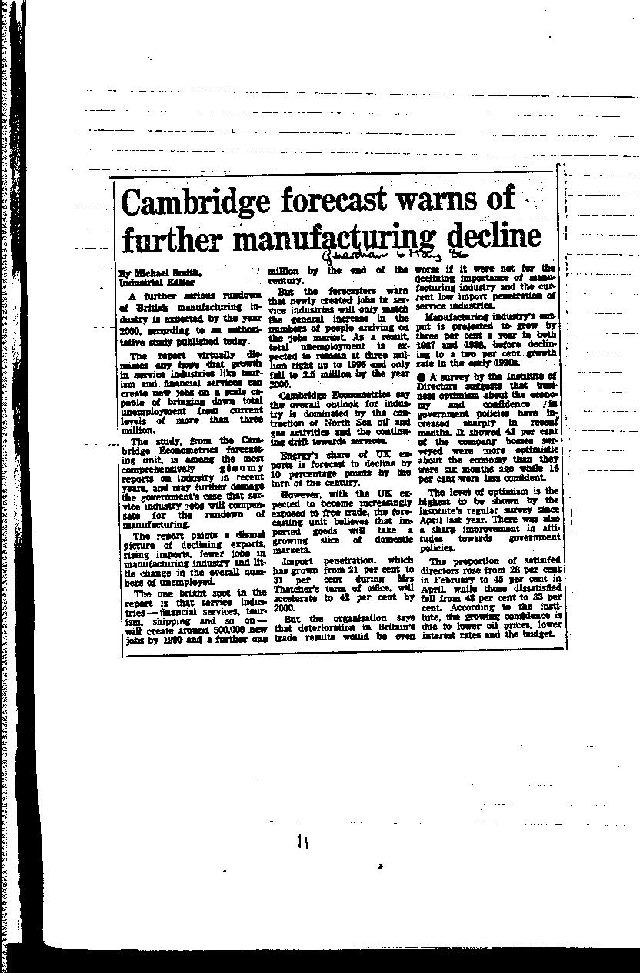

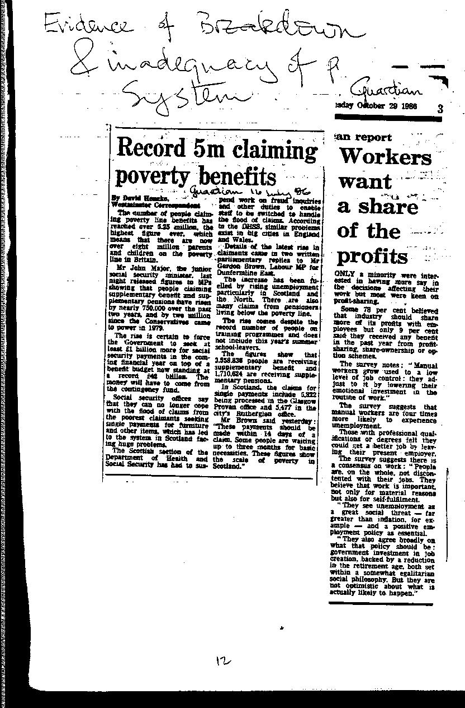

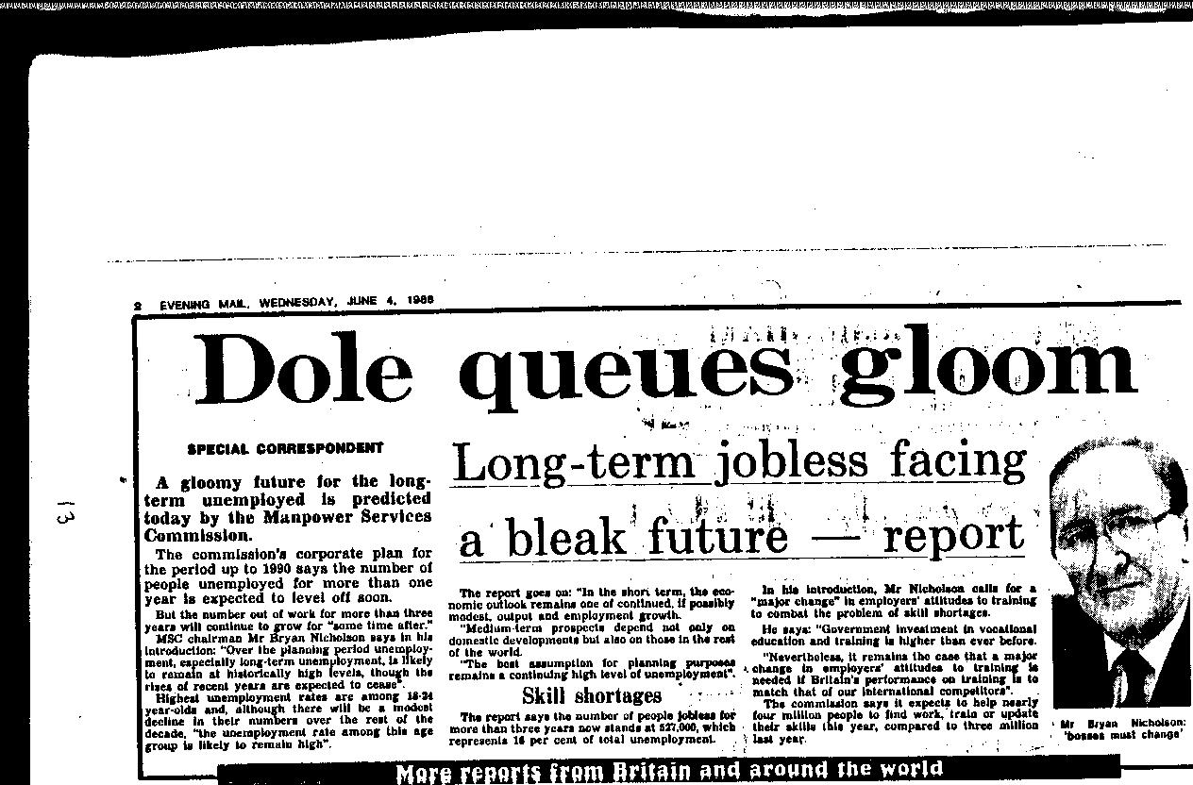

2. SACK THE BUREAUCRATS !

Bureaucrats! The very word smacks of waste, feather-bedding and inefficient
mindless activity. In reality most Civil Servants and Local authority workers are intelligent, dedicated and hard-working. So why have we got it in from these toilers from the Public Good? Why should Basic Income lead to a cut in the numbers of public servants?

It works in TWO ways :
BI is a straightforward system to administer. Compared to the maze of rules and regulations which surround the present system of taxation and social security, BI is simplicity itself.

BI also makes the prospect of giving people the sack far less painful. BI creates a climate where a job for-life is no longer a normal aspiration. BI means the bureaucrats, grudgingly at first, but soon joyfully, can accept their liberation from the drudgery of pointless activity.

You may find this cheerful acceptance of the sack by a large number of Civil Servants somewhat difficult to swallow - that is, I would suggest, because you are looking at the problem with today's lives. BI is as much about changing that that perspective as anything else. As we look at different sectors of today's economy, perhaps you can come to accept that by seeing things from a new angle, a smooth transition to a low-employment economy is possible.

So let's look in detail at the effects of BI on the numbers of Civil Servants and Local Authority employees. First how many Civil Servants and Local Authority employees are there? Here are the figures from 1984: (I have included details from departments which will be significantly effected by Basic Income)

Civil Servants (U.K.)

Total number: 624,000 (including 119,700 'industrial'

Departments :
25,100 Inland Revenue
9,500 Treasury
56,400 Employment
92,600 SocialServices
14,700 Trade & Industry

Local Authority Employees
England Wales Scotland
Total: 1,892,719 123,379 251,402
Social Services 207,808 13,271 30,483
Housing 54,568 2,051 5,454
Social Security

Basic Income is first and foremost a great and long overdue simplification of the maze of social security benefit regulations. BI is based on the notion of giving a single flat-rate adequate amount each and every citizen. Exceptions and additions to this should be rare in the extreme. Already a number of our citizens are enrolled in quasi-BI schemes - Child Benefit and the old-age pension. Child Benefit is paid on behalf of all children resident in the United Kingdom; the old aged pension is loosely based on an insurance principle. In effect they are both universal payments made to who qualify on grounds of being either young enough or old enough. Bridging the gap between these two, enrolling the rest of the population of working age in a similar scheme will present a relatively easy task in this age of computerisation. In contrast, the present mish-mash of benefits, supplementary benefits, special allowances and discretionary payments require a vast army of officials to administer and police them.

Probably top of the list of those we would most like to see done away with are the social security snoopers, especially those concerned with the dreaded 'cohabitation' rule - checking whether woman claiming single parent allowance has a lover who spends the night with her. Getting rid of this stain on society alone would be reason enough for introducing BI. SS snoopers can go too, along with several thousand administrators who will no longer be needed. The shear simplicity of the Basic Income scheme means that their services can be terminated.

But what of the carers, the social workers who tend to the needs of the destitute, the elderly, the desperate? Foolish behaviour which gets families and individuals into trouble will not vanish with the introduction of BI. But the help for these people does not come exclusively or even mainly from social workers. There is still a network of family and friends who make up the main source of support in our society. BI will strengthen this network, and shift much of the work done by the official social workers over to an informal society based one. Again this is a major reason for the introduction of BI:- it is a payment for looking after yourself, but also a payment which recognises the socially beneficial work of caring for others. It may seem a bit nasty to look forward to a reduction in the numbers of so overworked, underpaid, dedicated professionals as social workers, but they would be, I think, the first to recognise that a reduction in the need for their services is a highly desirable objective. (In fact a great deal of social work is caused by the complexity and inadequacy of the present system)

As you can see from the table of numbers employed, Social Services is a very large 'industry' indeed. A reduction in numbers of 200,000 in both local and central government sectors following the introduction of BI is not at all fanciful, a fine saving to be offset against the cost of its introduction.

Pensions:

As mass unemployment is accepted as a continuing reality, the nonsense, nay, swindle of the occupational pension scheme becomes indefensible. A form of Basic Income has been paid to Old Aged Pensioners for more than 70 years, and will continue, but at a higher level. This adequate Basic Income will be provided by the state; thereafter if an individual wishes to make other provision for old age that should be a private decision. This is just one aspect of the switch away from the money-based economy which is dealt with more fully in the next chapter.

So in common with all other employees, occupational pension schemes for civil servants will be wound up. This creates a slight reduction in the personnel section of the civil service, and a fairly large reduction in the National Insurance Office in Newcastle which deals with SERPS - the state earnings related pension scheme. Reductions in the personnel departments in Local Authorities can also be anticipated, including staff employed in so-called 'non-funded' pension schemes like that for teachers.

The number of staff involved in state and local authority pension scheme administration is of the order of a few thousand; the number involved in SERPS oth in government and in the employing organisations is greater still. It would be difficult to put a precise figure on this but a further saving of 30,000 jobs would be not unreasonable.

Taxation:
Little sympathy is spared for the taxman. Yet they too are suffering with the complexity of the system they are called upon to operate. BI will do away with most if not all allowances, and introduce a single percentage rate on all earnings (some of the schemes proposed for Basic Income have a graduated rate - I prefer a single rate together with a wealth tax). The upshot of all this is that fewer tax men will be needed; indeed it is a common complaint that it requires as many taxmen (and women) to collect the income tax from the population of the UK as it does to collect from the entire United States, despite there being four times as many people there. So on top of the savings due to the introduction of BI, there are substantial potential savings to be made from the simplification of administration.

Direct savings of about 15,000 or 20,000 tax officials are possible. In the world outside the tax offices, the simplification will lead to fewer tax accountants and advisors, less work in wages offices, and a lot less time spent by individual taxpayers filling in their tax returns - shall we say another 20,000 toilers liberated?

'Employment'

Perhaps the most inappropriately named government department is that of
Employment, which is responsible for such activities as Job Centres and running the Manpower Services training schemes. It also measures the numbers of employed and unemployed, a task which it has undertaken with imagination bordering on deceit in order to improve the look of the figures. Basic Income means that most of the activities of this department would be unnecessary.

Already the dividing line between 'employed' and 'unemployed' is being blurred. Following the introduction of BI, the distinction will largely disappear. Everyone will have useful work to do; some will be paid for it, others do work on a mutual basis, some work for themselves. The out-dated notion that only a full-time paid job is 'real' work can be laid to rest.

In these circumstances operating Labour Exchanges, or counting the numbers of unemployed becomes irrelevant. Operating training schemes which are just a means of keeping the unemployed off the streets can, mercifully, be stopped. (How people will acquire the skills they need will be explained later in chapter 11). There is still a small but vital function for this department to carry out - Health and Safety at Work (This used to be known as the Factory Inspectorate).

Out of a total of 56,200 employees in the Department of Employment most will not be required following the implementation of BI, so a further 50,000 or so jobs can abolished, and yet more wage slaves liberated.

The Treasury is not a very large department - a mere 9,000 or so, but here too BI will create an opportunity to reduce staff. The Treasury is not just involved in handling the money. It also attempts to run the economy. This task it fulfilled with some success from 1945 to 1975. Since then it has fallen into the grip of the monetarists, and we suffer the consequences - mass unemployment and a disastrous decline in manufacturing. Introducing BI is, among other things, a clear acknowledgement by government that its attempt to control the economy is futile - in reality there is little good that any government can do, and much damage it can inflict. The Treasury can give up its futile task of trying to understand and control the economy. The economists and analysts can go back to their Universities or writing their books. BI will have solved the economic 'problem'.

Environment and Housing
At the central government level, the department of the environment has the job of supervising local government. The main task it oversees is the administration of housing by the local authorities. The local housing departments deal not just with the council housing estates - they also have to administer many aspects of the governments housing benefit schemes. There have been many attempts to simplify the different housing cost support benefits. Administratively this sounds fine, but unfortunately the Tory government also saw this as an opportunity to cut the total of spending. So as not to have too many large winners and losers, the single schemes had a maze of complex and baffling rules. These have had to be implemented by the local housing offices, and require many staff to do so. BI will subsume all of these benefits in a single payment, equal to all, which will result in a substantial staff saving. (I do not want to give the impression that this aspect of BI is going to happen at once. The highly variable levels of housing support are a result of the great variability of housing costs in different parts of the country. It will take a long time to iron out these differences. Indeed, housing benefit is a major stumbling block along the road to BI)

The other main function of the local housing departments is the running of
the council estates. Abolition of council-run rented housing is not an essential consequence of BI. But maintaining centrally organised provision of such a vital and personal service runs counter to the BI philosophy of encouraging the small scale, the informal, the local. Privatising has acquired an unpleasant reputation of selling off publicly owned monopolies for private company profit. But selling council houses to tenants is quite a different matter - that is a highly popular policy.

Less popular might be the re-introduction of the private landlord to council estates. But there are many intermediate forms of ownership - housing cooperatives, tenant management schemes, which can replace the council run provision. There is also evidence that small scale landlordism, involving one or two properties is generally a much more pleasant and cheaper option. When landlord and tenant know and live close to each other, then rent maximisation is not the only motive.

Taken together, simplification of housing benefit, and virtual elimination of local authorities from landlordism, should reduce central and local government staffs by about 40,000.

Others
Two other departments should also be reducible by a significant amount - Trade & Industry and Customs & Excise. Already the Conservative Government has withdrawn substantially from an interventionist role in industry. Their reasons for doing so stems from a belief that industry doesn't matter, that service industries especially financial services are more important. BI would imply an even smaller amount of central government intervention in industry. This is not because BI is anti-industry - on the contrary BI gives the maximum possible support to all forms of production for use. This theme is expanded in Chapter 4. For now let us rejoice in the prospect of a further reduction in the activities and staffing levels of central government. Reductions in Customs and Excise staffs will follow from a reduction in the volume of goods in the traded sector (less VAT to collect), and from the reduction in the international flows of both people and goods. This may sound as if BI is going to mean a fortress economy, a turning back of the clock to 1940. Far from it - this reduction in trade will be as a result of progress and technical developments which will be explained in later chapters.

Taken together, local and central government are the largest employers at the moment. The introduction of Basic Income will reduce very substantially the numbers needed. An overall reduction of half a million jobs could be achieved.
3. DRIVE OUT THE MONEY CHANGERS!
"Money is the root of all evil" * are the words of an old song. It seems that money values are the dominant religion of our age. It is the accountants and economists who pontificate over activities and declare them to be in a state of grace - 'viable', or to be condemned and cast out because they are 'uneconomic'. Other values - social values, moral values, technical values - are treated as of no importance compared to the dominant cash values.
( * OK I know that this is really a biblical reference, and should go: "Love of money is the root of all evil" }.
Basic Income - which is a single flat-rate sum of money paid to each citizen - would seem to reinforce this trend towards the dominance of cash values. On the contrary! Basic Income is about REDUCING the dominance of money, of cutting back on the money changers and putting human values above the values of the tally clerk. Evidence for the dominance of money values is all around us. Walk down any high street and you will see
that shop after shop has been taken over by money changers - banks, insurance companies but above all building societies. The rapid increase in money 'shops' is the visible side of a dramatic increase in the numbers employed in the Finance, Banking and insurance sectors of the economy as shown in Fig. 3.1 and 3.2.
Comparison between the fate of the Engineering sector and the Financial sector is shows an even starker picture. While production industries have declined massively, the financial sector has flourished. Money changing is almost the only growth industry in Britain in the 1980's.
Finance is a service to industry, commerce and the community generally. Money handling does not of itself generate any useful product. So are we are all substantially better banked, insured or financed than we were back in 1979? Money may be more freely available on credit from the building societies, through credit cards and banks, but at a much higher real rate of interest than in 1979. Fig 3.3 shows how real rates of interest have risen in the period 1972-1986. Financial institutions have gained a huge and unmerited increase in their income. Unlike industry, finance houses do not have to produce more product to make more money. Their unique position as cash handlers has given them a huge windfall.
There are other reasons, significant, but not so important as interest rates which explain the continuing rise of the money changers. There is the increase in credit cards, there is the trend towards home ownership with mortgage tax relief and spiralling house prices. There are fluctuating exchange rates which open up the way for currency speculation - an amazing worldwide $150 billion in currency is traded each day, 20 times more than trade in goods or foreign travel requires. There is the much longer term trend to 'commodification ' - an ugly word which describes the turning of private activities into traded commodities. A classic case is the hamburger parlor - where once mother made junior a tasty meal at home, now they buy it from the local MacDonald’s.
Money is undoubtedly a very useful invention. If we had to rely on barter, then trade would be greatly hindered. Having money enables goods and services to be moved around to where they can be of greatest benefit (so the economists tell us). Acting as cash and cheque handlers, banks provide a valuable service. Other financial services add cost without adding very much to value. If we could have the same amount of useful goods and services, but with fewer bank clerks, insurance salesmen and other financiers, then we would all be better off. After all, the resources needed to keep all the High Street banks and building society branch offices going has to come from somewhere. The 'somewhere ' is the transacting public who are in effect taxed through interest rates to support this non-productive sector.
In any sane, rational society we should be continually looking for ways of getting by with fewer of these unproductive overheads like financiers, not adding to them as has happened in the last few years. Basic Income will provide many ways to reduce our dependency on the finance, banking and insurance sector. It also provides the climate of opinion where it is possible to contemplate shedding, 'liberating' many thousands of employees, and see it as a blessing, not a curse as a present.
Here are just a few of the ways in which our need for the financial sector can be reduced. Some of them are a direct result of the introduction of Basic Income, others arise from the climate of rationalisation which Basic Income will make possible.
de-commodification: instead of turning more activities into traded commodities, Basic Income will provide a mechanism which can reverse this trend. Do-it-yourself, local, informal domestic activity, activity of mutual benefit is all made much more practicable through Basic Income. The car mechanic can swop his time with the computer programmer, to the benefit of both. Growing or cooking your own food becomes a healthy and economic alternative to the fast food chain.
- the over-all reduction of employment described in this and other chapters mean that there need not be so much money flowing around the formal economy. The informal economy runs on a cash-in-hand basis, or even by barter, and so requires far less servicing by the financial sectors.
an end to inflation would bring some surprising results. Conventional wisdom tells us that it is not possible to have zero inflation because the effect on employment. Basic Income means that this fear is rendered irrelevant - the general level of employment in the formal economy would no longer be of political significance. Government controls the supply of money, and to some extent interest rates, so it could proceed to "squeeze inflation out of the system" without worrying about the employment consequences.
What would life in a zero inflation economy be like? It would be simpler, especially in relation to money. No longer would it be necessary to put your savings in a bank or building society, just to ensure that they held their value. Stable prices of things like houses would provide an excellent reason for not gearing yourself up with debt in the hope that inflation would wipe off the real value of the amount you owe. The ramifications of zero inflation are far reaching, and almost entirely beneficial. I have only hinted at the possibilities here. Basic Income gets politicians out of the Employment versus Inflation bind.
A few other sensible changes which would reduce our dependency on the manipulations of the money men:
stable international currency through such agencies as the European Monetary Union.
no fault insurance which could go a long way towards reducing premiums. Well over 50% of insurance money is paid out to lawyers, not victims of misfortune such as car crashes.
automatic car insurance for car drivers, funded through petrol tax; similarly automatic household insurance as a state funded service, with claims paid by the police or fire department budgets.
26 Feb 1986 The Times reports:
Tough new curbs are called for on Britain's 200,000 life insurance salesmen by the government 's proposed watchdog for the industry. They suggest registration and a computer based test for all prospective salespersons to ensure they are competent.
Question: How does this army of 200,000 add to the sum total of human happiness?
30 Nov 85 The Economist
'Round the World on $150 billion a day": With London holding onto 33% of the world foreign-exchange market, the greater volatility in rates has fuelled a doubling of the total transacted each day. More players in the game, using computer based models and new communications methods have speeded up transactions. Each dollar will be bought and sold twenty times before it is used in a genuine transaction of goods or services.
Question: has money gone mad? The unsettling instability is easy to understand when it is realised that money has been turned into a speculators ' commodity.
16 Feb 86 Sunday Times business news
"Super-pay tax threat" Margaret Thatcher is signalling political embarrassment over pay for financial whiz-kids. Examples of 25-year olds earning £200,000 quoted. Golden hellos of similar magnitude.
Question: What kind of signal does this give the brightest most dynamic youngsters? Become an engineer, as urged by Sir Geoffrey Howe (Foreign Secretary, lawyer) in a speech in the same week and earn one-tenth the salary of a bond dealer, if you are lucky.

But there are still two major areas of the financial scene to be deal with, and it is here I believe that Basic Income will have its biggest impact. The two sectors are :
the occupational pension schemes (including SERPS, the state earnings related pension scheme)
the building society, mortgage house purchase sector.

Pensions

The age of permanent full-time employment as the norm for all men and most women has to be recognised as over, a passing phase. It will never return, even if it was thought desirable. Basic Income will be a ringing confirmation of this inescapable reality, a celebration of the new liberation. Lifetime patterns of work can and should become more varied - spells of part-time paid employment, time off for learning, working for yourself or caring for others, plus some full-time employment in the formal economy as of old.
In the light of these developments neither the occupational or the earnings related pension schemes have very much relevance as a centralised government directed activity. (Occupational pension schemes are run by employers, who deduct contributions from wages. SERFS is run by the government, and is funded by Insurance-type contributions). It is really a sick joke to continue to encourage occupational pensions in an age of mass unemployment. These schemes have always been especially mean to those who leave early, before retirement age. This has been a severe drag on job mobility, imprisoning people in dead-end jobs. Those lucky or lazy enough to stay on are rewarded with a much higher pension. This is a state of affairs that has already been recognised by the Tory government, which proposed (in 1985) instead the idea of the 'personal portable pension'. Of course the proposal only applied to pensions in commercial companies -civil servants and local authority employees pensions must still be kept within the control of the employer. And even if you are the owner of a porta-pension, you must still contribute to a government-approved scheme.
The occupational pension funds are managed by a variety of organisations such as insurance companies and other city of London financial organisations. Control over how these funds are invested lies completely within their hands, and not surprisingly they chose to invest it in a very conservative fashion. The individuals who contribute the funds, the employees, have no say in how the money is invested. No matter how good an alternative might be for the individual, there is no way of getting control over the money.
This is not just an unsatisfactory state of affairs for the employees. The total amount controlled by the pension funds is a large percentage of all the wealth in the economy, as shown in Fig. 3.4. It is not too fanciful to suggest that this is theft on a gigantic scale - the savings of the working man are snatched and used to prop up the financial working of the City of London. True, the pensioners will get their pensions, but in one form only: an income in old age, and only so long as the system does not collapse. But is it not high time that earners were given full control over their own money?
SERFS unlike occupational pension schemes is widely loved and praised. Attempts by the government in 1985 to abolish it met with stern opposition. But unthinking support for the consensus views of the 1960 's and 70 's does not mean that earnings related pensions will continue to be appropriate in the 1990 's and beyond. Indeed no-one seems to ask why the government should arrange to pay more old-aged pension to someone who has earned more all his life in the first place? Government can discharge its duties by ensuring that there is an adequate BASIC pension for ALL the elderly. And why reward only those who contributed to society by earning a wage? SERFS seems riddled with contradictions for both Conservatives and Socialists alike. Basic Income offers an alternative to both occupational and state earnings related pensions. In the new age where permanent employment is no longer seen as the norm, where a single lifetime job is a rarity, the case for connecting pensions with wages is indefensible. It is not enough just to allow a private portable pension for each individual, Basic Income implies something much stronger:
DEFERRED
PAYMENTS TIED TO A JOB
(e.g. occupational pensions)
SHOULD BE BANNED.
ALL PAY FOR A JOB SHOULD BE MADE AT ONCE. PENSION FUNDS SHOULD BE WOUND UP AS SOON AS PRACTICABLE AND THE PROCEEDS SHARED OUT AMONG THE OWNERS.
Of course it hardly needs to said that the levels of old-aged pension envisaged in a Basic Income scheme would be higher than a present. What pensioners need is a secure guaranteed Basic Income, not elaborate, unfair schemes which give more money to those who need it least.
(A further consequence, which is not of immediate relevance here is that Retirement Age becomes an obsolete concept. The amount of Basic Income will increase with age, but the sharp 'sudden death' idea of a fixed date for throwing everybody on the scrapheap and of no further economic worth can thankfully be laid to rest.)
Mortgages
But where can all these newly liberated pension-fund victims invest their money ? Some will go straight back into the conventional money market of course, into the insurance schemes, the unit trusts, even into government bonds. But a great deal will go into another obvious place - the building society to pay off their mortgages. Mortgage tax relief, a much criticised bonus for the well-off, would be rapidly phased out, and the proceeds used as part of the pool of money to fund Basic Income.
The way the house price and mortgage spiral has increased dependency on the financial sector is shown in Fig. 3.5. Rising house prices may make existing householders feel better off, but there are two snags: the entry fee for first timers is becoming increasingly difficult to find; the spiral of house prices rising faster than inflation cannot go on forever. Bob Beckerman a well-known financial forecaster, predicts that the 'Downwave' - a major collapse due in about 1989 will start with a slump in property values. If Basic Income could cushion this blow, then a disaster would be made less painful.
Many households find themselves in a double financial bind - paying money into a pension fund on the one hand, and paying out for a mortgage on the other. If ever a scheme was devised to make work and transfer money and control into the finance sector this must be it. The mirror image between paying for a mortgage on the one hand and a pension on the other creates a perfect opportunity for short-circuiting the process. The chief winners from all this churning around of money in pension fund and mortgages are of course the financiers. The money tied up in pension contributions could be applied directly to house purchase. The 10 year mortgage could become the norm, cutting building society business in half if not more.
Outlawing job-related pension schemes is a consequence of Basic Income. The result is a massive reduction in jobs in the finance sector, both in pension funds and as I have indicated in the building society sector. You may wonder what will happen to the rest of the money which will not be invested, or used to pay off outstanding mortgage debt. Some will be squandered on holidays or even drink. But most of the surplus funds thus liberated will be used in a variety of ways which will be of long term benefit to the individuals involved - they will act as an alternative form of saving. Once you stop thinking of saving for old age in purely monetary terms, then a whole range of alternatives open up.
Taken together, some or all of these desirable changes on the financial scene are made possible by the introduction of Basic Income. The result should be a rapid slimming down of this bloated and basically non-productive sector, a welcome development for the public at large and the employees thus liberated. The rapid advance of computerisation, facilitated by Basic Income should give this slimming process a good push forward. Money, after all is just a special form of information, and that is exactly what computers are good at handling.

Figures 1 2 3 4 5 6 to accompany this chapter
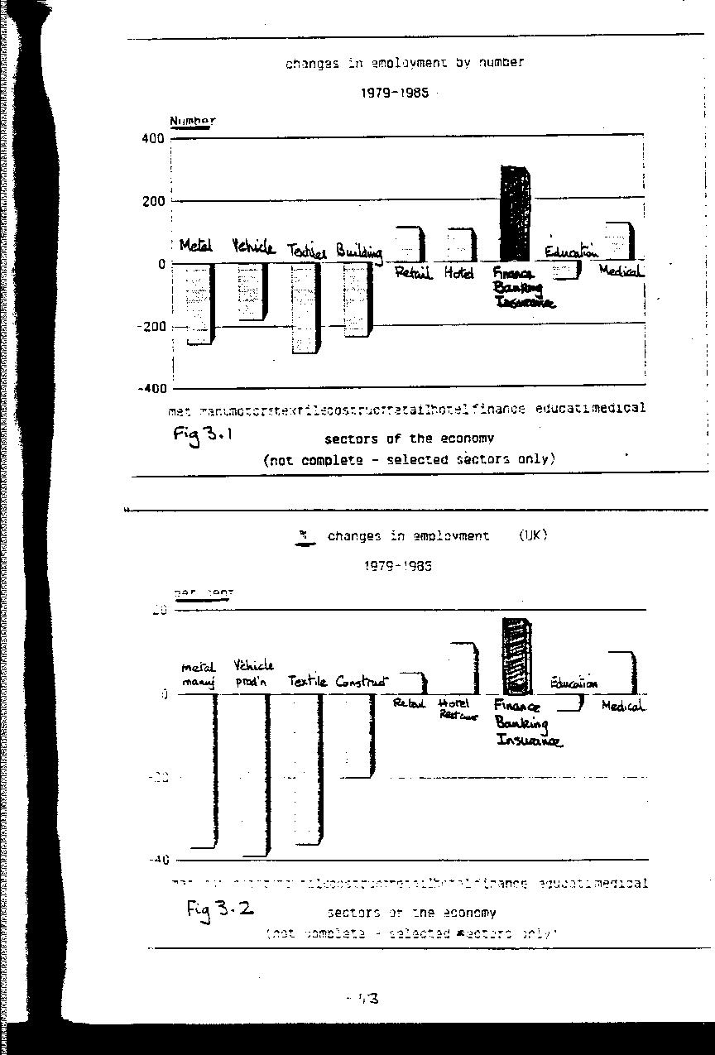

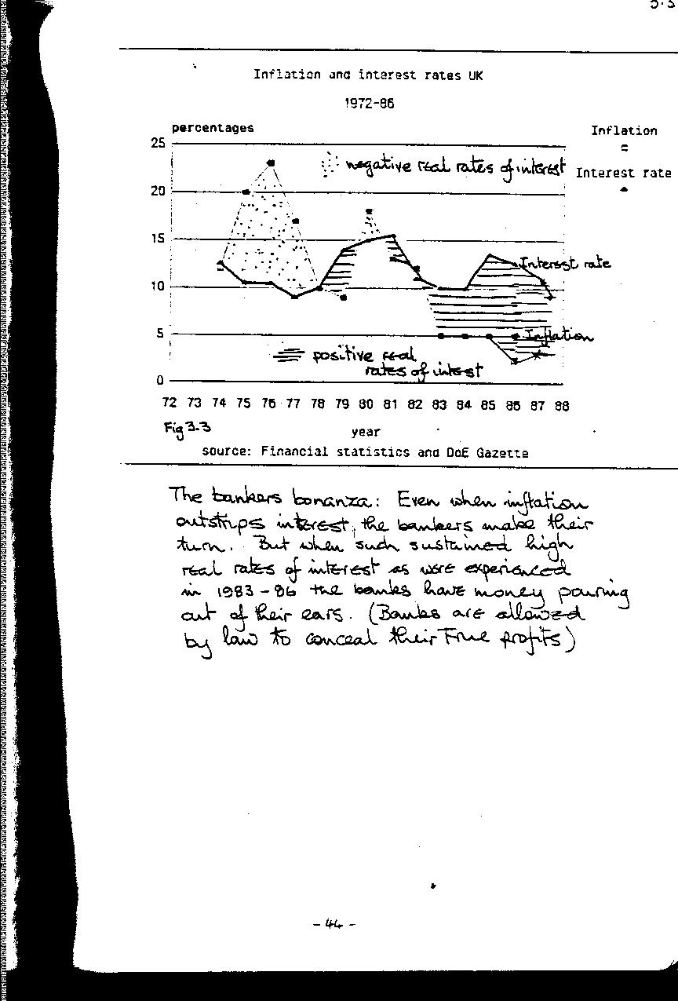

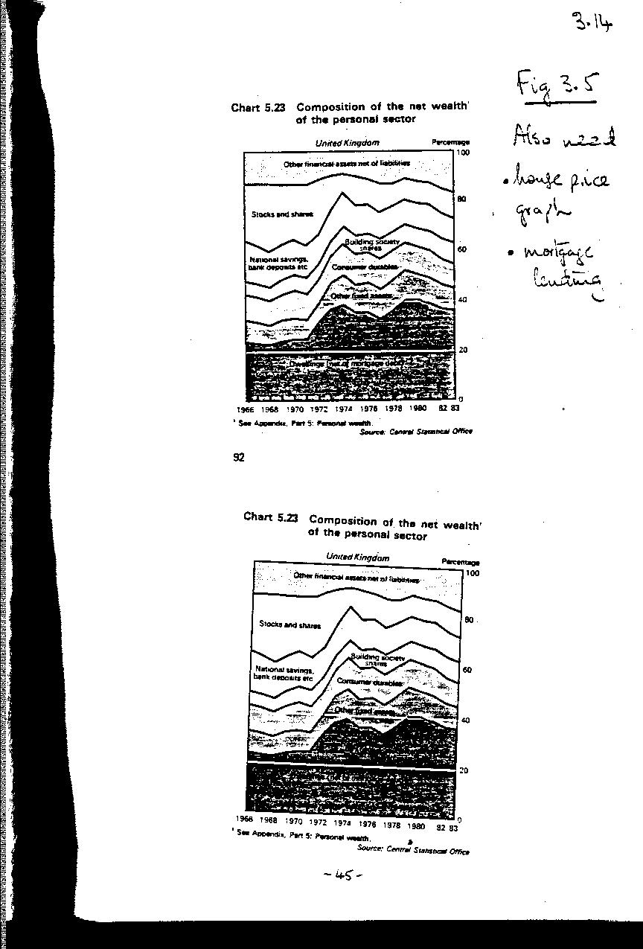

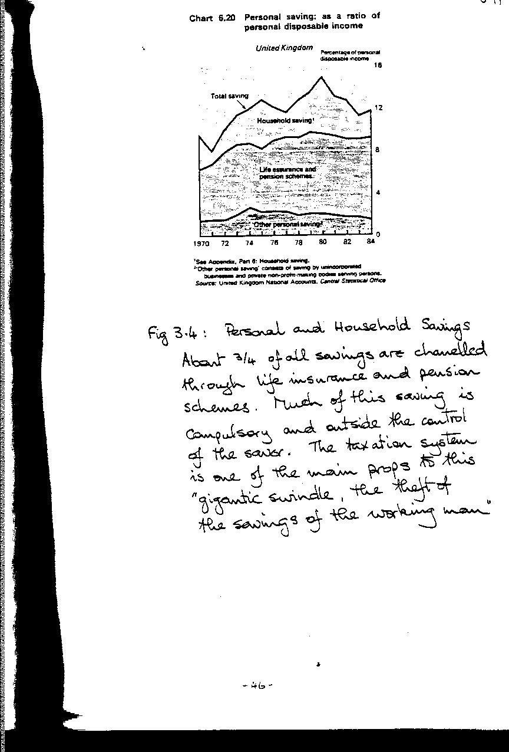

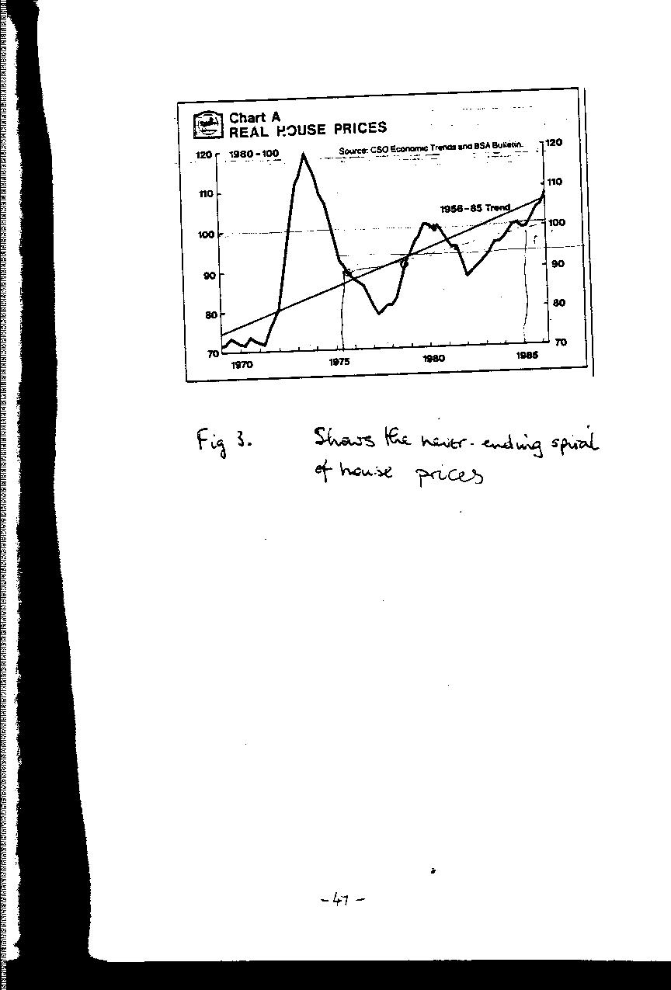
4. 'INDUSTRY: FEWER BROWS', LESS SWEAT

To suggest that manufacturing industry should get rid of more workers seems like a bad case of kicking a man when tie is down. Unlike the finance sector of the economy, industry in the UK has been going through a very lean time over the last few years. Take for example car making industry which was once the leading sector of the economy, especially in the West Midlands. Fig 4.1 shows how production has declined. With this decline has gone a steep reduction in the numbers employed in vehicle production, including those working in the component factories.
It is not only because fewer cars are now made in Britain that there are fewer workers in car factories. Increased use of robots, computerisation, scrapping older, less efficient plant means that a car can now be built with a fraction of the number of workers that were needed ten or twenty years ago. Even in Germany and Japan, where the car industry is thriving, automation has reduced the total number employed.
This trend in productivity causing increased job losses is going to continue, whether Basic Income is introduced or not. But if a Basic Income scheme were to be introduced then gains in productivity (and job losses] could be even more rapid. Basic Income can have a part to play both directly by giving current job shedding a boost, and indirectly in a number of other ways. The aim is not to reduce the total output of the industrial sector, that would be unthinkable. Unlike the financial sector, industry produces useful goods. As such it should be protected and encouraged. I would not be an advocate of Basic Income if I thought it would damage industry, or even prevent a healthy increase in the production of goods for which there was a demand.
Working in a factory is neither pleasant or desirable as anyone who has experienced it will readily confirm. In a sensible humane world we would welcome the prospect of liberating these toilers from such an alienating environment. In our present topsy-turvy world workers will fight tooth and nail to preserve their factory and its jobs. Strikes, sit-ins even mob violence are used by people who might be otherwise perfectly law-abiding. The only explanation for this behaviour is that the alternative to a factory job -the dole - is even more degrading. The introduction of Basic Income would cushion the blow, making loss of a job in a factory a less fearsome prospect. Instead of resisting redundancy, workers will be able to view it as inevitable and welcome progress.
There is an economic argument which might suggest that Basic Income will increase rather than decrease the demand for labour, which goes like this: Basic Income is paid whether you are employed or not, and acts like a general wage subsidy. Subsidised things are cheaper to buy than they otherwise would be, so in economic jargon, the 'demand' for labour by industry would rise given a flat-rate per unit subsidy such as Basic Income.
But the economic argument leaves out of account the negative feelings people have towards working in a factory. Even a job in the most up-to-date micro-chip factories has low status and little intrinsic reward. Given half a chance, most people would prefer to earn a living elsewhere. The half-chance is of course {Basic Income. The difficulty of getting people to work in a factory at any price will continue to be a great incentive for the industrialists to pursue mechanisation and automation. There is still plenty of scope for the engineers and managers to shed workers from the factories, as international comparisons show.
Productivity and the three-day week:
In 1974, in order to combat the coal miners strike, industry was forced to operate on a three day week, closing down completely for two days out of five. The reason for this was to conserve coal stocks at the electricity power stations. With only 60% of the normal time available, very close to 100% of manufacturing output was maintained.
Postscript: In 1986, twelve years later, total manufacturing output in the UK is at a level LOWER than during the three-day week.
"Training lags, says MSC Chief"
Mr Bryan Nicholson, the chairman of the government's 'Manpower Services Commission' declared that British workers and their managers were a bunch of thickies. With similar technology and equipment, the German managed as much as 63% greater productivity per man.
Radio report, 21 March 1986
As well as encouraging gains in productivity which will in turn lead to job reduction, Basic Income will also act indirectly to reduce the need for much manufactured output:
In this and other chapters ways in which Basic Income will cut down on the need for many jobs are demonstrated. Basic Income also provides the social lubrication to allow such job losses to be achieved. A lot of the output of industry is used to keep other employment going. fits the total number in conventional
full time employment drops, so the demand for some of the products of industry will no longer be required to the same extent as now. Cars, buses and trains to transport people to work, office equipment, even such items as dark suits, the working clothes of the executive will be less in demand.
Benign technology: There is a strong feeling that our current throw-away technology is unsustainable, and cannot be allowed to continue much longer. Cars designed to last a mere 50,000 miles, equipment which has to be junked once it develops a fault no matter how trivial, may be 'economic' by some very narrow accounting criteria. The true, full costs to society of such a disposable economy are much greater. Basic Income is not only about transferring control over resources from institutions to individuals, it is also
about shifting attitudes towards a more ecological viewpoint, living in harmony with the world around us. In the short-run, the switch in manufacturing from disposable to repairable commodities will add to cost (and employment). In the longer run, more durable and repairable products will mean that you need to replace your car, washing machine or computer much less often.
The combination of increased productivity and reduced demand, coupled with the intrinsic undesirability of factory work should see the manufacturing sector of the economy shed labour even faster after the introduction of Basic Income than at present. Already commentators like Charles Handy ( 'The Future of Work') and James Robertson ( 'Future Work') suggest that Industry could soon go the way of agriculture, and become the employer of no, more than five per cent of the workforce. Basic Income will certainly not hinder this development!

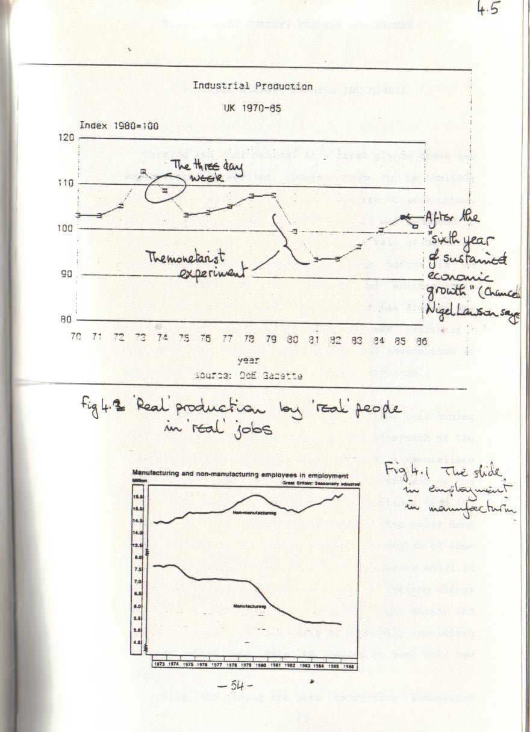
5. BASIC ENERGY: FARMERS AND MINERS

Farming and coal mining? At a first glance these two employment categories would seem to be unlikely companions, apart from a mutual dislike of each other. You may recall what happened when it was proposed to mine coal in the mainly agricultural Vale of Belvoir. The local farmers expressed their horror in no uncertain terms at the prospect of sharing their valley with coal miners. (One irony of the dispute was the source of wealth of the chief 'farmer' protester -the Duke of Rutland - his family had become rich by operating coal mines in the Industrial Midlands.]
The contrast between the two sectors, coal mining and agriculture, seems total. In the aftermath of the 1984-85 miners ' strike, coal appears a demoralised industry. In the twelve months since the end of the strike the numbers employed have declined from 180 thousand to ISO thousand. Farming on the other hand seems to be in a happy state. The wealth of some farmers is plain for all to see as they drive about in their Volvos and Mercedes. But even in farming things are not as rosy as they appear. Both mining and agriculture are in the grip of a heavily subsidised decline, which can only be halted by some bold new ideas.
Farming and mining are both 'extractive ' industries - they extract wealth from the world around us. In both cases the product provides us with energy, food, the human fuel in the case of farming, coal for burning from mining. In some countries, notably Brazil where sugar cane is used to produce a petrol substitute, the two activities are inseparable.
Another common factor which farmers and coal miners share is the sentimental regard which the public has for them. The farming way of life is a subject for much nostalgia. The countryside, which is the farmers 'shop-floor' is seen by city dwellers as a national asset to be cherished and conserved. Coal miners and their communities evoke a similar, if less widespread glow of affection as the farmers. This may be due mainly to the feelings of guilt at the past sufferings of the miners, who provided much of the basis for Britain 's industrial wealth.
But there is another characteristic which coal mining and agriculture share, which is highly relevant to our present discussion - they are both industries which receive huge handouts from the state. There are the direct subsidies, payments made by government to sustain demand for their products. There are indirect subsidies, which are just as much a cost to the consumer; these usually take the form of a ban or restriction on competition. The consumer has had to pay dear for the protection of these industries, and stands to gain hugely if a way can be found of re-directing the resources now being squandered. The mechanism for achieving this could well be Basic Income.
Fanning: the rape of the countryside
In recent years the English countryside has witnessed a strange new sight: vast fields of a crop called rape, with bright yellow flowering. This intrusive new crop could never exist were it not for the vast subsidy system known as the Common Agricultural Policy (CAP) of the European Community. This yellow peril is the outward symbol of an expensive and ineffective policy. Although agriculture is often hailed as a great economic success, by any other criteria - social, ecological, energy efficient - it is a catastrophic failure.
One of the objectives of the CAP and previous government farming support policies is the preservation of the rural way of life. In 1953 there were 454 thousand farms in the OK ; by 1981 this had shrunk to 242 thousand. There are now only 342 thousand people left working on the land (1985), and the number is still declining. This reduction in farms and farmers has been accompanied by great increases in productivity. Where once the tiller of the soil could only just feed himself and one other, today's British farmer can feed no fewer than 42 people. This achievement is all the more impressive when compared with the other European farmers. It is especially impressive when the poor growing conditions are taken into account.
So why am I going to suggest that we need fewer of these heroes of productivity? Surely here is one successful sector of the economy (unlike the car industry) which should be extended. Would it not be sensible to encourage more farm output so that our own land eventually produces two-thirds of all our food needs compared to the less than half as at present?
Sadly, the agricultural 'economic miracle', the result of so much dedicated effort by a shrinking band of farmers, is a shameful waste of resources, not just money, but energy, materials and above all people. It is a technical triumph, but in every other way a disaster which cries out for reform. Many commentators have drawn attention to the failings of the agricultural policy, none more effectively the Sir Richard Body M.P. In two books 'Agriculture: the triumph and the shame'(1982) and 'Farming in the clouds' (1985) he explains the massive lunacy of our present system of farm support. In a memorable illustration, Body likens the effect of the C. A. P. -the Common Agricultural Policy to ' growing bananas on the slopes of Ben Nevis ' - and points to something almost as daft which actually happens, the growing of wheat on the moorlands of Yorkshire. It is a technical triumph, but can only happen because the CAP keeps the price of wheat at twice the prevailing world level. Taken as a whole, the effect of the CAP has been of long term benefit only to a minority of farmers - those with very large holdings. Manufacturers of fertiliser and machinery benefit as well, and are part of the well organised lobby pressing for even greater subsidy. The majority of farmers must run ever faster just to stay in the same place - a herd of 75 cows is now reckoned to be the minimum to earn a living, whereas just 20 or so would have kept a farmer in business few decades ago.
To quote a few of the figures which Richard Body produces to illustrate the cost and futility of the CAP:
If free trade with the rest of the world was allowed, in the same way as it was in the Victorian times (1850-79) we could expect the following: - a release of enough capital (£3 billion +) each year to finance the start-up of TWO manufacturing companies of the size of I.C.I.
a rise in real personal income by 15% initially, as cheaper food becomes available, rising eventually to 25%. Of course there are many ways in which this money could reach the individual, including a Basic Income scheme.
a fall in output of the farming industry to about half its present level.
a vast reduction in the use of fertilisers, and a reduction in the use of oil (at present about a quarter of all oil is used in farming)
The arguments put forward for protectionism in agriculture - security of supply, savings on the amount of food imports, conserving the rural way of life -have all been perverted. As Body describes with telling clarity, the CAP has made supply less secure, has added to the total imports bill, and is a terrible blight on the countryside. By default, the case for free trade with the rest of the world in agricultural commodities is overwhelming.
So why don't politicians, always quick to spot an opportunity, demand free trade? I think most of them realise that the CAP is indeed nonsense on stilts, that great benefits would eventually flow from free trade, but .... in the short term there would be some very big losers, who would shout loudly - the fertiliser manufacturers and the big farmers especially. If only there was some simple mechanism which would maintain the farmers basic income, yet would allow free trade in food, this should prove mightily popular with the electorate.
Many commentators remark at the mountains of surplus food, the rape of the countryside, the continuing decline of the rural population. One option they find themselves compelled to consider is a direct income subsidy scheme. If such subsidies could be introduced as part of a universal Basic Income scheme, then the farmers would not feel like 'scroungers'. Farmers, their wives and children, farm labourers would all be treated in the same way as the rest of the population. Free trade would follow on as a natural consequence of the introduction of Basic Income, and the wasteful nonsense of artificially high prices and import controls can cheerfully be scrapped. (Great Britain would be in the doghouse with the EEC of course, but that is no reason why we shouldn’t 't ask what life after CAP would be like)
In Britain we frequently complain of the 'unfair' practices of the Japanese in engaging in supposedly one-sided free-trade. As it happens the Japanese along with the Germans, French and Americans all follow our example and divert massive resources into agricultural support. So how about a bit of 'unfair' competition of our own - how about unilaterally declaring agricultural free trade? Basic Income makes this quite feasible politically; the result it is suggested would be a massive 15-25% boost to the economy. Basic Income could be introduced first as a 'country dwellers subsidy' which in turn could lead to reform of the CAP (Common Agricultural Policy)
The consequences would of course be a further severe decline in the number of full time workers in the agricultural industry, and the industries which supply it. This again is an example of the beneficial unemployment that would flow from the introduction of a universal Basic Income scheme. Reforming the Common agricultural Policy could turn out to be the crowning achievement of Basic Income.
Miners
Farming and mining are mucky occupations, but mining is also dangerous and is carried on in black holes not open countryside. It would seem incredible to a visitor from Mars that miners would fight to hold on to jobs in the pits. But coal mining has attracted large state subsidies and fights to stay larger than either common-sense or economics would suggest. So what is the reason for sustaining employment in this dirty dangerous industry? Mining communities have developed which are heavily dependent on just one source of income - the mine. As things stand at present they know that without the income from the jobs down the pits then their communities must perish.
It is difficult and indeed controversial to suggest how much the coal mining industry 'costs ' the economy and the consumers it is supposed to serve. There is the direct government subsidy each year of several Hundred million (equivalent to about £4000 per miner). This is a. direct payment by the taxpayer to the British Coal (National Coal Board) to cover losses.
But there are other costs which fall of necessity on the consumer. Imports of coal from low cost producers like Poland and South Africa are banned. This affects the steel industry of course, but the main victim is the CEGB (Central Electricity Generating Board). This nationalised monopoly supplier of electricity not only is compelled to buy coal at double the world price. Because of earlier ordering policies 'for power stations, it must rely on coal for a very high proportion of its fuel requirements. This is all done in the cause of keeping pits open and maintaining employment. At the end of the day someone has to pay for all this indulgence - the electricity consumer, and the taxpayer, often the same person.
The cost of this indulgence is huge - several billions of misdirected funds. In the wake of the oil price collapse of 1986 the cost looks even higher. But there are other effects which are equally damaging -pollution and insulation - too much of the first, too little of the second.
Acid rain is the result of burning coal in power stations. Its dire effects on the forests of Germany and Scandinavia threaten to sour international relations with the OK, since Britain is the main source of the acid rain. Just like cigarette manufacturers who despite the evidence claim that the link between cancer and smoking is "not proved" so British diplomats stonewall over acid rain - "need more evidence to prove it really is our coal burners". But in their hearts they know that they are defending pit jobs not clean air.
Insulation of buildings and houses reduces the need for all forms of power including coal. It makes life more comfortable for the occupants, saves them money, reduces pollution, makes people generally less dependent on centralised suppliers. No doubt governments would like to claim that they are all enthusiasts for fuel saving, giving insulation grants, sponsoring advertising such as the 1986 'Monergy' campaign. But good though this public activity looks, there is no fundamental commitment to fuel-saving as a priority. Insulation grants are switched on and off, becomes unavailable as the needs of politics or the Treasury dictate. No effort is made to compel the public owned utilities to promote fuel saving though the price mechanism - on the contrary standing charges promotes inefficiency. Political expediency also means that hidden taxes can be imposed which destroy the plans of millions for switching to cheaper fuel. (This happened in 1984 when a £600 million levy was imposed on Gas, because it was "too cheap" compared to electricity and coal).
So we ought to be using far less coal for environmental reasons; we ought to be saving fuel by better insulation and we could get the coal we still need far cheaper from overseas. The economic benefits would be huge. But the implication of all this is a very substantial reduction in the number of coal miners.
Is this an impossible stumbling block? No matter how sensible and worthwhile it might seem to liberate great numbers from their toil in the pits, are the vested interests of the HUM (National Onion of Mineworkers) so powerful that we must throw money down the mines in order to preserve mining communities? This is where Basic Income has a very useful role. If preserving communities is the main aim, then giving money to the individuals in that community is much more effective and humane than pouring it down the pit. In view of the high passions that this issue has aroused in the recent past during the 1984-5 miners strike, it might be worthwhile introducing a special Basic Income supplement. As a thank-you for the flexibility of a free market in coal, each employee of the British Coal should receive an index-linked salary of say £3000 per annum for life, whether they work for the British Coal or not. This would, I hope, transform a situation which has witnessed great bitterness and despair, and bring much needed joy to these mining communities.
Agriculture and mining are not major employers of labour as they once were, so the potential for liberating employees is not so great - a few hundred thousand. Their potential for liberating misdirected wealth is of major concern. The small reduction in employment in these sectors can release huge funds which can be more usefully employed. Basic Income is a mechanism which allows these funds to be unlocked, because it creates a climate where holding onto a job is no longer the ultimate consideration.
6. SECURITY FORCES: MORE SECURITY, LESS FORCE

It would be very foolish to imagine that the introduction of Basic Income would herald a new dawn of goodness, where everyone feels so at ease with society and themselves that all impulse to evil vanished. It is worth reminding ourselves that this is more or less what the early social reformer believed, but human nature remains stubbornly resistant to improvement. Basic Income can remove some of the underlying causes of conflict within and between societies. It stands a better chance than most reforms of producing a real reduction in today's rising crime wave and unparalleled levels of armed hostility on the international scene.

The Armed Forces
Without any conscription, or National Service as it used to be called, Britain's army is one of the smallest for its population compared to other European countries. (see Fig. 6.1) The number is indeed quite modest. (table to show army sizes Fig .1]
There is no objective measure to indicate what size the armed forces should be. If we leave the figure of 300,000 as 'adequate', then we need look for no saving of jobs as result of Basic Income in this sector. But that is not the end of the story. In order to maintain the military machine it is necessary to keep them supplied with equipment of all kinds. It is reckoned that this 'tail ' of defence contractors employs 500-700,000 people directly, and it is here that we could expect a lot of un-necessary jobs to be axed. The result would not just be cheaper defence; there is good reason to believe that it would be better defence as well.
When it comes to supplying the UK defence forces politics and sentiment play a large part. The politics are exercised by defence contractors who have a highly effective lobbying machine at Westminster. A very effective tool is the promise of jobs in the constituency of MPs who might normally be hostile to arms spending. There are also powerful special interest groups such as the Navy lobby who are ready to pounce at the slightest suggestion of cuts. To these political forces must be added the sentimental baggage: that the OK should strive to be self sufficient in the supply of every type of weapon; that Britain should have a Navy which can go anywhere in the world e.g. the Falklands.
An example of the sort of thing that happens is shown by the jostling in 1985 for the order for guided missiles worth £100 million. Two contenders were an American system, available and working, and a more expensive British system yet to be built. When Michael Heseltine, the then Secretary of State for defence announced that the order was going to British Aerospace, he was showered with compliments, even from opposition Labour MPs. The reason was the job implications - it was considered even by those who might be expected to oppose waste in defence spending, that job creation and job saving was a greater good.
There have been some classic blunders as a result of this policy. The Nimrod airborne radar system is one of the worst. After 10 years of development, with continuous changes to the specification, it still cannot be made to work satisfactorily. A decision on whether to pour more good money after bad has yet to be made. The irony is that a working system has been available for years - from the US. A decision to go-it-alone by Britain has achieved the worst of all worlds - a lot of money has been spent without any result; jobs may have been preserved but to no useful effect. But the industrial-military complex is not put off by repeated failure. Through its system of mutual favours it produces an irresistible case for more job creation, more pointless spending.

Basic Income will allow one part of this dreadful conspiracy to be stopped. Since Basic Income means that job losses are no longer to be feared, then better weapons can be purchased at lower cost. But there is another trend which may both improve quality and reduce costs. Technology has invariably been seen as increasing complexity, cost and delivery time of defence equipment, but this need not always be so. Compare today 's television with the product of twenty years go; it is more complex, but performs far better and more reliably, and costs less and is produced in fewer man-hours. Mass production of consumer devices has followed a different path to defence procurement -similar stable technology and steady improvement can offer a much more promising future for defence procurement. This small scale appropriate technology idea is quite in keeping with the philosophy of Basic Income.

The Police
could expect a reduction of 10,000 without loss of security. Some commentators go further and suggest that police numbers could be cut in half without any significant increase in crime rates.
It is a mistake to think that the police are the sole or even the most important guardians of people and property. And if we wish to reduce rather than deal with the consequences then police are certainly a most ineffective instrument. As to the causes of crime, a popular and quite reasonable explanation is that of "alienation". Why should the unemployed youth, the black who is discriminated against feel any commitment to a society that has rejected them? Being deprived, or unemployed or black is not an excuse to commit crime, but reducing unemployment should reduce crime. Basic Income will of course deal with the unemployment, but it goes much further than that. Since Basic Income is paid to all citizens regardless of status, it is a tangible indication to each and everyone that they belong, that they are full and equal members of society. I would not go so far as to say that Basic Income will cure all forms of alienation, but it will create a society far removed from the in-work haves and out-of-work have-nots as at present.
Nevertheless human nature will always remain the same. There will still be those who steal, cheat and maim, after the introduction of Basic Income. Society will still have to protect itself against such people. Traditionally we look to the police for this task, but the main protectors of property and the person has always been people themselves.
At home it is up to the householders to ensure their homes are secure - locked up, not burning down. On the street it the presence of other people which is the chief protection against mugging. Since a result of Basic Income is to create a much more localised, informal styles of economic activity, this will result in more people at or near their homes, on the streets, at odd times of the day. This in itself should lead to a significant increase in the feeling of security.
Police are not the only people at present who are employed to combat crime and provide security. Security firms like Securicor provide a cash delivery service; on-site guards can also be hired from these firms. All organisations employ security staff, who check visitors and patrol the premises. It is reckoned that there are twice as many people employed in this way compared to the number of policemen. It is also a major growth industry, as fears of bombs and other terrorist activity grows. We live in a world which is beset by fears about its safety. But as fewer people are employed in conventional organisations as a result of Basic Income, targets and the need to secure them become less necessary. The de-commodification process described in Chapter 3 means that less money will need to be carted around in security vans. The small-scale local institutions of the post-Basic Income era will not be such worthwhile targets for the bomber.
Prisons are another aspect of law and order which could benefit from the introduction of Basic Income. This will be due more to the general climate of common sense, and desire to find simple effective mechanisms for dealing with our problems. Britain in 1986 has a prison population of about 70,000 - 48,000 prisoners and 19,000 warders. By international standards this is extremely large ( see Figure 6.3).
(Fig 6.3 Prison populations in Europe)
If all this imprisoning was doing any good it might be defensible. But there is a wide measure of agreement that it is entirely counter-productive: prisons are the finishing schools for criminals. A reduction by half or more of the prison population would NOT increase crime or reduce security. It would seem eminently sensible to set a prescribed limit to the prison population, say 10,000, and once that limit was reached to reduce all sentences in proportion. The judges could then decide amongst themselves how they wished to ration out the total punishment available to them. Admittedly this reform has nothing to do with Basic Income, but is similar to it in one way. The simple mechanism, a number limit, with proportionate reductions, is similar to the single universal payment mechanism of Basic Income.

Northern Ireland

Nowhere in the United Kingdom is security a greater problem than in the troubled province of Northern Ireland. At the risk of over-simplifying, we may explain the problem as one where two groups cannot agree on an acceptable form of government. Opposition to each other takes violent forms, with neither side acknowledging the right of the other. The protestants fear the religious domination of the other side, the catholics fear the political control by the others. The quarrel has taken a very vicious turn, resulting in bombings and killings. This has called forth a security response in the form of troops and extra police facilities. But there is also a huge cost in lost revenue, and additional security burdens on the rest of Britain, and to an even greater extent on the Republic of Ireland.
What contribution would Basic Income have in 'solving ' the Northern Ireland problem? On its own Basic Income has a number of effects which should be of significant help:- Since Basic Income is paid to all residents without qualification it creates a feeling of equal citizenship. Whoever controls the machinery of government becomes less significant. But Basic Income is also about transferring the power that goes with control over money right down to the individuals within the community. It may be too soon to talk about the "withering away of the state", but Basic Income certainly reduces the leverage the state has over the individual. The conflict between the two communities over who 'owns ' the state apparatus would become largely irrelevant.
As time passes the standard Basic Income scheme should be a pacifying influence on the passions of the people of Northern Ireland. In the meantime there is no reason why an interim scheme directly related to the needs of security should not be introduced. There seems to be no shortage of money to throw at the problem -£1,500 million a year is the figure usually quoted for subsidising Northern Ireland by the OK government. Instead of spending this huge amount - £20 per week for each man, woman and child - on shipyards and police
equipment, it could be paid out directly. The only condition that would be applied is that the security position has to improve. This could be done in stages. For each month that goes by without bombing or killing the amount could be increased by £1 per week. Since the terrorism is a product of the community, it would be a foolhardy bomber indeed who acted directly to reduce the income of himself, his neighbours and his friends. This scheme is likely to branded as "mere bribery", but if it works why not try it? After all international companies are frequently bribed to locate factories; homeowners are bribed with tax relief. What is so wicked about bribing the people of Northern Ireland to live in peace?
In this chapter I have touched on a wide range of issues connected with security, both in the local policing sense, and in the wider military sense. There are many big issues involved here, and I don't expect that everyone agrees with all the ideas put forward here - we all have our own pet theories as to the causes of crime and international tension. All I would claim is that Basic Income allows us to throw out some useless baggage, like defence procurement being good if it used to save jobs. It also can help to create a new balance of power and control in society, where individuals in communities take over from centralised institutions.

add: Any suggestion of cuts in defence programmes is met with loud opposition from MPs with constituencies where jobs might be lost. This opposition cuts right across parties – local jobs are cherished be they for rifles, Trident submarines or anti-personnel explosives. But these jobs are costly. A quick calculation based on the 1988 Defence Estimates suggests that the taxpayer must fork out £22,880 per defence employee. It would be nice to think that the taxpayers were getting their moneysworth – but tales of poor quality, badly performing defence equipment abound. The classic case is the Tornado aircraft – 32 costing around £500 million are in store, unusable because their radars cannot be made to function.

7. MIND BENDING: DRUGS OF ALL KINDS

Say "drugs" and the picture for most people is that of the needle-sticking heroin addict in the last stages of depravity. But this is just a tiny part of a huge business which covers many kinds of drugs, that affects nearly everyone and employs millions.
A drug is any substance taken which changes the state of mind of the user. Heroin and cocaine are labelled 'hard drugs ' and their sale and use is illegal. Alcohol and cannabis are 'soft' drugs, distinguishable by one being widely and legally available, the other being branded illegal. After alcohol, the most widely used substance is tobacco which yields the drug nicotine. To this list we should in fairness add tea and coffee which are mild stimulants.
But there is another major category - the therapeutic or medicinal drugs such as tranquilisers and anti-depressants. These can only be obtained with a doctor's prescription. Many people make the mistake of believing that some drugs are alright in moderation, and that it is possible to identify dangerous drugs which are harmful in any quantity. This leads to a moralist approval of powerful addictive drugs like sleeping pills and a hysterical witch-hunt against mildly dangerous substances like cannabis.
The inescapable truth is that ALL drugs are damaging, some more so than others. In an ideal world we should be able to get by without recourse to drugs of any kind. In the less than perfect society that exists, we will always feel the need for some drug-induced escape. The best that can be hoped for in a general reduction in the total of all drugs consumed.
The number of people 'employed' in illicit drug dealing is of course not easy to calculate. The fact that cannabis, heroin and cocaine are illegal yet in demand creates jobs. Extra customs officials, police drug squads and hospital staff are required (the drugs are of very indifferent quality and often are cut -extended with lethal additives). Illegality also pushes the price up, so that a dealer can make a living from peddling quite a small amount of dope. There is a very reasonable case for saying that governments ought to stop trying to prohibit these drugs, and concentrate on controlling them. They should ensure that users can get supplies of known strength and of 'merchantable quality'. It seems the lessons of the Prohibition
experiment in America 1919-1933, have yet to be learned by moralistically inclined governments. Legalising and taxing these drugs would bring about a modest reduction in the numbers in full-time if sometimes unconventional employment; it would also be a useful source of revenue.
The legal drugs - tobacco and alcohol - have spawned huge industries which employ thousands. The damage that tobacco does is well documented - at least 80 premature deaths per day in the UK are caused by smoking. The puffing habit is in decline, but cigarette manufacturers are not above using any trick to support their business.
"1p on a packet of 20 means 1,000 lost jobs"
was the message from tobacco companies to the Chancellor in newspaper advertisements prior to the Budget of 1986. The suggestion is that saving jobs is more important than saving people from a painful death by cancer. If this is so then it is grounds for saying that our present economic system is evil. Any system that seriously values jobs above health in this way is immoral and needs changing.
Alcohol consumption rose sharply during the 1960's and 70 's and is now at twice the level it was in 1950 (see fig 7.1) This industry employs large numbers in brewing and distilling - no fewer than 100,000?. A large amount of farm produce is used to keep them supplied with barley, hops and so on. Special requirements like peat are needed for whisky distilling. When it was discovered that peat cutting for the local distillery in the Highlands would destroy a rare breed of geese, the 'saving jobs' argument was trotted out. The geese lost.
Fig 7.1 changes in alcohol consumption 1950-1985
At the other end of the alcohol supply chain are the pubs, off-licences and supermarkets. Since pubs are favourite meeting places, and provide a charming addition to many a town and village, I for one would not like to see them closing down because of a slump in alcohol sales. But most of these hostelries have already diversified into bar food, entertainment and other non-booze activities. A halving reduction in the take from alcohol need not be catastrophic.
A cut in half of alcohol consumption would have many good consequences. Diseases such as cirrhosis of the liver, injuries in car accidents and the terrible damage to the families of alcoholics can all be expected to drop as alcohol consumption goes down. The means of achieving such a drop are not blanket Prohibition or restrictions on opening hours - they are ineffective and counter-productive. Just as for smoking it is an undramatic campaign of public education and awareness, drawing attention to benefits of less smoking, less drinking that should lead to a tapering off of these habits. To be effective such campaigns to moderate the use of all drugs should not have to compete with the blandishments of drug advertisers. A ban on the promotion of drugs is surely the mark of a civilised, caring society.
The other benefit of a reduction in tobacco and alcohol consumption would be a drop in the numbers employed in these death-dealing industries. Basic Income means that job losses will no longer be an inhibiting factor. Bi also means that the economic imperative of a job at all costs can be re-examined -the employees of these firms can be free in a meaningful way to choose whether or not they wish to work for a firm of drug peddlars.
The third class of drugs - the therapeutic or medicinal - affect the lives of millions of people, but the industries which supply them do not employ great numbers. Tranquilisers and anti-depressants are often prescribed to overcome the stresses of modern living.
This is just another way of blaming the victims of the
put-on employment-based society. I sincerely believe that BI will
be of benefit so that tranquilisation will be far less used. Freed from the high pressure lifestyles that go with today's industrialised society, BI will allow more humane, harmonious patterns of living to develop. The use of mind controlling drugs is a symptom, not of sick people but of a sick society. BI and the other measures it will bring should go a long way to curing the sickness. At the end of the day, human nature remains, weak and susceptible to temptation. No society has ever eradicated drugs altogether, and I don't expect we will either. While continuing to educate people about the negative aspects of drugs, warning ' of , the dire consequences of over-use of all forms, we must still permit access. Some control over supply will benefit the consumer and prevent exploitation, but at the end of the day the only practical course is to allow some form of access to all drugs.
The reason why such a moderate and sensible approach to the drug scene is not adopted is not difficult to understand - the vested interest of the companies and the tax take of governments provide the clue. The 'saving jobs ' argument is used quite shamelessly as an excuse for not taking effective action. BI blows away this feeble and immoral excuse, and clears the way for effective action. It enables individuals to freely choose whether they wish to work for drug peddlars, without the goad of a job at all costs.
Nothing worse than drugs!?
May 1986: The Criminal justice Bill proposes that drug dealers shall have all the usual legal protection removed. Banks will be obliged, if they suspect drug dealing, to disclose all details to the police. The bankers will be granted total immunity even if it turns out that they are completely mistaken.
A study in Liverpool by the Society of Biophysical Medicine reveals that 86% of addicts were unemployed, that they spent on average more than £10,000 per year on drugs. The money came mostly from criminal activity - shoplifting and housebreaking.
Tin- [Kiwi-r of the Alcohol lobby: FOUR major incidents:
1978: Think tank report for the Labour government on alcohol abuse suppressed; it is classified secret, and it is a crime to quote from it.
A.A.A Action on Alcohol Abuse set up by government but starved of funds and ignored.
Alcohol Concern receives £0.3 million and spends £0.298 on offices and staff. This leaves just £0.002 mn for campaigns ( the alcohol industry spends £220 million on promotions and campaigns)
- Alcohol Forum, a DHSS sponsored body, strangely sacked its chairman, a widely respected Professor. Widely believed that this was as a result Of alcohol industry pressure.
(these examples given in "Brass Tacks" programme 15 Oct 1986)

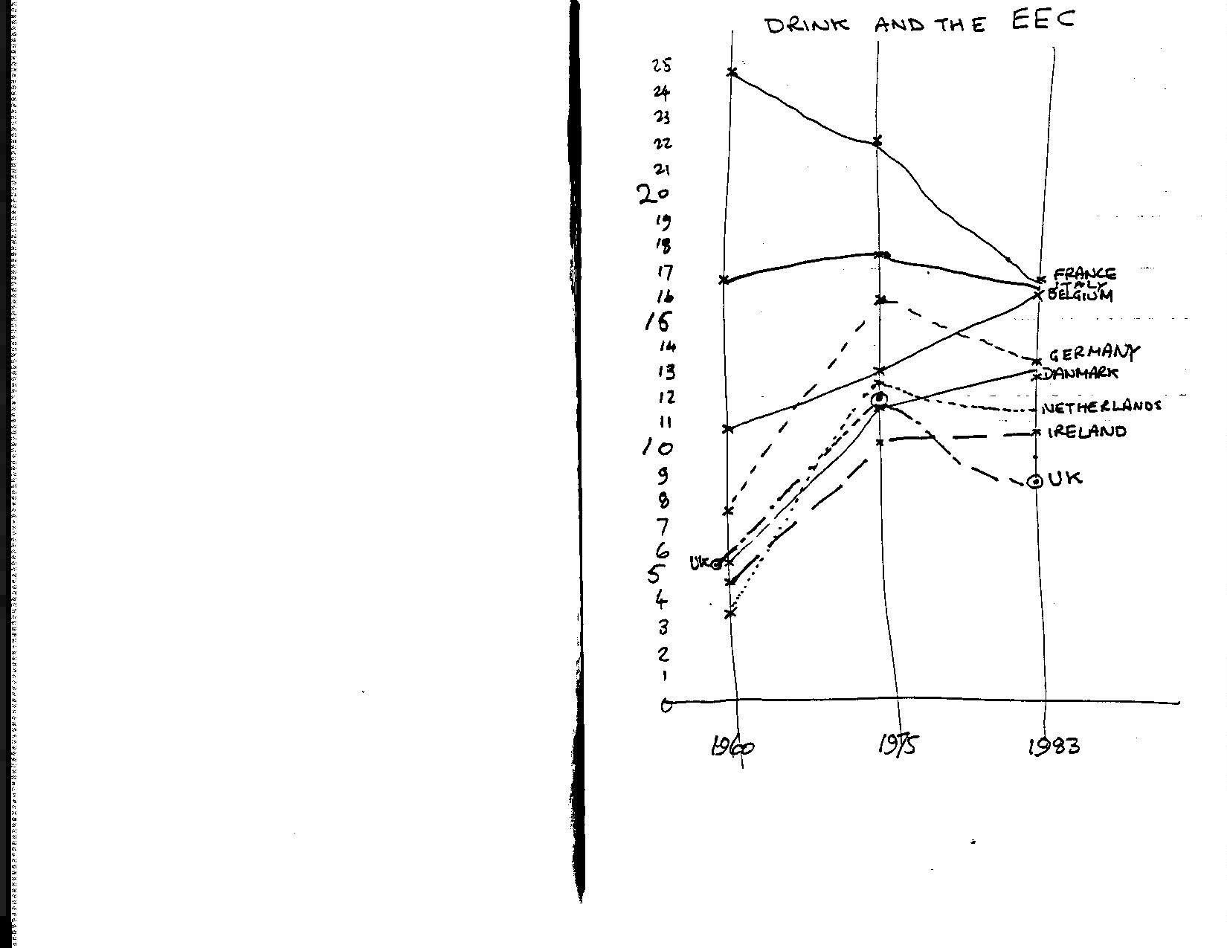
8. EDUCATION AND 'TRAINING'

Warning! This chapter is going to challenge beliefs dear to many of those who might otherwise be supporters of Basic Income. The BI idea does not crucially depend on the suggestions of this chapter.
Education is one of those things which everyone seems to approve of, and most people think we need a lot more of. I am going to argue in this chapter that it is time to see Education is an over-inflated industry, set up to cater for vanished needs. As this seems to be so contrary to public opinion let me make one thing crystal clear right away - I passionately believe in the value of knowledge and learning, that it is the right and duty of everyone to develop their maximum potential. What I would like the reader to appreciate that institutionalised education - the schools, the colleges, the universities - do not have a monopoly on learning, and in many ways these institutions are factories of ignorance!
Education as an employment category is quite large - there are 500,000 people, mostly teachers in this sector, a massive rise since 1950 (300,000), but a slight drop since 1979. in fairness as well as considering those employed in a conventional wage-earning sense, we should add in all those fully occupied in education, but not receiving a salary. I refer of course to the students and pupils.
In the age range 5-16 education is compulsory for all children, so the alternative of a job does not really apply. The number of pupils and students in each age group is shown in Figure 8.1

Figure 8.1 numbers in education by ages

The school leaving age is currently set at 16, so after that age you have, in theory, the choice of staying in education or taking a job. So in a sense all those aged 16 and over are 'employed' if they are at school, college or work. If the amount of full-time education were to be reduced it would increase the number of the Unemployed. Higher education if often seen as an alternative to a job, with the payment of student grants a sort of recognition of this.
This whole education industry represents a huge cost to society, a massive investment of time by a great many people. Society is entitled to ask what it is getting in return. Individuals should ask themselves what they are really achieving by years spent obtaining qualifications. Surprisingly, the right wing libertarian economists such as Milton Friedman or Sir Keith Joseph find education so sacrosanct that they only propose to tinker with ways of paying for it. Educational vouchers are the favourite ploy for introducing market forces into the system. None dares question whether the system and its institutions - the exam boards, the schools, the universities - should be radically transformed or even scrapped. So let us boldly go where no pundit dares to tread; let us ask the question "Has the time come to replace some or all of the institutions of education with something more appropriate?"

Compulsory mass schooling

In Britain, universal primary schooling dates from the Foster Act of 1875. The motives for introducing this Bill are illuminating, and has lessons for us today. As Victorian industry became more complex, there was a need for a docile workforce with rudimentary skills in reading and writing. But much more immediate was the problem of gangs of boys roaming the streets of London. "Teachers will be cheaper than policemen" was the telling argument put forward by Foster in support of compulsory schooling. Education up to the age of 16 still has objectives of Obedience, Punctuality and Rote Learning. These fulfill the need for training a well-conditioned industrial workforce. Of course there are useful skills that may be picked up on the way, like writing and arithmetic. Later on life-enhancing subjects like literature and art may be studied. But teachers must not stray too far. Parents have been conditioned to want formal methods, discipline and above all exam results.
But why are exams so important? This is intimately tied up with the job market. Passes at '0' or 'A' level are seen as the next step to getting a job. But does an exam result prove anything much about what has been learned by the pupil? Is the subject matter of much importance to the prospective employer? In the great majority of cases the answer is a resounding "No!". The whole process of exams is largely a self-sustaining sham.

A pass on an exam means no more than that on one day you were able to answer 40% of the questions. Note that this means an exam pass can quite correctly be obtained even when you don't know 60% of the answers. It was Ivan Illitch who coined the dictum "the purpose of education is ignorance". This may be overstating the case, but take for example learning a foreign language like French. It is not unusual to spend hundreds of hours in school on this endevour, only to find at the end of the process that your practical skill is very limited. A businessman who needs to learn French can easily pick up more practical language skill in a week than a schoolboy in five years. In nearly all areas of the school curriculum the same failure to learn very much in the time spent can be found. The main lesson in school seems to be that you are a failure - that you can learn little, that your ignorance is great.
Up to the age of 9 or 10 children find school interesting and rewarding. the topics studied are useful and applicable. It is no coincidence that this primary sector is mercifully free of examinations. As well as the learning achievements the are other benefits from this early schooling, which it would be a shame to lose. In an age of small families, school is for many the only opportunity of socialising, learning how to get on with people of your own age. Primary schools also have the attraction of being small scale, local and humane. There is a very good case for maintaining primary education as it is, on a free universal basis.
But beyond 11 or 12 there is a very substantial case for questioning the need for compulsory education. The basic compact which has kept this sector going has broken down. "OK, I know what I'm teaching is boring and irrelevant, but pass your exam in it and you will get a good job". Since a job of any description can no longer be guaranteed, it is difficult to sustain the compact. The need for such conditioning by the schools to produce docile factory or office workers is also largely gone. Given the choice not many teenagers would willingly sit for hours swotting Shakespeare. In an age of mass unemployment there is no point. For the majority of school children who never sit exams, the system of compulsory education serves even less purpose.
In case you feel that a school leaving age of 12 is a horrifying suggestion, the beginning of the end for civilised values, I would like to stress that I fervently believe that everyone should continue through life acquiring knowledge and learning throughout life. What I would question is whether teenage is the only or even the best time to do this learning, or whether teenage learning is not counter-productive. But if not in school what will all these teenagers get up to? Will not mass civil commotion break out? I will return to these themes of life time learning and public order in part II, and try to explain how these newly liberated teenagers could be usefully occupied.
Basic Income has a very large part to play in this. BI is paid on behalf of each child, at a rate well above today's child benefit. 12+ education could thus become optional and fee-paying. This would undoubtedly lead to a rapid reduction in the number attending school, with a consequent reduction in the number of teachers. BI helps these redundant teachers too, giving them a cushion to fall back on whilst they use their undoubted intelligence to seek activities more suited to the emerging post-industrial society.

Youth training (16-19)

The response to the massive rise in the numbers of unemployed, especially among school-leavers was to invent huge make-work schemes. Like nuclear plants with a history of accidents, these schemes continually change their name. We have had YES - Youth Employment Scheme, WEEP -Work Experience Employment Project, CEP -Community Enterprise Programme, and more recently YTS -Youth Training Scheme. These are all run by MSC -Manpower Services Commission, a body with decent enough beginnings, based on cooperation and consent, but now perverted into a conspiracy against the young. These schemes are based on the idea of providing a preparation for the world of work. The numbers employed are enormous - about 400,000 in 1985, a huge increase over previous years. So despite paying minimal wages to these trainees - £26 per week is the norm - the total cost of the MSC is over £2 billion.
Not all the training set up by the MSC is futile or harmful; it would be difficult indeed to spend so much money on training without doing some good, equipping some people with useable skills. But the real purpose behind all this activity are not difficult to discern:-
o political: to reduce the numbers on the unemployed register to save the embarrassment of a figure over four millions.
o social: to keep order by keeping youngsters off the streets and forcing them into long hours of monotonous work under threat of losing their £26.
o financial: to provide a cheap source of labour for businesses, especially in the service sector.
The sick joke of all this activity is that it is training a generation for jobs that will never exist, in skills which are no longer needed. The remedy is obvious and flows directly from the introduction of Basic Income - to pay all school-leavers a single flat rate benefit, whatever they do. The MSC could be reduced to a proper role of providing useful training to those who seek it, in skills which they require. This will release huge number from a very squalid form of pseudo-employment. With it will go many of the employees of the MSC. Again Basic Income can produced the means for liberating thousands from un-necessary employment. Higher education 18-21+
To suggest cutting back on provision for education in the 18+ category may strike the reader as the ultimate in barbarism. Do we not live in an increasingly complex world? Don't we need lots more highly trained specialists in all these new areas like information technology and microbiology?
It is certainly true that we need a well educated population, capable of dealing with new technology and new ideas. What I would challenge is whether the conventional 3 year course at 18 provides such an education. In many ways, higher education is like schooling - serving needs for a job market which is rapidly losing relevance.
So much of the full-time education at 18 is pointless, a relic of a declining industrial age. For many this does not matter. Three years spent at college, supported by a grant is an attractive alternative to the dole. But the idea that a mind can be crammed full in three years as preparation for a lifetime of high-level work is a dangerous delusion, convention has it that this is the best way of learning, and only this mode is properly supported. Employers and professional institutions respond to this, and require degrees for entry. Often this is just a device for keeping numbers down. It is a common experience for a newly qualified graduate to find that his three years at college have given him little useful skill.
Basic Income again provides a mechanism for getting out of this unsatisfactory situation. In common with all other 18 year olds, basic income would be paid to students, without regard to what they studied or how. The state could restrict itself to financing a much smaller number of courses like medicine deemed to be essential, and unfundable in any other way. This again will lead to an increase in the total of the 'unemployed', both among the academics and the students.
In this chapter on education and training I have suggested ways of massively boosting the numbers of the unemployed. By substantially cutting back on the institutionalised provision of education, getting on for half of the teachers can be liberated from their blackboards. But by far the biggest addition will come from the release of trainees and students from their often coerced existence. Although not formally employed in the conventional job market, they are engaged in an alternative form of employment.
l would stress yet again that cutting back the institutions of education is not an attempt to plunge the country into a black pit of ignorance. On the contrary, I would claim that these institutions are themselves factories of ignorance. Basic Income provides a means whereby a cutback can be achieved and even looks desirable. But BI also provides something much more positive - the opportunity for everyone at all stages in their life to take time out to learn, to acquire knowledge, skills and understanding. Basic Income is indeed a Learners Charter. I will be returning to this theme in the Part II.

9. TRANSPORT, HOLIDAYS AND BUILDING

This is the last chapter which deals with the beneficial job-destroying effects of Basic Income. In the previous chapters I have illustrated ways in which this effect could work out in major employment sectors of the wage economy. In this chapter I consider some of the 'consequential' losses - jobs which can be abolished as a result of the earlier job reductions.

The sectors that would be affected by basic income are not limited to those described in this and previous chapters. There are other areas where there might also be good reason to believe job reductions are highly desirable. In medicine for example, there are many who feel that much of our high-tech methods are both costly and ineffective, and could be cut back with little or no damaging health consequences. (Satz and Illitch are two commentators who make this point). I would invite the reader to make use of his or her own experience to imagine what other ways Basic Income can reduce the total number in conventional full-time employment.

Transport

One obvious effect of the Great Slump of 1979-82 in the industrial West Midlands was that the rush hour became noticeably less frantic. The local bus services lost trade and had to lay off staff as a result. As the job-shedding effects of Basic Income take hold on an even larger scale we can expect to see busmen laid off in even greater numbers. Since transport systems are geared up to meet the peak rush hour demand, the effect of reduced travel to work will be all the more significant.

Basic income will also encourage new patterns of working. Great hopes have been pinned on the prospects for tele-commuting - working from home making use of a computer terminal. So far this has made little impact; there are quite significant drawbacks. But there are many other electronic communication devices - voice, data and picture transmission - which can replace a lot of today's travelling about. As the cost of these devices becomes cheaper there could soon arise a 'critical mass' of users, and usage could explode. This has happened already in France where the telephone company has installed a computer terminal/telephone directory in millions of homes. This has created many spin-offs in the teletext field.

Another job-related transport requirement concerns business travelling. Whether by car or by train, there is a steady flow of business folk on the motorways and on the inter-city trains. The cost of this travel is high - company cars, petrol to run them, expense account meals are all tax-deductible, and so are a loss to the taxman. But these activities, being paid for by someone else are usually far more lavish than the business traveller would choose if it was his own money. As the total amount of business reduces so less of this costly and time consuming travel will be needed. In the post Basic Income era such travel may be seen as less of a perk of the job, more of a burden on the firm and the individual.

Transport of goods is another area where a lot of unnecessary moving about happens. Basic Income has little direct effect except in encouraging the small scale and the local. The current conventional wisdom is that we need bigger lorries operating from fewer depots. As an example of what happens, take the brewing industry. Giant tankers travel huge distances to keep the pubs supplied. Yet the product, beer, is 95% water, and can be easily produced locally. A return to the small local brewery with little need for transport, would be very much in keeping with the Basic Income philosophy.

There are many sound ecological arguments for reducing the total amount of fuel used in travelling. The simplest way to achieve savings is through the price mechanism. At present there is great reluctance to do this for fear of the job-loss consequences as well as the effect on the cost of living. Basic Income offers a way out of this dilemma. Job-loss fears become irrelevant. The effect on cost of living is compensated for by the fixed flat-rte payment of Basic Income. Fuel tax already yields huge sums for the taxman, as well as indirect 'job-preserving' hidden bills on the consumer. If these levels of tax were maintained it would both encourage fuel saving and provide much of the funding for the Basic Income scheme. The other by-product would be a reduction in the numbers of those employed in the transport industries.

Holidays, Sports and Leisure

Holidays and leisure are often seen as what you do in the time left over from your job. The job occupies 38 hours a week 48 weeks a year for many. The rest of the time is for recreation - literally to re-create yourself, presumably to get fit enough to re-enter employment. A whole industry has sprung up to cater for this activity - travel agents, package holiday firms, hotels, restaurants, night clubs. Many thousands of people are employed to ensure that the money you earn on the job is efficiently taken off you again while you re-create.

As the total number in full-time employment declines, tthe frantic two-weeks-in-the-sun escape from the job becomes even more absurd than it is at present. For some of the popular tourist areas, this reduction in numbers would be a most welcome relief. Sheer weight of numbers threatens to destroy many of the finest historic buildings, and areas of outstanding natural beauty. Fewer people spread more evenly through the year would gain more pleasure from their visits, and preserve the fabric of what they have come to see.
You may find it odd that I should suggest that a huge increase in the numbers of the unemployed should lead to less leisure activity, and fewer package holidays. If Basic Income heralds a new post-industrial era, is this not the great leisure opportunity that the wage slaves have been waiting for? Perhaps the first thing to recognise is that the annual holiday idea is a relatively recent invention, which arose in the heyday of Victorian industrialisation. As we move away from the age of mass production, mass consumption, employment as the normal full time occupation for all men and many women, we can expect other ideas like the annual holiday to lessen in significance as well. Unlike the enthusiastic commentators of the 1960's, I do not anticipate a new leisure-for-all age. The experiences of today 's unemployed and other alternative lifestylers demonstrates that purposeful, relevant work is far more satisfying than pointless self-indulgence.
Sport is a most peculiar 'industry', which seems to produce more employment as each year goes by. The idea that playing a game can be turned into a 'real ' job would have seemed fanciful a few decades ago. Sport should be an activity for fun, for pride, for well-being. But sport as a job?
The employment of sports professionals started with Soccer. Payment was possible because of the crowds of spectators who would pay to attend. The introduction of the Saturday afternoon off at the factory released the crowd to attend. Today's sport still attracts paying spectators, but in smaller numbers. The big money these days comes not from the turnstiles, but . from the sponsors. Their enthusiasm is not for the sport, but for the advertising it gains for their product. Crucial to this is TV exposure. As we move to a less commercialised, less commodified age as a result of Basic Income, so we can expect these sponsors to be less in evidence. By intensifying the professionalisation of many sports, they have destroyed the spirit of the game. (A professional is anyone who does something for money. Curiously the word seems to have taken on a different meaning, indicating skill or competence)
Building
As Basic Income reduces the numbers in employment, so fewer offices will be needed. As transport is used less, so fewer new motorways need be built, and the existing ones will last longer. Schools, colleges, warehouses, factories will not be required in such number. All of this means less employment for builders and all those connected with the construction industry.
But there is a deeper reason why Basic Income will reduce the amount of large-scale construction work. Big building projects are invariably funded by big institutions; the government is the biggest institution and by far the biggest commissioner of buildings. It is in the nature of institutions to establish and institutionalise themselves. the best way of making a permanent mark is to put up a building. Institutions are very good a getting control over funds and turning them into concrete reality. Basic Income represents a fundamental shift in cash resources away from institutions down to individuals. By cutting off their most important resource - money - institutions will have less scope for their favourite activity building.

Conclusion

Taken together all the developments described in this and the previous chapters should cut the numbers in conventional employment by at least a half, probably more. Most of what I have suggested is the elimination of pointless or wasteful activity and should be pursued in any event. Without some scheme like Basic Income this could only be done with appalling consequences for society and for individuals. But with Basic Income these developments are not only possible, they are welcome, seen as a blessed release from futile activity.
There is no suggestion that this drop in employment means a real drop in the standard of living. In the ridiculous money terms that we use to measure Gross National Product, such a reduction in employment may appear to be a major loss. But in terms of quality of life there is no loss. In many other ways, not measurable in money terms, life should be much better after Basic Income.
Basic Income works because it provides the lubrication to allow the reduction in employment to be achieved without too much distress. It also creates the stimulus for changes, by creating a climate of opinion where human needs and aspirations are the most important consideration. Basic Income works because it blurs the distinction we have today between those in a job and those who are unemployed. By embracing all the people equally, Basic Income helps us to escape from the damaging notion that only those in employment are full members of society, that all others are outsiders, dependants. When 'unemployment' as we think of it at present reaches 15 million in the UK as it ought to, we can hail it as a triumph for humankind, a great liberation.
But what will these newly liberated millions do all day? What activity will they find to keep themselves occupied? Will Basic Income not create an aching void of nothingness, a black hole into which vast numbers will fall and just rot away? In the second half of this book I hope to demonstrate that this far from the case. Basic Income opens up vast new opportunities for purposeful activity. Post-Basic Income society may not have much employment as we know it now, but there is still plenty of work to be done. Basic Income is the signal for a busy life!

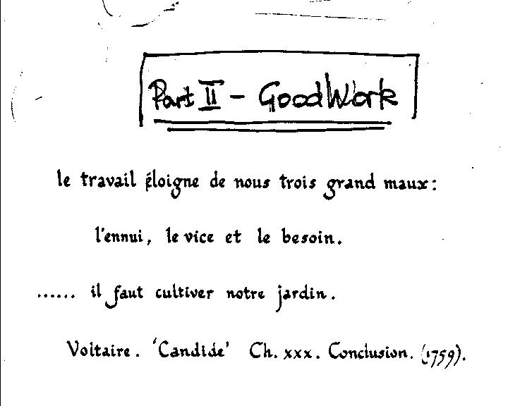

10. THE EMPLOYED RUMP

It will take a long time to eradicate the view that only those in paid employment do any real "work". Even now in 1986, it is possible for a feminist writer to declare that "Paid work brings financial independence, promotes emotional and intellectual development, and gives opportunity for self-expression and independence of spirit". This statement appeared in a review in the Guardian 13.5.86 of 'The Ultimate Seduction', a best-seller in the US by Charlotte Chandler. This ignores the reality that a job is often far from (fulfilling, that women frequently find themselves in subservient roles at work. Paid employment is foolishly seen as the only valid way of becoming a full member of society.

If people feel that strongly about having a job, then in the true libertarian, individualistic spirit that inspires Basic Income, we must certainly let them be free to seek employment. But the status which goes with having a job is a result of tunnel vision over what constitutes 'real work'. It is simply not true that only in paid employment can you do useful and fulfilling work. As was shown in Part I, much of what passes for work in the employed sector is wasteful, pointless, even socially damaging. Also, a great deal, probably the majority of what must be called 'work ' Ls done voluntarily without pay. Example of work of no 'value'?:

Having a baby, including the last part called ''labour', is undoubtedly work, hard work at that. Women undertake this work free of charge - indeed it has been made illegal to pay a woman for this service, surrogate motherhood as it is called. Despite this, agencies have found a way around this law. For a fee of £13,000 you can 'rent-a-womb'; the mother receives £6,000. This is one example, admittedly a most unusual one of a cash value being established for a service which is dismissed as of no economic worth. If just this one activity, child bearing was converted to cash values, it would add £10 billion to the Gross National Product of the UK.
Basic Income is no more than a recognition of the fact that most work done is voluntary, unpaid and carried out within families or the community. Basic Income confers status on those who work, but do not get paid for it. This will go a long way towards lessening the overblown esteem given to employment, and free people from the myth that only through a job can they hope to be full members of society. As the relative standing of being in a job declines, fewer people will feel that they must have a job at all costs, that any employment however demeaning is better than none'. But there will still be a need for some people to undertake paid employment. Despite the drastic reductions suggested in Part I, there will still be organisations and institutions who need to employ people to carry out their functions.

o Government will still have to provide many services - Military forces for defence, police forces for law and order on the streets. Schools especially in the primary sector will have to be maintained. Many Health services will still be operated, and in some cases expanded, such as preventative medicine. Financing these activities will still require tax collectors. And of course there will have to be administrators to ensure that the Basic Income scheme properly administered. But these and many other essential government-run services will be carried out with far fewer staff than at present. The exceptions to this might be the military and the police, where special arrangements may have to be made. This will be Described in more detail in Chapter 16.
o Industry using today's conventional methods will •it ill carry on. Factories, especially the mass-production plants will still need workers to maintain and run them. Life would be much the poorer if we did not have our supplies of cheap televisions, computers, cars and all the other gadgets which extend the range of what we can see and do. We would still need factories producing clothes and food. Fuel and power would still come from large coal mines and centralised power stations. But all these activities in the productive sector will employ less people as the benefits of new technology are exploited to the full. The total production of useful commodities can easily be increased while the numbers employed to produce them diminishes.
o Commerce will still be with us in many forms. Shops, including the big multiples like Sainsburys and Marks & Spencer will remain big employers. Their product lines may change, and their total volume of business go down, but they will still need to hire many workers. Other services like banks and building societies will continue to trade, if at a much simpler level. Trains and buses to provide public transport will need employees to keep them running.
The end is certainly not at hand for all paid employment. The total number in full-time employment will be very much less. This will be far fewer than number that would be in a job if "Full Employment" that politicians dream about were to return. Many arrangements that now exist are based on the belief that full employment is the norm, unemployment a passing phase. But there never again will be enough jobs, indeed there is no need for all these jobs. The introduction of Basic Income will be the clearest signal that this new reality has been accepted. Since Basic Income is paid regardless of work status, anything which discriminates between those in a paid job and those not in formal employment should be outlawed.

Here is a list of things which will have to be changed if Basic Income is to be introduced:

o National Insurance Charges (NIC) paid by both employer and employee must go. All adults will be deemed to be insured. This is a natural consequence of recognising that everyone works; some would be in paid employment, for others the compensation is Basic Income.
o Employment Protection legislation of all kinds can be scrapped. Basic Income reduces the importance of having a job, and creates an equality of citizenship of a much more meaningful kind. There has been little evidence that this legislation did very much to help the people it was intended to help anyway - women, racial minorities, disabled, unfairly dismissed employees.
o Minimum Wage legislation: Warm-hearted socialists like the idea that you legislate so that no-one can be paid less than a 'living wage'. But such legislation is easy to evade, and is counter-productive. It serves to jack up the wages at all levels, it destroys just the job opportunities that the disadvantaged could take. If you want to boost the disposable income of the very poor, minimum wage laws are a very ineffective and expensive way of doing. Basic Income is 100% effective in ensuring a subsistence minimum. It does so at the least possible cost, and leaves workers free to pursue jobs at whatever rate they wish.
o Pension contributions taken out of wages or paid by employers would be prohibited. All wages owing for work done would have to be paid at the time. Saving for old age would be a personal matter. The effects of this were discussed in Chapter 3. The reason for divorcing jobs from pensions stem yet again from the blurring effect of Basic Income on employment status. Under these circumstances the occupational or earnings related pension ceases to have much validity.
o Income tax to be abolished!?! This sounds like the stuff of dreams. Most of those who describe Basic Income assume that the funding for it will come from a flat rate income tax. A figure of 45% is sometimes given. The problem as I see it, is related to thinking in conventional ways. If the definition of in or out of work becomes hazy as a result of Basic Income, then income from employment becomes similarly vague to define. In the highly varied patterns of lifestyle in the Post-Industrial Society, what constitutes wages, and what is money from other transactions will be so varied that tax on incomes becomes difficult to identify let alone collect. There is also the problem of the shrinking numbers of employees - Basic Income will reduce the tax base.

It is for these reasons specific to Basic Income that I feel income tax ought to be abolished. There is also the privacy argument - why should the government know so much about an individuals private cash dealings? But why do most people see income tax as an acceptable way of raising tax revenue? It is I believe, because income tax and VAT are levied when money changes hands. To charge a tax where no flow of money is directly involved is disliked. Rates on property and car road fund licences are particularly detested. The fact that ownership of property confers benefit in kind, that wealth is far less evenly spread around is not acknowledged. All that matters in the public consciousness is that this is a tax for which there is no ready cash. There is a need to educate the public in this area.
If not income tax, what sources are to be used in order to finance Basic Income? I would identify three:

VAT at a much higher rate than at present. It has been calculated that a rate of 50% would pay for all Basic Income. There are attractions to an all- VAT funded Basic Income, but such a high rate would be too distorting.
Fuel tax, levied equally on all fuels, at a rate equivalent to the present petrol tax. This would be a substantial revenue raiser, and difficult to evade (which is why it is much favoured in Italy). It also has to advantage of vigorously encouraging energy conservation.
Wealth tax. We already have a rudimentary tax of this nature in the form of rates. There is a long history of agitation for this form of tax going back to Henry George and the 'single tax' campaign (c. 1900). A wealth tax encourages efficient use of resources. It is much more appropriate than income tax as the main source of revenue to fund Basic Income.

Taken together, abolition of National Insurance charges, Employment protection, minimum wages and pension contributions add up to a huge reduction in the costs of employment. It is reckoned that at present because of these overheads, an employer has to find £150 per week in order to give a worker a take home pay of £90 per week. If this employee is a married man with two dependent children, then £90 is not far short of what he would receive on Social Security and Supplementary Benefit. Thus we have a situation where the additional ( 'marginal') cost of hiring an extra worker is £150, while the marginal benefit to the worker is close to zero. This is an extreme, but far from unusual case. It illustrates the marginal cost barrier which exists at all levels against employing more people.

Basic Income tackles this problem from both ends directly and effectively. Since Basic Income is not withdrawn as earnings rise, each extra £1 earned is given its full value. Since the employer has few if any costs beyond the wage paid, each £1 paid out in wages is received in full. This argument about the need to reduce the marginal costs of employing labour has been elaborated by an academic economist Professor Martin Weitzman. In his book 'The Share Economy', he suggests that employees should be paid a low basic wage plus a percentage of the total profits of the company. This he argues would move the costs of employing an extra worker away from the average wage as at present, to a marginal wage. In this way eventually we would get full employment, Weitzman argues, because there would always be sufficient demand due to the low marginal cost of employing.

The Share Economy as a solution is unproven in practices (unless you accept the example of Japan given by Weitzman). It would certainly take a long time to have any significant impact on the jobless figures. It has no significance for public sector employment. Nevertheless, it represents a significant shift away from conventional thinking, and shows a willingness to try new ideas. Workers share ownership has been on the agenda for many decades, most notably promoted by the Liberal Party. There are good reasons for pursuing it -it promotes worker-boss harmony, and hence greater efficiency. But there is little evidence that profit-sharing or co-ownership schemes bear out Prof. Weitzman's central thesis - that the share economy is a way back to full employment without inflation.

It is possible to start from the same analysis -that marginal costs of employing extra labour are causing unemployment, and arrive at the conclusion that Basic Income is a more direct and certain method of overcoming the problem. Basic Income is also a solution which does not require a long period of adjustment. Once a full Basic Income scheme is in operation the concept of unemployment vanishes, if the economic argument is valid. You could say that Basic Income restores the golden age of full employment, because there will always be an excess of demand for labour (albeit at very low wages in some cases).

But what sort of effect can we expect on business people as a result of introducing Basic Income and dropping the other imposts like National Insurance and Employment protection? If wages paid to employees were to remain unchanged, then the 20-30% of overhead it costs to amply staff would be saved. In all probability the wage needed to coax out an extra worker would be considerably less. Remember that there will be a totally competitive situation with workers only hired when needed, laid off when not. All workers will be in receipt of Basic Income, so a wage will only be a 'topping-up ' figure.
In labour-intensive employment like the Health Service or teaching, the effect on costs will be very substantial. Such government-funded activity will be able to make major savings which can be offset against the costs of Basic Income. In commercial activity, the benefit will be felt in full. All forms of service - restaurants, shops, banks - should be able to employ many more people while keeping the same or higher profits. This should in turn lead to lower prices as competition works its way through.

In manufacturing, the effect is not so clear-cut. Labour-intensive activities like clothing will reap benefits, although wages have always been low in this sector. High technology plants will benefit from lower staff costs, but lose out if a high rate of capital taxation is imposed. The high rate of VAT should help exporters, as this is rebated when goods leave the country. On balance the effect on of Basic Income on industry would probably be broadly neutral, reducing the cost of labour, but increasing other costs notably capital taxes and rates.
But if Basic Income will increase the demand for labour, could it then return us to the golden age of full employment? This seems to contradict the job-loss picture I painted in the first Part of this book. If Basic Income and the changes it brings makes labour cheaper, then employers will be able to make more profit by taking on more workers. That is what Economics tells us will happen, so long as all other things remain the same.

Employers may clamour for this low cost labour, their profit-seeking zeal undiminished by Basic Income. But the same cannot be said for the workers. Basic Income does more than reduce wage costs. It also transforms the worker-employee relationship. Most of the work carried out by employees is dull, unfulfilling, and sometimes hazardous as well. Given the chance not many people would choose to be an accountant, a shop assistant or a miner. It may be enjoyable to get out of the house and meet people at the workplace, but work itself is rarely the attraction. Remove the goad of destitution and the stigma of being unemployed, and a great many people will not find the idea of a full-time job attractive at any price.

In the era of Basic Income employers may have to be more imaginative in getting other people to work for them. Very high wages might do the trick, but that route is not very profitable. Improving the conditions of work would help - more flexible hours or a less rigid year. A lot of part-time working seems the most likely outcome, but with greatly varying working hours. Basic Income has the potential to achieve a part-time job for everyone. In this sense "full employment" could then be a reality, but achieving it is no purpose of Basic Income.

Given a labour force less willing to seek paid jobs, employers will have two options - replace workers with machines, or to sub-contract to an outside firm. This could be a major growth area as a result of Basic Income, as many employees turn themselves into independent sub-contractors. Basic Income makes the relationship between employer and employee more equal. 'Sweated labour' arose when the workers are weak and exploitable. With Basic Income if a job is not to your liking, you can terminate it without fear of total ruin. You still have your Basic Income, whatever happens.

It is sometimes said half jokingly that a job is a form of wage-slavery. Real slavery was once the usual method of getting someone to do work for you. The free-born Greeks and Romans of ancient times saw slavery as a normal practice. Later in medieval time, serfdom was developed as an acceptable alternative to slavery. Seen in this light, the wage contract was an improvement, although it was normally a bargain struck between unequal partners. To balance up the deal workers formed themselves into Trade Unions, and achieved special legal immunity. Are we now ready for the next advance in labour relations? After slavery, serfdom and wage employment, could the next stage up be Basic Income/Contract Labour?
Government will still have some interest in what happens in the workplace. Although a free, unrestricted market in goods, services and employees will be allowed to flourish, some intervention is still required. Two main areas spring to mind:

o Safety: given half a chance, greedy employers would skimp on safety standards. The Victorians realised this and introduced legislation like the Plimsoll safety line on ships which saved many a sailors life. To avoid a return to 'coffin ship' conditions, it will be necessary to keep some safety legislation and inspectors. ,
o Product labelling: to enable the market to operate most effectively, purchasers need to be able to compare prices. Manufactures do their best to mis-inform the public, pretend that their product is unique. A requirement that each product should be clearly labelled can only be enforced by government.

After Basic Income is introduced, there will still be what would recognised as paid employment. Although most people would probably engage in paid work, it will not be the single dominant form of activity. Even though most people will obtain more cash resources from wages than from any other source eg Basic Income, working for money will not be the mainstay of most lifetimes. Basic Income helps us to escape from the idea that only in
employment can we be fulfilled, and opens the way to a more rational society, where human values are what matter, and working for money is maybe only a part-time activity.
11. LEARNING FOR LIFE, LIFETIME LEARNING

To learn is human. With our immense and unrivalled intellect, we are the only animals capable of understanding and controlling our own environment. (Whales and dolphins may have brain power equal to ours, but cannot match our achievements). Lacking the range of instinctive behaviour found in animals, we humans have a need to learn. Our complicated social structure, our highly developed feelings, make learning, remembering, understanding, interpreting all the more crucial. Even the dullest of humans has capabilities such as speech, and numerical ability far in excess of any dog or horse. But these things have to be learned.
Even now in the last days of the Great Industrial Age, a high proportion of everyone's lifetime is spent in learning. Most of this is crowded into the early years. There is the compulsory schooling between the ages of 5 and 16. Many stay in school or higher education for many years more. After this early education there is still some job-related training or re-training for some. Others may pursue adult education courses out of interest. Developments like the Open University show that there is a large untapped market for serious adult education.

But do not be deceived by all this 'educational activity. In comparison with other developed economies, the UK is said to be seriously deficient - youngsters leaving school have often an inadequate grasp of basics; there is a marked reluctance to engage in continuing skill updating. It is also vital'to remember TWO facts that are often overlooked or ignored when discussing education:
much of the formal education as provided is ineffective and can even be counterproductive.
- a great deal, if not the majority of learning is not part of the school or college curriculum. All the important lessons in life - walking, talking, relating to others - are learned elsewhere, often in the form of games. Learning is much more than the formal education system.
Learning could well replace employment as the principal activity for adults once Basic Income is in place. Basic Income supports the learner financially while he or she studies. In that respect it is a replacement for the present system of students grants. But unlike a grant handed out to a lucky few, Basic Income is not tied to any approved course of learning. The grant system only encourages a single mode of learning - the full time three year course. Basic Income allows for long or short courses of study, for high or low level work, at an institution or independently. Basic Income liberates the learner, giving real opportunity to all learners at all ages.

Initial schooling for 6-12 year olds
There is near universal agreement for what happens in school at this age, which is a strong argument for retaining this part of education virtually unchanged. The reasons for this wide consensus are, believe: it is well understood that the 'basics' - reading, writing and arithmetic, the 3 R's - are needed by everyone. This gives an agreed curriculum, and a recognised objective. Certificates and examinations play no part in this which may go a long way to explaining the success of this sector. As well as basic skills, primary schools provide an opportunity to learn how to get on with others. This is just as important as the 3 R's, both for the individual and for society. The whole community gains from having universally accepted norms of behaviour; the classroom and playground are an ideal place to learn how to behave.
Primary schools also have the virtue of being small scale, local and made as humane as possible. The only change that might be proposed for primary education in the post-Basic Income era is to reduce the number of hours per day, finishing around midday, avoiding the need for school dinners.

Young adults*

(* 'Young adults 'may sound a bit patronising, but it is a reflection of the inclusiveness of Basic Income. Everyone, even 'teenagers' or 'students' are to be acknowledged as full members of society as a result of Basic Income)

For many of today's young adults, in the age range 13-21, life is one long round of sitting in classrooms, studying and passing examinations. The shadow of the exam looms large for the youngsters. Their natural inclination, given their healthy young bodies, is towards activity and getting together in gangs. Instead, we concentrate them into colleges and schools, and hold them down to individual study. A small number take to this process without too much strain. Many survive it, but acquire a lasting dislike of all learning. For the bottom 40% who gain no exam passes and leave at 16, schooling has been a great waste of time.

Why do we do it, why do we expect youth to be a time of formal study and learning? Common-sense would suggest that this was the LEAST suitable time for quiet contemplation.
The clever answer is that there is a right time to learn, that young minds are especially flexible and receptive. In addition, it necessary to prepare children once and for all for a lifetime occupation. A more cynical view is that we keep so many kids busy in school and college because we cannot think of anything better for them to do.

But is there a 'right age to learn'? We can observe that all children learn to speak easily and effectively at a very early age. Memory is certainly more effective among teenagers than older age groups. It may be easier to learn when you are young, but evidence shows that learning is just as effective at older ages. What is more important is the desire to learn, and the maturity to understand. You can learn effectively at any age.

Education as mere job preparation would be inadequate even if there was old-fashioned full employment. In an age of mass unemployment it is a nasty joke. Present complaints from employers concern lack of basic skills, which are the responsibility of the primary school. In a world of changing technology, 'job-preparation' can have little lasting value. In any case the best preparation for a job is a job itself. If training is to have any relevance to the world of employment, it needs to be done on a continuing basis, not as a once only inocculation at an early age.

So that leaves us with the last excuse for all this educational activity among the young: that there is nothing better to do, and it is a pleasant way of passing the time. This was not an option in the days before the industrial age, or even in the early part of that age. All hands were needed to help on the farms and factories, and that included the children. Now that we do not need youngsters to do any useful work 'we give them futile activity instead.
Of course even futile activity can be of benefit. Social, moral and emotional issues are helped by interacting with sympathetic teachers, and also by socialising with people of your own age. Exposing even unwilling minds to gems of intellectual insight such as Shakespeare may eventually be appreciated. But compelling young adults to go to school is still indefensible. Basic Income will provide the financial support for all learners and give them the freedom to choose whatever course of learning they wish, at any age.

So what alternatives to school are there for young people? Here are some of the possibilities:
o Sport: a passion for many youngsters, and a more than full-time endevour.
o Paid employment: many jobs can be quite adequately undertaken by teenagers, and why not?
o Home help: caring for younger children, and helping with running the home is a normal activity among third world countries.
o Music, entertainment: pop groups seem to be getting younger all the time, and (I am assured) give pleasure to many. Acting, art and other forms of expression can be tried out as well.
o Entrepreneurship: the home computer boom has produced many junior tycoons. This example of enterprise could be followed in many other fields.
o self-discovery: outdoor adventures, treks to Katmandu, pilgrimages to Lourdes are all examples of voyages of self-discovery.
o Voluntary service: harness the youthful idealism in a thoroughgoing way, in the service of the sick, the old, the deprived and for the benefit of all.
o Learning: and of course there is absolutely no reason why in among all this activity it would not be possible to engage in study, if that seemed appropriate.
In a nutshell with Basic Income, adult life begins in a meaningful way at an early age, and continues until death. Teenage is just the beginning of a life of diversity, a diversity which is available for all. All our life we should remain learners. with running the home is a normal activity among third world countries.
o Music, entertainment: pop groups seem to be getting younger all the time, and (I am assured) give pleasure to many. Acting, art and other forms of expression can be tried out as well.
o Entrepreneurship: the home computer boom has produced many junior tycoons. This example of enterprise could be followed in many other fields.
o self-discovery: outdoor adventures, treks to Katmandu, pilgramages to Lourdes are all examples of voyages of self-discovery.
o Voluntary service: harness the youthful idealism in a thoroughgoing way, in the service of the sick, the old, the deprived and for the benefit of all.
o Learning: and of course there is absolutely no reason why in among all this activity it would not be possible to engage in study, if that seemed appropriate.

In a nutshell with Basic Income, adult life begins in a meaningful way at an early age, and continues until death. Teenage is just the beginning of a life of diversity, a diversity which is available for all. All our life we should remain learners. recognisable form at low cost through small locally operated outlets are a model of how it might operate.
o Unbundling: Today's consumer of education is given very little choice. If you want to gain a recognised qualification, you must undertake one of a limited range of 'packages ' or 'bundles ' - for example a three year degree course. You cannot judge what is in any of the bundles on offer, and have no guarantee if parts of it are poor, or will become poor shortly. The costs of pulling out are very high. There is little consumer sovereignty here. Most education is a matter of choosing between a selection of pigs-in-pokes. The solution is to unbundle the packages. Again the Open University leads the way with its system of unit credits. Instead of buying a huge package, you buy a small part or unit at a time. A collection of units passed are deemed to be a degree. There is no reason why the units have to come from the same supplier, or the degree awarding body, so long as there is a method for validating each unit. Of course in many cases studying a unit will be to satisfy some need on the part of the learner, and validation will be of no consequence.
o Verification: In order to make the system work, a widely accepted and agreed system of verification of the units would be needed. We have a model for this -the driving test. It nationally administered, and tests on standard criteria. Government or government-sponsored bodies seem to be the best organisers of such tests. But there are problems letting control of such tests fall into the hands of central government:
teacher autonomy: it is seen as progress when teachers have some part to play in devising schemes of work, as with the recently introduced GCSE syllabuses. Universities and Polytechnics allow their lecturers great freedom to invent their own courses. This freedom is intended to reflect the professional status of the teacher, and to allow them to have control over what is taught. The result is a mish-mash of badly designed courses all doing much the same thing. We could compare this with running restaurants: it is wonderful to aspire to the very best. But to achieve this requires first rate chefs, who are in short supply and are very expensive. The franchised steak houses on the other hand provide good food to a mass public using semi-skilled labour, and at a modest price. In education as in restaurants it may be necessary to curb the freedom of the suppliers in order to provide a consistent product of good quality.

The 'dead hand' effect: exam syllabuses once laid down become difficult to change. Faced with the need to change a whole course, or to produce a replacement for one part of it, leaving things alone was always an easy option. So why will the same fate not overtake education in the post Basic Income age? The main reason is that the learner will have control over what can be learned, and not by the school or college. There might still be a problem with the central body responsible for verification. It will be important that such a central body be required to provide validation in as wide a range of topics as there is demand.

So the learning environment can become much more encouraging as a result of Basic Income. Learners can choose from a much wider range of courses, subjects and institutions, selecting units of a reasonable size. They can get their achievements confirmed by widely
accepted tests. If required, a collection of test results could be sufficient for a degree or A-level or whatever. But learning would not be confined to the acceptable or the tested. There will be nothing to stop anyone learning about anything, and with Basic Income every encouragement to do so.

What is to be studied and learned?

There has to be some reason to undertake learning I am not suggesting that study is such fun that large numbers of people will do just for the heck of it. Learning is hard work for most, so there has to be a strong need before doing it. What we all need is skills in order to survive and prosper:
o Job skills: whether working for yourself or for a wage, there are many things to learn in order to perform effectively. As techniques evolve so new skills need to be acquired. As people move from one job to another so different skills will be required. Take some examples:
- Word processing on a microcomputer
- Repairing and maintaining vehicle electrics
- Account management
- Building and planning law requirements
- Elementary biochemistry.
There is a huge range of single topics, many of a very specialised nature, which involve a skill or require understanding. This can be of direct application to a job, or provide a better understanding of the environment. Thus an accountant in a printing firm can learn about photo-composition. A bin man can learn about local authority finances. Many skills can be acquired in the hope that one day they will be of use. That is not such a waste of time as it seems. All knowledge helps the individual to perform more effectively; and it is surprising how often something learned previously suddenly becomes useful. Learning a foreign language like French or German may have little immediate benefit, but may have longer term payoffs.
o Survival skills: Looking after oneself and one's home is a responsibility placed on most adults with little help or guidance. In many important aspects the responsibility has been taken over by 'experts ' or by some system such as the NHS:
In health we leave it to the experts of the medical profession to tell us when we are ill, what foods are safe to eat.

In financial matters, saving for old age has been largely taken out of the hands of the individual by pension fund managers. Such dependency on experts and institutions can be very damaging. Experts do not have all the answers. Institutions may start with the best intentions, but soon develop a dynamic of their own. Control over these helping institutions and the individuals who depend on them can easily fall into unsympathetic hands. Basic Income will help to make people less dependent on experts and institutions, and give them more responsibility to look after themselves. To meet these new responsibilities people will need to know more, to equpip themselves with knowledge and understanding in such areas as:
- diet and nutrition
- plumbing and electrics in the home
- laws on wills and inheritance
- child psychology

As life circumstances change so different topics become important. Even if you don't learn enough to do everything for yourself, it helps to have some understanding of many things. Experts and institutions can be used much more effectively by knowledgeable individuals. Reducing dependence through Basic Income will change the balance but not eliminate the need for the professionals altogether.
o Life enhancing: This could be the biggest market of all for learning. Reading Shakespeare, or studying nineteenth century French novels may be heavy going, but can be very rewarding.

There is a whole range of topics from mathematics to music where studying and learning can be a lifetime activity. I have suggested three groups of learning - job skills, survival skills and life enhancement - but these are not of course watertight compartments. Some topics could be of benefit in all three areas at different times. Something studied for pure enjoyment could turn out to be job-related. What is important is that learning is seen as a continuing process, that there is no such thing as a right age to learn anything, that learning does not stop at 16 or 21. Basic Income creates the climate where learning which is enabling is both possible and necessary.

Where will all this learning take place?

From the last section you may have gotten the feeling that all education is going to become like adult evening classes. There will be a lot like this, but the opportunity given by Basic Income will encourage and enable many more forms of learning. Correspondence courses, short intensive courses, self-instructional manuals are just some of the means that can be used. Modern technology creates a whole range of possibilities with audio and video tape, compact disk and of course the whole range of computer based techniques.

There could still be a role for a central Education Department in this. Besides running primary schools, they could also be responsible for examinations and testing. In special circumstances, such as a national shortage of expensive-to-train technicians, the Department could similarly intervene. What we must get away from is the idea of education as coercion, forcing young people to learn what we think is good for them. The hostile feelings which this has created has often put youngsters of learning for life. If you believe, as I do, that learning is a gateway to personal fulfillment and liberation, then you have to believe that people will want to learn. All that has been lacking is the opportunity which Basic Income will allow.
12. CARING AND SERVING
"To get the whole world out of bed,
and washed and warmed and dressed and fed,
to work and back to bed again,
Believe me, Saul, costs worlds of pain."

So said the poet John Masefield. He might also have pointed out that-
without this private unpaid effort, no work would ever get done,
and - even for those without paid work there is still what Masefield calls the 'pain' of caring for themselves. Social workers care for the less fortunate in our society; probation officers care for the criminally inclined. Staff in children’s and old folks' homes look after those 'in care'. Nurses and teachers have specialised caring roles. All of these caring activities are organised and paid for - usually through government or local authority financing.
Caring is not limited to the professionals. There is also a large voluntary sector. Many charitable organisations like the NSPCC and the churches are run by enthusiastic volunteers and provide useful services to the needy. Groups like Scouts and Rotary provide fun for their members and also help others and themselves. The total effort of the professional and voluntary caring organisations is trivial in comparison with the major source of care in society - private care within the family home. Apart from the very young and the disabled, personal care, the washing, dressing, feeding and generally looking out for oneself is carried out by individuals for themselves. As parents we spend huge amounts of time caring for our children. As spouses we minister to each others needs both physical and emotional. As grown-up children we care for our elderly parents - care in an old folks home applies to only a small minority of the elderly. For most illnesses the primary source of help and care is the home. All this caring is mostly taken for granted. Only when there is a failure to provide this basic care is there a need for an outside agency.

There have been piecemeal attempts to recognise the social worth of some of this caring activity. The old-age pension and child benefit are forms of Basic Income which have been in existence for a long time. In very special cases such as invalidity or where there is a need for constant attendance on a disabled person an allowance has been granted (In 1986 the government grudgingly extended it to married women). In addition there are many more categories for which it is claimed a 'carers allowance' should be paid - single parents, daughters caring for an elderly parent for example. There are many groups active in promoting the special worthiness of specific deserving cases; at times government cynically plays one group off against another.
Instead of piling up yet more special payments, for circumstances more or less deserving than the last, Basic Income makes just one payment to each and everyone. No longer do you have to prove how deserving you are. No longer has the paying out agency the right to pry into private and intimate details of your life. Basic Income is a recognition that everyone cares for somebody, or needs to be cared for by somebody. Basic Income encourages and strengthens the natural caring unit - the family at home. This is not by imposing duties on the family, it is by providing tangible, unconditional support. Nor is it a recipe for undue dominance within whatever family groupings might emerge. Each individual has a separate right to their own Basic Income. Alternatives to the biological family such as mutual support groups, communes, or even care which is purchased is all made possible through Basic Income.
Basic Income as an allowance for caring, paid at an identical rate to all with no extras for cases however deserving; this is not an easy idea to accept, even for some people who are favourably disposed towards the general idea of Basic Income. Today's universal benefits as the child allowance are frequently attacked with astonishing venom. It is necessary to look at some of the arguments why a 'targeted' system which restricts handouts to the 'really needy' is often advocated.

If all special needs allowances - for disabled, elderly, incontinent, blind etcetera, were to be withdrawn, and replaced with a single flat rate basic income, this could mean a severe drop in cash benefit for some of the most severely disadvantaged in our society. (It may be necessary to retain some ultimate 'safety net' in the basic income scheme, and most Basic Income proposals include such provision. In any case there will be far less need for special provision for exceptionally deserving cases.) Basic Income is a different kind of welfare benefit. Because it is paid to all without any test, it is far more helpful. It encourages the maximum of self-reliance, it enables the disabled to make a contribution without fear of losing benefit. Above all, the natural dislike of having to prove to an investigator how disabled you are will mean that few if any would wish for an extra payment over and above the Basic Income.
Basic Income will put tangible substance into the 'general duty to care' which lawyers invoke from time to time. You could say that Basic Income is the payment for caring not only for yourself and family, but for your neighbours, friends and all of your fellow citizens as well. So working with a self-help group for a particular form of disablement, caring for an elderly infirm relative, are made possible, and in a sense become a repayment for one's Basic Income, when the Basic Income of the carer and the cared for are added together it should provide an income not far short of the amount paid to today's myriad of special cases. But by being unconditional, this income is of a much higher quality.

There is a great danger when looking at help for disadvantaged groups to get distracted by special pleading. This takes two forms: one is to claim that your group of victims is more deserving, needs more targeted help than any other; the other trap is to demand that help be withdrawn from people or groups thought to be especially undeserving. No doubt spastic children are easier to sympathise with than drug addicts. A single parent in a tower block has a much higher call on understanding than members of a hippy convoy. But critics of universal benefit paid without test should realise that selectivity has a heavy price, a price that is paid be everyone, deserving and undeserving alike. If you wish to target on especially deprived victims, then you must make these victims undergo a humiliating test to prove their weaknesses. For the sake of letting a few blatantly undeserving people 'get away' with their Basic Income is not freedom from prying bureaucrats a small price to pay?
When a society operates on the basis of an adequate minimum basic income paid to everyone without It could also be made into a specific duty by introducing a form of national service.

Compulsory military service - the Draft in the US, euphemistically called National Service in the UK - has long been used to overcome the unwillingness of young men to join the Military. It is not a popular way of forming armies, but is usually recognised as being in the National Interest. In some states, notably Switzerland, military service is seen as sacred duty and a cohesive force in a society that is otherwise divide by language religion and mountains.
There are still many countries which make use of compulsory military service, and it could easily be re-introduced in the US or the UK. But the current high-technology, aggressive defence strategy depends on a small elite of highly trained professionals. There is simply no role in the high-tech battlefield for a large citizen army. But there are voices raised against this type of aggressive defence. The technology is rapidly developing which would allow for small scale dispersed, non-aggressive defence. Tanks and helicopters are now highly vulnerable to cheap yet sophisticated hand held weapons. As the Americans found in Vietnam, and the Russians are finding in Afghanistan, superior technology is no match for a large army of well armed and motivated guerrillas.

This alternative defence - defensive defence as it is called - has features which mean it is much more appropriate to the Basic Income era. It is cheap, it requires no elaborate training. What it does need is large numbers of people spread out over wide tracts of the countryside. The present high-tech aggressive defence policy with its reliance on nuclear weapons delivered by submarine or rocket has but one inevitable outcome:- Sooner or later nuclear war must break out with all the terrible consequences so luridly portrayed in several TV documentaries. An alternative to this madness is vital, new thinking is needed as never before. Defensive defence could be the answer; national military service based on Basic Income could be the means of achieving it.

There are other forms of service which can be envisaged as a way of 'earning' your right to a lifetime of Basic Income. One problem which might arise after Basic Income is that no-one would want to take on the so-called 'dirty jobs'. In the past these have fallen to outcasts, immigrants, the blacks. In industry, working in foundries, where dirt, noise and fumes predominate, the jobs are left largely to West Indians and Pakistanis. In the Health Service cleaning and portering jobs are similarly staffed. Will anyone want to work at jobs which combine low pay and low status, yet are so vital for society? Will Basic Income destroy the goad of destitution which gets people to accept such jobs? Economists will have us believe that there is always a price which will coax out supply. This may be satisfactory for purely commercial undertakings like foundries. But many of these unlovely jobs are in the public service sector, and the jobs are vital for society. Perhaps it would be better if these were to be done on a 'National Service ' basis - each and every citizen to devote a year in their late teens to services agreed to be unpleasant but socially useful.

Examples of such services might include:
- Street cleaning
- sewage farm worker
- hospital porter
- cleaner in home for elderly or disabled
- refuse disposal operative (bin man)
The idea of serving the community need not be restricted to ensuring that necessary but unpleasant work was carried out. Just as military service is held to be in the national interest, so could conserving the national heritage. There are many museums, art galleries, castles and other old buildings that need caretaking, repairing and general overlooking. The countryside too, is part of the nation's heritage. A large corps of Rangers would be highly beneficial in keeping such public open spaces neat, clean and accessible.

There would be a further spin-off from all this community activity. The presence of large numbers of cleaners on the streets and rangers in the countryside will make them safer places to visit and pass through. There is a mistaken belief that only policemen can provide streets safe to walk in or homes free from burglary. A simple calculation would show that even ten times the present number of bobbies would have little chance of catching these opportunistic criminals. But the permanent presence of many more community workers in public places would make a difference.
There are those who would say that letting gangs of youngsters loose on the streets even in a good cause would merely be giving them a better opportunity to commit crime, not prevent it. It certainly is true that the majority of crimes are committed by young men in the 16 to 21 age range. Much of today's 'training' schemes such as the YTS seem more concerned with getting these youngsters OFF the streets, and worn out with tedious labour, so that they lack the strength to commit crime. But young people are idealistic; I believe that if you were to ask them to do something useful, something that society obviously valued, then attitudes would change.

Of course all crime will not vanish overnight, even if some of the main causes of crime are modified. Another form of community service could include assisting the police, carrying out patrols, acting as night-watchmen. All the forms of community service suggested will be of immediate benefit to the community. They will be of benefit to the individuals too, allowing them to give to the community, to learn about the unpleasant but vital activities that are essential for life. It is not too far-fetched to believe that this will lead to a better feeling of comradeship among society as a whole. Having all experienced a spell as community workers, all will share a common bond. Linking Basic Income paid for life in return for such community service adds to the 'virtuous circle' of reinforcement. There are many ways in which this community service could be implemented; I have just indicated a few possibilities. But it well illustrates the possibilities for beneficial change that can flow from a Basic Income scheme, its potential for allowing and encouraging Useful Work.

13 ART: LET A THOUSAND MILLION FLOWERS BLOOM

During the bitter Coal Miners strike of 1985 there were many TV reports from mining villages. No-one could doubt the sincerity of the wish for the people of these villages to remain as viable communities. The only way they could envisage their own survival was by keeping the colliery open, and with it their jobs down the pits. Yet this cost the taxpayer is around £4,000 a year for each miner. How much better it would be if the money could be paid for some beneficial activity. The sad fact of life for the miners is that much of their output is no longer needed. Instead of paying them to go down dark holes in the ground, could we not pay them to carry out some more inspiring activity? There is a long tradition of brass band playing in the mining communities; so why can't they be paid to produce music rather than coal? Instead of covering the countryside with slagheaps, why not fill the air with melody?
Such simple, obvious and beneficial changes are but a pipe-dream, so long as conventional economics and full employment remain the norm. Music, painting, theatre are all seen as separate from the 'real' world of work. Even so, a small number of entertainers can 'make a living' by performing. Some art-forms like opera and ballet are considered so worthy that most of their cost is borne by the taxpayer through Arts Council grants.

The number of people in full-time employment in the arts and entertainment generally is quite small. There is a much larger number of hopefuls who would like to get into acting or music performing. There is also a flourishing amateur scene in all forms from country-and-western to oratorios. Many people would gladly spend much of their time pursuing artistic or performing roles and find it a rewarding experience. Convention has it that such activities are 'uneconomic', and not real jobs.

Basic Income is a way out of this stupidity. If there is no need for men to go down the pits, if they would be happier playing the cornet in a brass band, then why not subsidise music rather than coal? Basic Income is a mechanism for allowing a much greater range of artistic endevour to flourish. Writers need no longer starve in garret - they can live frugally whilst trying their hand at that great novel. Painters can paint without dying of consumption. Musicians can devote all their waking hours to practicing, without worrying about earning a living. Basic Income nourishes talent at its most vulnerable time - before it is recognised.
A consequence of this encouragement of the arts is that the need for an arts council dispensing money is less pressing. It has always been an odd notion that a group of worthies could decide what has artistic merit and deserved support. The potential (and reality) of undue influence, even censorship arising out of such a system is ever present. Patronage in the form of handing out taxpayers money has always been a dubious exercise. With Basic Income the artistic aspirations of all those with talent (and without) can be exercised to the fullest extent wished for by the artist.

Performance in front of fee paying audiences will undoubtedly continue after Basic Income. Some may be highly successful and command huge fees. Many will perform for no fee, with the admission charge only covering the expenses of the performance.

All this talk of money in return for performance leads on to a much wider issue - commercial art and un-artistic performance. You could object that it might be alright to subsidise Good Art; but why pay Basic Income to the thriller writer or the pop musician?

Yet again the problems of selectivity are greater than universality. If we have to weed out the 'commercial ' artists from Basic Income then we would have to have a method of selecting the 'Good' artists. This would get us straight back to the present system of establishment favouritism, with thought control by the bureaucrats. It is far better to allow universal Basic Income, which gives encouragement to all. The cost in money and to the morale of trying to stop ,1 few 'undeserving' cases is just too high.

An alternative argument against encouraging art via Basic Income, is that the market is perfectly capable of picking out the winners and losers. If your artist is any good, they might say, let him test himself in the marketplace. Will anyone pay for his records or books? Royalties are a time-honoured method of ensuring that the artist shall reap the reward of his endevours. Copyright is the mechanism which has long been used to encourage and protect intellectual property.
The pure market case is obviously deficient, otherwise governments everywhere would not feel obliged to subsidise the arts. The market may deliver what people like, but it certainly does not promote great art. Successful writers like Mickey Spillane and Jeffrey Archer make no pretence of producing gems of literature - just a good read. Frank Sinatra and the Beatles made millions, but no-one takes that as a sign the their music represents landmarks of civilisation. It is worth looking more closely at the present mechanism for rewarding artists; Basic Income may have as a consequence not just the encouragement of new talent, but may also allow the rewards to be more evenly spread. In short, is it time to abandon Copyright as another relic of a fading era?

Should we fear the abolition of copyright as a consequence of Basic Income? The usual case for copyright is that it protects and rewards creative artists, thereby stimulating production. In practice copyright is merely a mechanism for profit and control by big business. A handful of writers and performers do very well out of the system, but it is the companies who market and control their output who make the big money. Abolition of copyright would deprive them of their excessive profits. Do not weep for the Sinatras or Archers of this world however - they will still be able to make substantial sums from their endevours.

At a more modest level, writers and artists who sell in modest numbers need not fear destitution - Basic Income will still provide their bedrock support. Given the modest numbers of books, records or pictures they sell there will be little fear of piracy. Artists who are genuinely committed to their craft would be more concerned with achieving the widest possible audience.

Abolition of copyright would bring about some changes which some might not welcome. Dubious gems of modern culture such as 'Ghostbusters', 'Rocky I-IV' are very costly to produce, and can only be made in expectation of a huge return. Without copyright protection, this return would be impossible. Future generations would thus be deprived of (spared?) these over-hyped Hollywood spectaculars. In the short run too, there is the distinct possibility that TV and radio could be swamped with poor quality productions especially from America. In the longer run, as people tire of endless commercial pap, it is likely that something much better could emerge. In the search for authentic experience, there are two obvious alternatives - to make your own entertainment, be it music ,' painting or whatever, or to attend live performances. For both of these things Basic Income creates the opportunity and the climate of opinion which encourages doing rather than watching. Copyright is not only about profit and control; it is part of the debilitating dependency-creating mechanism so characteristic of the consumer society.

Snippet: the mariachi bands in Mexico:
These used to be a common sight throughout Mexico, sometimes an annoyance to the tourists, but generally a splash of colour and bright sound. Open-air restaurants welcomed them as cheap entertainment for their customers. Then along came the cheaper cassette recorder; the restaurant owners found it easier to sooth their customers with muzak.
With copyright gone and Basic Income in place could we see a re-emergence of this kind of live music? A string quartet in the hotel foyer? A swing band at the football stadium?

14 DOING IT FOR YOURSELF AT HOME

In terms of output of useful product, the 'home was once totally dominant. Production of most goods and services was domestic, in the house or in a workshop attached to it. The Industrial revolution swept away most of this cottage industry into centralised and more efficient factories. Yet as Scott Burns points out in 'The Household Economy', not all production disappeared into factories. What changed most was the method of measuring useful production. So-called 'real' jobs only count if they are in the formal employment economy. Because the product of the home is mainly between its members, and because no money changes hands, it counts for nothing in economic terms.

But the output of the home is not only real; it is also useful, produced by the users in response to a real need. Scott Burns reckons that if we could measure this output in conventional economic terms, then its value could exceed that of the corporate sector. Also, he suggests, while big business is shrinking, the product of the home, the 'household economy' is expanding. Of course Basic Income would be a wonderful shot in the arm for this household economy. Basic Income would also be a long overdue recognition of the value to society of the efforts of so many housewives, children and other so-called 'dependents'.

To take a few examples of the sort of activity that could be encouraged by Basic Income: In all these cases there is nothing new, just a change of emphasis away from the money economy towards the home economy:

FOOD:

Somewhere to live and something to eat are the basics of subsistence. For most household budgets, food and shelter are the largest single items. The effect on Housing as a result of Basic Income will be dealt with in the next chapter.

The changes in spending on food and meals consumed outside the home suggest that we are better fed and enjoying life more. That may be true in money terms, but in every other way we are worse off. It is not true that we are eating more, in fact the total intake of nutrition has declined in the last few decades. What has happened is that food is more processed. The 'added-value' arises from the packaging, the additives and the factory processing. This explains why (see Fig 14.1) although we are eating less, it is costing more.

Fig 14.2: Changes in food consumption and spending

But perhaps the explanation for this 'more-means-less' situation lies in the quality of the food? Where once greasy chips were the staple diet, now meat is a daily item for most people. Again, the appearance of improvement masks a worsening. Highly processed food is now seriously damaging our health and despite appearances factory-made food does not even provide much variety. 'Convenience' for the manufacturer means improved shelf life. Three ingredients are extensively used: sugar, salt and fat. Colouring and additives may create the illusion of varieties of flavour, but our high tech eating habits have given us less true variety than many third-world peasants.

The switch to meals bought outside the home is another facet of so-called added value. The Conservative government has high hopes that the fast food shops will provide many new jobs, to replace those lost in productive industry. If more people stayed at home and prepared their own hamburger meals, unemployment would rise, and the Gross National Product would fall. Basic Income will help this trend in several ways: It will reduce the number of people going out to work every day; it will give people more time to prepare their own food, and it will provide a cash incentive to do so.

There are other, stronger motives for home cooking. Using fresh unprocessed ingredients, with less fat, sugar and salt will be good for our health. There is also the pleasure which many people derive from cooking. It is an area in which many people could learn more, and find satisfying and creative.

If cooking your own food is going to be encouraged by Basic Income, then growing it will be the next logical step. Again the money based economics is out of step with the real needs of people. Growing vegetables on an allotment may not save much money, and it will take a lot of time. But there are benefits which the economists cannot include: there is the spiritual refreshment of getting close to the soil, there is their health benefit of manual labour, and there is the taste benefit of your own varieties, freshly picked.

Mending and tuning:

In every home there are many gadgets in use. In the kitchen there is a cooker, washing machine and fridge. In the lounge there is a TV, stereo and video. In the garage there is the biggest and most expensive gadget of the lot - the car. Outside in the garden there are many implements for growing and cutting. All of these items of the household economy need to be cared for, to make sure they work effectively. They also need mending, a task made much more difficult by the throw-away philosophy of today's wasteful society. It is somehow 'economic' to scrap rather than repair.

With Basic Income this argument weakens: The cost of hiring a mechanic compared to spending your own time changes in favour of do-it-yourself. The benefits of repairing, extending the life of your gadgets is not just the saving in cash and materials. By learning how your gadget works, you learn how to use it better. There is also the satisfaction of being in control of your own situation, not dependent on a call-out service.

It would not be difficult for engineers to design and manufacturers to build products which were easier to service and repair. It would add slightly to the cost, and reduce the performance a little. But it would result in equipment which could be kept going, which would be cheaper in the long run. Consumers could be helped significantly if manufacturers were obliged to state the design life of their products (how long they expect them to last). To allow the home repairer to operate requires a full set of instructions; this too should be included.

The benefits from mending the gadgets about the home do not stop with the saving of cash involved. Host repair jobs involve solving a problem. To do this requires 'tinkering'; as Mike Cooley explains, this is what we humans are especially good at. Automated factories manned by a very small number of people can produce a steady flow of manufactured goods, but mending and servicing can never be automated. Technological necessity and human need for useful work can be satisfied together.

Another benefit of tinkering is the transfer of skills it involves. The ability to work with different materials - wood, glass, plastic, copper, metal- and with different processes - water, electricity, gas -have to be learned in order to carry out repair jobs. These skills can be applied in many other ways besides mending. Even if you do not wish to practice these skills, at least you will know something about them. The next time the plumber calls you will be better able to describe what you want, and to ensure that you get it!

Making and fixing-up:

As well as making sure that existing gadgets are kept in good working order, there is a wide range of household goods which can be made at home or in small locally based workshops. Clothes of various kinds - not only knitteds!- are made by housewives. Their husbands, if handy, can make a wide range of furniture. This only indicates today's conventional roles - in the future, the freedom of choice given by Basic Income could do away with such sexual stereotyping. Being at home supported by Basic Income makes time available for self-production. It also becomes financially more attractive.

In production units slightly larger than the typical home, even more ambitious production is possible: Pottery is already practiced widely. Utensils such as pots and pans could also be made simply and cheaply on a local basis. It is technically possible already; all that has been missing is the financial incentive.

The benefits of local or home based production are many - local control, maintaining wealth within the community, the satisfaction which comes from making it for yourself. The disadvantages might seem greater, especially since we have all been conditioned to expect a steady flow of cheap factory made goods. Home-made, handcrafted items may be quaint, but they can also be crude, inexpensive and ineffective. The independence of local production may be illusory - many components such as screws, lengths of material, wool - would still have to be bought in. So despite a sentimental preference for small scale local production, is it likely to be either a delusion (dependent on mass produced raw materials) or a flop (because hand-crafting is slow and expensive)?

In the recent past such small scale, local production would have been neither technically effective or economic. But there are major changes taking place which mean that large, centralised factory production will no longer be the best way of making many items.
Take kitchen furniture: In the old days we hired a highly skilled cabinet maker to produce an individual design, which fitted our requirements exactly. Today, that would be a very expensive procedure. It is much cheaper to buy a standard self-assembly kit from the large retailer. But it is possible to take this a stage further - to combine the cheapness of mass-production with the individuality of the craftsman. Information technology is the new factor. In the future the home handyman can review a selection of designs using a tele-text service. Having chosen the design, he can feed the overall dimensions of the cupboard into a computer. This will produce a cutting and parts list. The local timber-yard will cut the material to size; the small parcel of components can be sent by post. The amount of skill involved in the final assembly would be little more than that required for today's kits.
With the right blend of information technology, factory production where appropriate and local assembly a great variety of household items can be produced quickly, cheaply and locally.

New Technology:

The last section gave one example of how the new electronic technologies could change the balance between the large centralised operations and the small scale, local ones. There are many who see new technology, especially the computer, as the great hope for the future. John Graves in 'Liberating Technology' (1986) paints such a picture. The electronic cottage would be the centre of this production revolution, with the microcomputer giving independent power to the toiling millions.

The present reality is different. Working at home with the aid of a computer terminal has not taken off in any significant way. The numbers involved are tiny. The experience has not been favourable. The loneliness of the electronic cottage is hard to bear. The real action is still back at the office in the city.

The technology used does not help the independent home-worker either. The design philosophy of terminal networks is dominated by the need for central control. This is not surprising, given that they were designed by and for large US corporations. They were interested in central control, not user liberation. It doesn't have to be like this; there are some moves afoot to provide information technology which is for the benefit of, and under the control of the user.

Whatever the production possibilities from new technology, these can never be realised without social and economic changes as well. Just using technology to reinforce the dominant centralised institutions may work for a while. But if the full benefit of the new technology is to reach the people, then new forms of organisation are needed. Yet again Basic Income can be the essential ingredient in allowing these changes to take place.

Salvage and rubbish:

In the end, no matter how well made they are, our gadgets will fail and have to be dumped. Even here there is a potential for the local, small scale activity that will characterise life after Basic Income. Basic Income will shift the balance of values between labour and material, making materials relatively more valuable.

Already paper, glass and metal are salvaged. After Basic Income I would expect most households to save these and other materials more methodically. A regular market for scrap materials would also encourage the process. More detailed dismantling of old fridges, washing machines, TVs etc. would become worthwhile. You may feel that picking over old rubbish is not exactly 'Good Work'. As a permanent job in today's conventional sense it would be dreadful - but in the Basic Income era salvage would only be one among many pert-time activities. There are also strong ecological reasons why as much material as possible should be salvaged. This could add to the satisfaction salvage.

Bricolage

Denis Pym writes in his book (The Employment Question) about the household and local economy. His hero is the 'bricoleur' - a French word for the local handyman. Because the bricoleur caters directly for peoples ' needs, his output is far more valuable, more 'real' than the so-called real economy. In the capitalist system described by Adam Smith the 'entepreneur' was seen as the lynchpin; if fancy French names are in vogue, perhaps in future those who work and produce in the home can feel proud to be Bricoleurs?

15 BUILDING HOMES AND CATHEDRALS

After food comes shelter. Building a home has always been an important activity. For more than a century, even the humblest of houses has been built by professional constructors. But it was not always so, nor even today is house building left entirely to the professionals.
Few thatched cottages with daub and wattle walls remain today. In olden times they were the usual form of housing for the many. Once the peasant married, he acquired a plot of land. Next a large pile of wood, straw and mud was assembled. With the aid of friends and relatives this was turned into a traditional cottage. The result was a very cosy home built with local material in keeping with its surroundings. It may not have been as spacious or clean as a modern council house, but it was cheap and easy to build, re-build or extend. And when its useful life was over the thatched cottage just melted away - biodegradable housing!

The desire to building your own home has not completely vanished. A small number of intrepid people do-it-themselves - all the plumbing, bricklaying, electrics, roofing, glazing, painting and of course lots of labouring. Others work in co-operative groups, where skilled tradesmen are especially welcome. Another method is to supervise the job yourself, hiring the skilled labour, doing your own manual work. But it must be said that these self builders produce a small number of the all houses built.

Refurbishing - taking over derelict properties and doing them up - is a form of self building which is much more widely practised. Often it is the only way for young couples to get a roof over their heads at anything like reasonable cost. Improving and upgrading property is not just for the newly-weds; many people are actively engaged in improving and extending their home. It has been repeatedly found that the unemployed are enthusiastic home decorators. But the really constructive improvement of the home requires the income which comes with a job.
Basic Income would be a great boost for all types of self building. When the natural desire to create one's own home is coupled with the availability of time and a little money, then this result is a certainty. Exactly how self building of homes develops is not certain, but it could follow one of two paths:

DESKILLING : Look at any building site and you see little evidence of skills in use. Pre-formed roof trusses, factory made doors and windows are assembled into the house under construction. Even the concrete is delivered ready-mixed onto the site. Where some skill is still required, life is made simpler – plumbing fixings that screw together easily, plaster that needs little careful mixing. Such simple ready-to-use materials and sub-assemblies should create little problem for the future do-it-yourself builder supported by Basic Income. There are disadvantages of this method which must not be overlooked - it is expensive, suitable mainly for new building only, and the mass-produced components do not offer much variety in style.

NEW SKILL/ OLD SKILL: An alternative path might be to relearn some old, forgotten skills. Windows and doors hand-made by a local carpenter with the aid of an on-line design service could be just as good as the factory made items. It would also cater for a much greater variety of styles and situations. Salvaging bricks, timber and plumbing fittings would provide a further supply of re-usable material. In the Basic Income age when people are, I trust, more attuned to the rhythms of nature then the slow but rugged art of stone masonry could be re-developed.

Whichever path is followed, Basic Income is certain to be a great encouragement. The result should be not only better homes for more people, but should bring other benefits too. The psychological satisfaction which comes from constructing your own home nestbuilding - should not be undervalued. The houses that will be built in the Basic Income era will be ecologically made benign, requiring less raw materials to build, using less fuel to run and looking much more at ease with their surroundings. Many dream of their ideal home - a thatched cottage in the countryside. This is just the sort of house that could emerge again as the popular form of housing.

Planning and building regulations as they exist at present would stop this form of spontaneous development There is a school of thought which says these laws should be repealed either because they are ineffective or that they serve only to deprive the very poor of adequate accommodation. In an over-crowded island like Britain it could be argued that some control over development is needed if only to prevent violent squabbles among neighbours. On balance I would choose the libertarian case and propose scrapping of all planning laws. It would be prudent to monitor the situation as Basic Income transforms the homebuilding scene.

CATHEDRALS:
In medieval times, cathedrals were the form of expression of whole societies, gigantic monuments celebrating themselves. They have been compared to the effort in the 1960 's to put a man on the moon. Like the pyramids before them, these cathedrals were built with huge armies of labour. Some of this labour was skilled, but most of the work done was unskilled. It was often undertaken as a religious duty.

There are still monuments being built which proclaim wealth and power. Just look at the new Lloyds building in London, gigantic and vastly expensive. This is surely a temple to the religion of our age, Money. Sport too, is a quasi-religious activity, but does not command quite the same resources, except in totalitarian states like the USSR. A favourite feature of such buildings is there technical wizardry, to make them higher, more elaborate, made from more exotic materials. They are celebrations of the dominant financial-industrial power which controls our lives today. The scale of these monuments to Mammon is not just inhuman, it is anti-human. People are a disfigurement on the outside.

It is impossible to predict what will be the dominant religion in the Basic Income age. It will certainly not be money; it is likely to have strong ecological overtones. If monuments are required they may take the form of restoring industrial wastelands to a natural state. Smaller-scale local monumental buildings will be desirable too; places such as meeting halls spring to mind. There is no reason why these should not be an opportunity for the people in the post-Basic Income age to turn their communal feelings into concrete and ornamental expression.
Again, Basic Income provides the essential ingredients - a large number of people who are freed from having to earn a basic subsistence and so can be free to engage in construction for the public good.
16 FREEDOM AND EQUALITY

Progress in equality these days is measured by the number of women, blacks and other members of disadvantaged groups who achieve top jobs. It is of great concern to discover how many black head-teachers are in post. In Northern Ireland it is necessary to have a quota of judges from each religious persuasion to ensure fairness. The '300 Movement' seeks to increase the number of women M.P.s to half the total.

But this is an old confidence trick, equating liberation with colonising the power structure. Power is concentrated into few hands; control is exercised through the dominant institutions of society such as:-
o universities, schools, colleges
o medical legal and other professions
o industrial, financial and commercial corporations
o the executive branch of the state operated by ministers and civil servants
o local authorities and statutory bodies like the NHS.
If a woman sits on the board of a company, or a black becomes a head teacher this is undoubtedly a personal success for the individual involved. But does it really alter the lot of the others, the ones who do not get the plum jobs? We have the telling example of a woman Prime Minister who does little to help her sisters. On purely women’s issues her government is distinctly unhelpful; the attempt to abolish the universal Child Benefit shows how little Margaret Thatcher cares for the plight of the ordinary mother.

The Milk Marketing Board has the job of efficiently distributing milk. It seeks to sell as much as possible at the highest price. For years it used its monopoly position to keep the price of a 'pinta ' well above European levels. Despite strong evidence, it refuses to accept that dairy products taken in excess can be a health hazard - to admit that it should worry about the health of the consumer would lead to 'inefficiency'.

Nirex is the Nuclear Waste Disposal Executive. If it had any criterion other than commercial efficiency it would declare itself bankrupt and foreclose on itself at once. No-one wants its toxic products which will be a health hazard for centuries. Only the relentless logic of institutional control of energy could produce such an anti-social monster.

Freedom and equality will not come from deprived groups gaining representation among the small number of people who run these dominant institutions. What is needed is to distribute their power as widely as possible. True, the majority of those in positions of power and authority at present are white, middle-aged and male. But changing the faces of those in charge does not change the fact that most people are in a state of dependency, have their lives controlled by these institutions. This is just as true for the majority of white males as anyone else. Institutionalised power can only be exercised by a minority.

But how can power be taken from the few and given to the many? Institutions exercise their influence, not by brute force, but through the power of the purse. If you cut off their supply of money then institutions will die. Money is the vital oxygen which keeps institutions alive. The easiest source of cash for most of these institutions is of course the Government. Universities, for example, get most of their funding from the state. Industrialists find it much easier doing business with the military, where the government ie the taxpayer foots the bill for all the latest in death-dealing systems.

State-supported monopoly is another means whereby institutions keep up their supplies of cash. British Telecom is profitable because most competition is excluded. Institutionalised medicine operates in two main methods - it controls, with state backing who can practice medicine; and it ensures that the state pays most of the bills for medical care. There is no doubt that doctors as a body wish to deliver the highest standards of health care, but they also make sure that it is institutionalised care available only under their control. Institutions all need some steady flow of cash in order to keep going. Cut the cash and their power is gone.
Basic Income represents a major shift of money away from the institutions and to individuals. By cutting down funding of institutions directly by the state, and by eliminating most of the state-sponsored monopolies, the power of these institutions to control the lives of people will be greatly reduced.

With the loss of power of the institutions goes a transfer of responsibility as well. Dependency on institutions brings some benefits, chiefly freedom from being responsible for oneself. The education system for example permits a very small range of choices, with entry at the discretion of those in charge. If you do as you are told, and clear all the hurdles, then the state will pay for your course, and the college or school where it is taught. Fall at a hurdle, and the system rejects you.

In the future, each citizen will receive through Basic Income the money that would have gone to education establishments. This places him or her in a different relationship with the education system. Instead of asking "What exams do I need, and who will allow me onto such a course?", with Basic Income you ask "What do I want to learn, and where can I buy that knowledge?" This is just one small example of the shift of responsibility and control brought about by Basic Income.

There are other possibilities for ensuring that the jobs in the dominant institutions are shared equally among all sectors of society. Affirmative action is the current favourite method - positively discriminating in favour of disadvantaged minorities. This may still be worth pursuing even in the post-Basic Income era. But the main liberation will come about when each citizen has the power of the purse handed over in the form of Basic Income.
It will not be so cosy in this Basic Income supported post-institutional world. 'They' will not take responsibility for you; you will have to look out for yourself. This will be made a lot easier with the security of a basic minimum income to support you. This is the satisfying work that the disadvantaged should seek - being responsible, taking decisions. It can be done by first reducing the power of the institutions, and then giving it to individuals. The mechanism for spreading this good work through the population is of course basic income.

17 MEANING TO LIFE: MEETING RELIGIOUS EXPERIENCE

It is common to hear people say that we live in an unreligious age. True, the numbers in church on Sunday are tiny, compared to the crowds t the Saturday football. Vicars are not even considered worth lampooning any more. Not many British people are actively religious, but there remains a residual feeling of good-will towards Christianity. A proposal to abolish a daily act of worship in schools met with considerable protest. We still like to marry and have our funerals with the benefit of the clergy.

On a wider world scene, religion is far more significant compared to Britain's secular society. In America, born-again fundamentalists can deliver enough votes to change government policy. In Moslem countries the rise of Islamic fundamentalism has rocked and toppled regimes. Iran seems to be run by ayatollahs; Egypt scarcely contain its zealots. Religion is taken very seriously indeed in most societies. Priests, imams and gurus are treated as honoured and respected members of society, a brahmin caste fulfilling the highest function in society. Only Britain and parts of western Europe have been converted to the belief that religion is a marginal activity, that being a minister of religion is little more than a glorified hobby.

Basic Income will affect the practice of religion in many ways. It will make it possible to pursue the life of a monk or hermit without worrying about money. It will support existing ministers of religion. At present the Church of England needs to engage in financial activity, sometimes of an unsavoury nature, like landlordism. With Basic Income to support its parish clergy, it could follow the injunction of its founder and “go sell all you have and give to the poor".

Basic Income in itself will not promote a major religious revival, but it not inconceivable that such a revival is on the way. Historically these things come in waves, and a new wave of religion is long overdue. Should that happen then there is no limit to the numbers who could engage full-time in prayer, organising services, going on pilgrimages and so on. In case you feel this is a far-fetched idea, remember the case of Tibet. Until very recently this remote and inaccessible country was ruled by a theocracy Bhuddist monks were in charge. One third of the adult male population were happy to be monks, living a celibate life in monasteries. The stories of the Inn of the Sixth Happiness were based on this land, and as anthropologists found, were not far from the truth. Life in old Tibet gave much contentment, even if it lacked the excitement Westerners seek.

It would be unwise to dismiss the idea that such a surge in religious vocations could ever occur here. The basic desire for some sort of spiritual experience is widespread, although it has been squeezed by the requirements of employment and the belief in rationality. What Basic Income could foster is a much wider participation, and a variety of spiritual activities, some old, some new.

The network of conventional religion is still mostly intact and could easily be expanded. Caring for church buildings, organising services are time-consuming activities. Services do not have to be restricted to Sundays, congregations can come together at many times. The pay-off for those with a strong religious belief is a great feeling of fulfillment, not to mention a greater prospect of rewards in the life hereafter. For those newcomers who join in, but maybe do not have a strong belief there is undoubtedly a spiritual uplift. Coming together with a group of neighbours, or with people with whom you have some kind of common bond confers psychological benefits too.

But for many in this scientific age such religious activity is a quaint, meaningless survival, alright as a form of folklore, but irrelevant otherwise. If you are a Marxist it is even worse: a dangerous delusion, "opium of the people". But science itself is coming to the realisation that there is more to life than provable facts. Physicists like Fritjof Capra have delved deep into the structure of matter and found puzzling answers. What first seems rock hard reality dissolves into a fuzzy welter of probabilities. In physiology/ which studies the functioning of the human body, the brain has proved to be an unfathomable mystery, far more complex than anyone could imagine. Science is turning into what can only be called a religion, with some scientists proposing the Gaia hypothesis, which puts forward views close to Bhuddism.

There is an emergent quasi-religion which blends eastern mysticism with western science. The Transcendental meditation movement is one manifestation of this. Could this be the dominant form of religion in the post-industrial society? It is possible to see the convergence of a number of trends - the use of mind altering drugs, the breakdown of scientific certainty, the various consciousness movements - and see this a the beginning of a new form of religion. It could coexist with the old religion - there are many traditions of mysticism, or it could be an alternative, not seen as religion at all, more a form of mental hygiene, or therapy.
The conflict between economic and other values is nowhere more intense than over religion. From an accountant's point of view a church is an unproductive overhead, an item of consumption only. By any other measure a church is a productive powerhouse, generating the most valuable commodity known to humankind spiritual fulfillment. What better work could there be than organising and joining religious activity? What greater justification is needed for Basic Income than that it gives people the opportunity to recover their souls?

18 STEPS TO BASIC INCOME

In the preceding chapters I have tried to paint a picture of life after Basic Income. But how would we get there? What steps would have to be taken, and in what timescale to achieve a full Basic Income scheme, 'a single adequate universal payment made to everyone without regard to employment or other status varying only with age '.

In fact many of the necessary features of Basic Income are already in place. It is already possible to gauge the effectiveness of such payments as Child Benefit and Unemployment Benefit, because they have been in existence for many decades. There is one fundamental problem with all these social security payments: the clash between the two major principles of Universality and Adequacy. If the main aim is to ensure a totally adequate income for the very poor, then this can only be achieved by means tests and selective payments. A payment which is both universal -paid to everyone, and at a level adequate to relieve present poverty would be expensive. But selectivity and means tests have severe drawbacks. The chief problem is the rate at which benefit has to be withdrawn as income from other sources rises. At present this can lead to the so-called 'poverty trap' where each £1 earned causes a loss of more than £1 benefit. Schemes for negative income tax retain the idea of 'tapering' benefit as income rises. Instead of the poverty trap a taper of 80% is proposed. This means that 80p of benefit is withdrawn for every extra £1 earned. Those who advocate selective benefits must make it clear why they believe an effective tax rate of 80% on the very poor is justifiable. Alternative schemes which involve lower rates of taper are said to suffer from a problem of excessive cost.

The guiding principle of Basic Income is Universality. The choice is between a fully adequate benefit for the very poor with a steep taper, and a lower but adequate benefit paid universally. Basic Income paid universally may appear to be less effective in relieving poverty, because it would provide less to the really poor. But the fact that it is paid to everyone without tests or withdrawal makes it more much valuable, especially the poor and inadequate recipient. Child Benefit comes closest to the universal ideal, and has been found in surveys and investigations to be the single most effective help to all parents, especially the poorest, despite the fact that £7 per week is pitifully inadequate.

The disincentive effects of means tested benefits are widely recognised. If you have to prove how ill you are, how unfit for work you are, how pathetic are your circumstances, then you are not likely to want to do much to help yourself. This feeling of dependency is a result of the insurance principle which Beveridge felt was so essential. Benefits were only meant to cover those few who have fallen on bad times, whose income was insufficient. In the main these were the small percentage of people who had become unemployed. But insurance is based on the idea of cover for rare occurrences. With Unemployment at 15% or higher, the insurance principle is no longer valid. Universality is necessary to deal with the new age; Basic Income is that single universal payment.

The Universal Payments:

The twin pillars on which Basic Income can be built are the Child Benefit (formerly Family Allowances) and the Old Aged Pension. Both have been in force for more than half a century; both are as near-universal as it is possible to get. Every single child up to the age of 16 generates an income of about £7 for its parent. Every single man over 65, (60 for women! receives £39 per week. For a couple it is £52 per week. Neither is adequate of course. Child benefit is but a fraction of what it costs to keep a child; the old age pension needs a whole raft of schemes to supplement it.

Nevertheless, inadequate though these payments are, they are highly effective. They represent the most efficient spending by government in the relief of distress. The administration and the regulations needed for the payment of these universal benefits are long established and well proven. If and when a Basic Income scheme is implemented it can follow the same procedure. All we require is to fill the gap between 16 and 65, paying a form of pension to everyone!

Old Aged Pension:(GAP)

The principle of the OAP is sacred even to the flintiest-hearted monetarist. Anyone who tries to tamper with it brings down a storm of protest. The pensioner has been doubly protected - the pension rises either in line with inflation or with average earnings, whichever was greater. Even so the amount paid out is widely felt to be inadequate. A very high proportion of the elderly, especially the very old (80+), need some form of supplementary assistance. A small proportion (about 5%) cost the state upwards of £150 per week to maintain in old folks' homes.

The Basic Income proposal would mean just one payment to all pensioners with rare supplements. The rate would obviously have to be higher than the current £38 per week. The total amount spent at present on all forms of help to the elderly could, if spread evenly, universally and without conditions, be sufficient to provide a sum approaching £50 or £60 per week. No other assistance would be provided.

This might sound like a formula for massive destitution among the elderly. Should society not make special provision in cases of exceptional need? The reasons for NOT doing so are manyfold:

Money paid unconditionally is a much more effective way of helping rather than a means tested benefit, the disabling effects of being classified 'retired' ie useless and on the scrapheap would be lifted, Basic Income would apply to the whole population, so the provision for the elderly would be seen as an extension of that universal right to benefit.

In the light of medical advances, and with increased lifespan, perhaps the time has come when old age should be thought to start at 75 or 80. Basic Income could reflect this with a much higher rate of say £60 to £80 per week to those we would now consider very old. At the other end of the 'old' scale an immediate change should be the unifying of the age at which benefit starts, plumping for the lower age of 60 for both men and women. It would however be ludicrous to call a man of 60 an old-aged pensioner: so many of them are fit, healthy and quite capable of doing useful work. Instead the payment should be called Basic Income. They can engage in any form of work, full-time or part-time, be deemed to be insured, and pay tax on all their earnings, starting for the first £1. As indicated in compulsorily wound-up, although there would be no ban on individuals making whatever provision they wanted for a private income in old age.

Child Benefit (CB)

If the old-aged pension is a sacred cow, untouchable even by Tory monetarists, the same cannot be said for child benefit. For some commentators the idea of paying a miserly £7 to mother for each child generates a dislike bordering on the venomous. The Fowler proposals to 'reform' Social Security tried to de-index CB in order to make it wither away. The Institute of Fiscal Studies, in its widely publicised proposals for reform would have abolished universal CB and replaced it with totally means tested family support. The fact that the IFS scheme meant a 'tax-rate' of 80% or higher for the very poor (the so-called taper) seems to have passed without comment. Economists and tax experts complain that 60% is too much of a burden on the very rich, so why is 80% acceptable for the poor? Anyone who knowingly proposes such a tax on the poorest and weakest members of society is guilty of a grave social crime.

Fortunately the Conservative Government was saved from folly by its own party members. Quiet words by lady Tories to their MPs made it abundantly clear that small though it was, Child Benefit was a vital subvention to most households. In an amazing about-turn, the Economist magazine, so often a denigrator of universal CB, grudgingly changed its tune. In an article reproduced here, the Economist confesses that contrary to previous belief they now accept that CB paid universally without conditions is highly desirable - it helps those in need, it gives most help to those who need it most, it does not destroy the incentive to take on a paid job. However the Economist cannot bring itself to the obvious conclusion - that if CB is so good, MORE CB would be even better.

Fig. Economist article

The intellectual case for retaining and increasing CB has been well and truly won. Only those with dubious motives (ie the grind the faces of the poor brigade) still wish to cut CB. On the positive side both Labour and the Alliance propose increases. In a well-researched programme for Social Security the Labour party proposes increasing CB to £14.36 for the first and £10 for subsequent children. This will be paid for by abolishing the married mans tax allowance, treating all adults as individuals for tax purposes.

Of course the amount paid per child in a full Basic Income scheme would be higher still. In addition Basic Income would be paid to the parents, so the amount of unconditional support for child-rearing households would be substantially greater than at present. The positive moves now underway are highly encouraging. Every step nearer a full Basic Income scheme will be of benefit in helping the whole community, releasing talent and energy for the good of all.

Mortgage Interest Tax Relief (MIR) and Housing Benefit (HB) :

Housing receives government support in many ways. Home buyers get tax relief on their mortgage payments. Tenants are helped via Housing Benefit to pay rent and rates. The scope of these schemes is enormous; housing costs vary widely over the country and the support given similarly varies greatly. The upshot is that the majority of households both owned and rented are in receipt of some kind of government subsidy. The situation is complicated and any change will be difficult, likely to leave some very much worse off. The experience of 1983 when local authorities had to implement a slightly modified Housing Benefit (HB) scheme have been well documented. Because the amounts of money and the circumstances of individuals are so varied in relation to housing, reform in the shape of a universal single flat rate payment - Basic Income -will not be easy to bring in. It is still a useful principle to adopt. We can think about the possibilities of Basic Income only support for housing costs, while not belittling the problems of reforming the present system.

Mortgage Interest Relief (MIR) is just one of the tax reliefs which would need to be phased out and replaced by Basic Income. MIR is very costly of course, but it is has features which should make it shameful: It gives more money to those with least need, it puts up the price of houses, it is not even used primarily for house purchase (over 50% of new mortgage advances are calculated to leak out into consumer purchases). The moral argument for phasing out MIR is over - both the Duke of Edinburgh and the Archbishop of Canterbury have condemned it.
But politically MIR is a hot potato. Labour and the Alliance are committed to at least trimming the worst excesses of MIR, limiting it to basic rate taxpayers only. The Conservatives say they wish to retain it in its present form, even to extend the upper £30,000 limit. The reasons for this weakness in the face of justified criticism are easy to see - politicians dare not lose the votes of the homeowners.

So is the next step, abolition of all MIR impossible because of the vested interests? As a single change it would be, but taken slowly with compensating payments it could be made politically palatable:

Step 1: Tax relief limited to Basic Rate only. Upper limit of £30,000 retained.
Step 2: As explained in Chapter 3, a reduction in financial dealings should reduce interest rates. This would drastically cut the cost and value of MIR.
Step 3: Replace MIR with a single cash benefit paid to all households. Means tested Housing Benefit could be reduced which would help pay for the Universal Housing Benefit.

Finally all special housing allowances could be absorbed into a single Basic Income scheme.
The results would be far-reaching. There would undoubtedly be an effect on the market for houses, slowing down the rises that have been seen in recent decades. Coutrywide variations could even out. The climate could be right for reform or even abolition of the Rent Acts. A voluntary switch from owning to renting which would be more suitable for many could result. Because housing support policies are at present in such a mess, it is sometimes difficult to see any way out! Barriers to Basic Income:

As well as taking positive steps towards Basic Income, it will be necessary to clear away many barriers. Anything which discriminates between those in full time paid employment and those who contribute in other ways will have to be re-examined.

Pensions, whether of the occupational or earnings related kind should be phased out as explained in Chapter 3. There have already been some small steps in this direction - the idea of a personal portable pension has been introduced. Abolition of SERPS, the state earnings related pension was mixed up with a cost cutting exercise. The argument that it was no business of the state to ensure that those who earned more during their working lives should get more when retired was never aired as it should have been.

National Insurance(NI), which is widely recognised as a disguised form of taxation, should also be eliminated. The S.D.P. has already proposed combining Income Tax with NI. There are some minor consequences of this move - the old age pension and unemployment benefit are supposed to be funded by NI. The elderly and the unemployed are said to feel better about receiving back what they have paid for on the insurance principle. Since this link is largely fictitious and meaningless, it will not be difficult to terminate.

Employment protection legislation and minimum wages laws are designed to prevent exploitation in the jobs market. There are those such as Milton Friedman who suggest that these laws are worse than useless; they deprive the poorest of job opportunity, they increase manufacturing costs, and in any case are widely flouted. The intentions of the legislation are well meant, but the outcome is patchy. Workers are still exploited in sweatshops, blacks and women are still discriminated against, more so in times of high unemployment. Already some of the minimum wages legislation has been repealed, not to help the poor, but to encourage a supply of low paid workers. Once Basic Income is introduced, the remainder of these ineffective laws can be scrapped, but this time for the best of reasons - they are no longer needed. Basic Income ensures that everyone has an equal opportunity, and that no-one is open to exploitation through fear of destitution. Basic Income will give the encouragement for everyone to maximise their lifechances.

'Youth ' 16-21:

It could be that the provision of income and activity for this group could be the trigger for a fundamental re-think, and the first major, positive step towards Basic Income. There can be no doubt that it is youth unemployment which scares government. The now almost yearly ritual of street rioting sees the young unemployed at their most frightening. It is not surprising that so much effort goes into YTS and other youth schemes. An anti-trade-union government swallows its principles and sits down with the 'enemy within ' on MSC in order to retain wide support for pseudo-training and cheap labour schemes imposed on the young.

In other areas, youth presents a different problem. There is no a shortage of applicants for higher education, not surprising when it is seen as an attractive alternative to the dole. It is also well supported, with the total of grant and college fees far exceeding the support for an unemployed person. In many cases, higher education is an acceptable way of spending three enjoyable youthful years.

There is a simple and obvious way out of this dilemma of expensive students and pointless training courses: to pay ALL youth a single flat-rate allowance whatever they do, to deem them to be outside the employment market. The amount paid could range from £24 at 16 to £35 at 21, and replace all other grants, benefits and allowances. Such an idea has already been proposed by the Labour Party for 16-18 year olds, including those who stay at school. Paul Lewis of Youthaid has proposed such a scheme in a paper entitled "An Income for Youth".
As a result of this payment there would be no need lor much of the schemes of the MSC. Higher education would also find its supply of students with grant cheques would have dried up, and questions of value for money and customer satisfaction could be aired.

The last great leap to Basic Income: 21-60:

Paying money to the old, to the young, to the non-economically active like mothers with young children: these are all acceptable as things now stand. But paying money to people who now have a full time job requires a sharp break with tradition. Of course some people in this age bracket currently receive money both directly and indirectly. Family Income Support (FIS) is paid to fathers on very low wages. Employees at British Coal or British Leyland would be jobless or on much lower wages were it not for huge state subsidies. Paying money directly to an employer to keep someone on in a job was tried in the late 1970's, but fell foul of Common Market legislation.

Perhaps the biggest step towards the goal of a Basic Income for all, including adults in a job, would be the introduction of Negative Income Tax(NIT). This would combine income tax and social security in one scheme. if income falls below a certain level, this would trigger an automatic payment. As income rises this payment would be gradually withdrawn. This idea has been advocated by moderate Conservatives and would be a major step towards Basic Income.
There are international complications to paying all those of employable age a Basic Income. EEC regulations would not allow it, GATT conventions would be breached. This last major step would require wide international agreement - but this may not be far off. Already in Belgium, Germany and Ireland there are moves to introduce universal adult basic income. Given the problems of the Common Agricultural Policy (see Chapter 5) and the obvious solution - BI for farmers - perhaps an unwilling British government might be compelled to introduce a Europe-wide Basic Income!

19 FRIENDS AND ENEMIES OF BASIC INCOME

"I am not suggesting one overall plan which will solve all the problems of an industrialised state... To do so would be a combination of arrogance and foolhardiness" says Barrie Sherman in his book 'Working at leisure'.

Most books about the future are long on analysis yet evasive on practical suggestions about what needs to be done now. The book you have just read is different. It contains detailed practical steps which can be taken to cure unemployment IN TOTAL. No doubt it is arrogant and foolhardy of me to make such a bold claim. But the times cry out for real solutions of the problem of unemployment. We have abundant resources and skills to satisfy reasonable demands. What is missing is the will to find some way of distributing the fruits of our inventiveness, evenly and fairly through the community, to create a society in which everyone has a place. If you do not believe that BI is the cure for the mass unemployment that disfigures our society, then please, I beg you, think of something that will. So far the 'experts', the economists, the politicians, the financiers, the labour market theorists have nothing to offer us but more pain, with a faint hope that in a distant future things will work out. Nowhere can I see any plan which will quickly and surely free us completely from the scourge of unemployment. We must have a plan which will solve the problem!

The futurologists, writers who look sympathetically towards the future include such names as Sherman, Handy, Robertson, Porritt in the UK, Ferguson, Kapra and Toffler in the US. They are agreed that we are in a time of unique transition from the 'Industrial Society' characterised by mass-production factories and mass labour forces, to what can be called the 'Post Industrial Society'. Exactly what this new age will be like is not clear, but it will be a sharp break with the recent Industrial past. Institutions and ways of doing things which served well in the past will have to be reexamined, commonplace assumptions replaced. All of these writers are agreed that new attitudes, new modes of organising are needed. Their favourite means of achieving this is by education, which they trust will enable people to adapt to the new realities.

All the writers mention, but only in passing, the need for a system of wealth distribution along the lines of Basic Income. I would not disagree with any of the main conclusions these eminent forcasters of the future arrive at. Where I find my main disagreement is about means not ends. Education is undoubtedly important in order to change peoples attitudes, but it is more effective to provide a mechanism which will enable change to happen.

A bold stroke from a previous age:

With Unemployment in the 1980 's we are faced with a problem similar to the urban squalor of the 1880's. Most Victorians realised the need for sewage, water supplies, street lighting and the like. But it required the foresight of a man like Joseph Chamberlain in Birmingham to hit on the mechanism - deficit financing. Against all the then current wisdom he let the City borrow money to build sewers, waterpipes and gasworks. Once the success of his mechanism was proved, then little education was needed to get other cities to follow.

It will be important to win the intellectual argument in favour of Basic Income, and it is to be hoped that this book will play some part in that process. It is encouraging to gain the support of writers who analyse trends in society. But at the end of the day if Basic Income is to move from theory into practice, it will have to be adopted by one or more political parties. But before the idea gains powerful advocates, it must achieve acceptability among the establishment.

Academics and Civil Servants:

An idea like Basic Income which is first, hatched by obscure individuals, next needs to become accepted on a wider basis. This is the realm of the academics -university economists and civil servants - advisors to the Treasury. Once they adopt the idea is is set fair to become 'conventional wisdom'. For example, despite opposition, it remains conventional wisdom that we need an Incomes Policy.

At the moment Basic Income is not even on the agenda for discussion. The establishment is well aware that unemployment is a major problem, but they still cling to the belief tht somehow Full Employment can be miraculously restored. The favoured mechanism vary -some say remove the obstacles to a full and free market; for others it is a dose of Keynesian reflation that is needed. What has yet to be accepted is that no mechanism will restore full employment.

Basic Income if mentioned it is either misunderstood or dismissed in some derisory way by these influential advisors. A favourite comment is to call it 'money through the post' or to complain that it is merely 'churning' - turning the same money over from government to receiver and back again. The minds of the establishment seem closed against new ideas, whatever the crisis on the streets.

But things can change. The adoption of monetarism in preference to Keynesian economics in the late 1970's is a prime example. The stimulus for fresh thinking was the Oil Price shock of 1973 and 1979, and the runaway inflation that followed. So academics and policy making civil servants can adapt; let us hope they will soon start thinking about an adequate response to the menace of unemployment.

Marxists:

It is still quite trendy to be a Marxist. Indeed the journal 'Marxism Today' is probably the most interesting of all the political periodicals. It should be easy to convince marxists of the virtues of Basic Income. In the jargon they use, Communism will be established via dictatorship of the proletariat, which will witness the withering away of the state. It will be a society of 'to each according to his needs, from each according to his abilities'.
This divorce of income and labour perfectly describes the effect of Basic Income. The dialectic method may produce other mechanisms, but Basic Income is compatible.

Right wing Libertarian Economists:

Following an almost total eclipse in the post war period, these old fashioned liberals have recently risen to prominence. Chief among them is Milton Friedman of the Chicago school of Monetarism. Their influence has been substantial, especially on the 1979 Conservative government. Their philosophy is strong on individual liberty. This is usually interpreted as freedom to make money, but true believers also accept that it must include freedom to pursue an individualist lifestyle, free from interference by laws. This aspect of libertarianism has proved far less acceptable; the mood of the times seems to favour more repression, intolerance and control by schools, jobs, police and social security.

Basic Income should evoke a positive response among the right-wing libertarians. It translates the notion of freedom and equality into tangible, measurable reality. There can be no greater step forward in creating a true free market of players with the only vote that matters - an independent income which frees them from coercion. No longer will some actors in the market - the employers, the big businesses - be able to say to the workers "submit or starve".
It may be that the right-wing libertarians are doing nothing more than provide a cloak of respectability to the capitalist sharks. It remains a challenge to them to show how everyone in the community, not just the strong and the rich can benefit from a truly free market economy.

Trade Unions:

Trade unions may claim to protect the weak against the strong and to extend the rights of the underprivileged. They certainly like to parade their social conscience over matters like South Africa. But Trade Onions exist first and last to protect their members jobs. Their main concern is with those in employment, particularly the male, full-time employee in large organisations. It is not easy to ask these usually well-meaning organisations to transform themselves. When faced with the mass unemployment of the 1980's, the Trade Union Congress responded with a 'right to work campaign'. Nowhere was it suggested who had the duty to employ, or whether it was really necessary to get everyone into a -job.

snippet:
Sept 1986: TUC conference: A debate about the future of nuclear power stations was in full spate inside the conference hall. Prime mover against nuclear was Arthur Scargill. Whatever his words, everyone knew his motivation was jobs for the coal miners, seen as the alternative fuel to nuclear. Meanwhile, outside the hall, a mob of workers from the Sellafield (formerly Windscale) nuclear waste disposal unit, chanted "Save our jobs!" and "What a load of rubbish!" as Scargill spoke.

A job at any price, even if it means poisoning the environment? Both coal and nuclear do so in their different ways. This combination of wickedness and folly shows how our present system of employment is destroying us.

It may be too much to ask of trade unions to act in the best long term interests of all their members and embrace the Basic Income idea. But the Industrial society that gave birth to the Unions is changing. Either they change too, or they will deserve to be consigned to the dustbin of history.

The professionals: Teachers, doctors, lawyers and the like:

The middle class gravy train has rolled prodigiously in the post-war years. The majority of the funding for the legal, educational and medical services has come from the state. It has been the success of the professions to first create a need for their services, and then get the state to force the public to pay for them by taxes, not fees. Monopoly and astute manipulation of imaginary needs have sustained the income of acountants and scientists, especially those working in 'defence' industries.

The individuals who work in the many professions are in the main highly intelligent, hard working and well intentioned. They have spent many years learning their specialised skill. It will not be easy for them to accept that the funding they feel deservedly comes to them direct from the state should be channeled to individuals via Basic Income. They or their professional organising bodies can recognise a threat when they see one. There will still be a need for some of the professional services, and even without state-supported monopoly, people will be prepared to pay high fees. But the spirit of Basic Income is that people should help themselves, that BI enables them to do so. However much the professions tell us that they exist primarily for the benefit of the client, it is highly unlikely that any professional body would willingly make the ultimate sacrifice- vote to abolish its privileged position.

The 'Military-Industrial Complex':

Among the most powerful, most successful groups of the Industrial age is the so-called 'military industrial complex' (so-called by President Eisenhower as long ago as 1956). The firms which supply the war machines of the major western nations combine with the* enthusiastic support of the military men. Using the plea of National Interests, and by exagerating or inventing external threats they have consistently succeeded in extracting huge funds from the taxpayer. The leverage used on the elected representatives is frequently the lure of jobs in their constituencies. Again the paramount desire to obtain a job at any price overrides all other considerations. Basic Income will effectively weaken this threat, allowing, even encouraging legislators to contemplate major job 'losses - or as I would prefer to put it, to liberate thousands from the wickedness of producing weapons that maim and kill.
As with trade unions and the professions, we can expect the Military industrial complex to oppose Basic Income. It would fundamentally weaken their position. The future for armament manufacturers after BI will be less cosy, but they will still have a job to do, producing defensive defense weapons. The military men will also have a continuing role training the citizen army. This is not the future that the military-industrial people would like, and it is only to be expected that they will use all means at their disposal to stop Basic Income.
Lucas Aerospace: Much has been written about the Lucas Aerospace Shop Stewards Combine. Briefly: In the late 1960 's is become clear that the military business of Lucas was in decline, with the threat of job losses. The response by the trade unions was unusual. Instead of striking or occupying factories, they tried a more positive approach. Under the inspired leadership of Mike Cooley they sought out products which were socially useful and could be made using the existing skills of the company. The management at Lucas at first responded positively if reluctantly to this initiative. But a steady process of undermining this most celebrated 'swords into ploughshares ' venture was soon underway. After producing a few token products, Lucas Aerospace was soon back 100% to making weapons. The shop stewards combine was completely outwitted; Mike Cooley now spends much of his time giving talks and writing books, no longer employed by Lucas. The military industrial complex has the power and the cash to beat off its rivals.

Reform from within along the lines of socially useful production or a switch to defensive defence seems a near-impossibility. The highly secret decision in 1979 by the Labour administration to order the Chevaline upgrade for Polaris shows how this influence can get round even those in power who are opposed to more military spending.

As well as introducing Basic Income, other methods of controlling the military industrial complex may have to be developed. Their power to frighten legislatures is great, and could remain so even after the introduction of BI. A part of the fundamental Social Contract which establishes Basic income could include a figure for Defence spending. This could be expressed as a percentage of GNP, similar to today's level of around 12%. We can expect measured GNP to drop as a result of BI as useless activity is eliminated. By linking defence spending to GNP it should be possible to say that the military industrial complex is not being deliberatly cut down, while in fact doing exactly that.

The political Parties:

If a change such as Basic Income is eventually to be effected, then it must first be adopted by a political party, preferably several. During the 1930's 'Social Credit' parties sprang up and flourished in Australia, Canada and New Zealand, inspired by the writings of Major Douglas. Despite considerable electoral success, none of them ever achieved the majority necessary to implement their policy of social credit, which is has features similar to the Basic Income ideal. Thwarted of a chance to exercise real political influence, these parties degenerated into right-wing populist pressure groups.

Single-issue political parties do not have a good track record. Unless a party has a range of policies covering all issues it cannot expect to command the support of the electorate. It is for this reason that the present day supporters of Basic Income do not intend to form a 'Basic Income Party'. Instead their aim is to convince the existing parties that BI is a policy that they should support. So what chance is there of achieving political party support for the Basic Income idea?

The Green (Ecology) Party: Not a major group in the UK, although important in Europe, especially Germany. The Greens have adopted Basic Income as party policy. Although they are keen on BI, it is not a central theme their main concern is with lifestyles and the environment.

The Liberals: have chosen a halfway stage to Basic Income. This is seen only as a reform of the socil security/taxation system. More encouraging is the Liberals tradition of rugged individualism and openness to new ideas.

The traditional ideas of liberalism are rooted in respect for the individual's rights. In Victorian times this brought many benefits, but it also had its dark side. In order not to interfere with the right of the individual entrepreneur to make money, legislation to protect the weak from exploitation was opposed. This form of pure nineteenth century liberalism has reemerged, but not in the Liberal party. In many ways the 'Nanny State ' has undermined individual freedom, giving government too much control over peoples lives. Present day liberals might agree, but accept this interference as an inevitable price for helping the less well off.
Basic Income offers liberals a way out of this dilemma. Because only the simplest of conditions are made for receiving BI, the state would have no need to enquire into personal circumstances. But BI should be paid at an 'adequate ' rate so that basic provision would be made for everybody. Thus Basic Income could become the basis for a new liberal consensus, a policy which gives much more individual freedom, while ensuring the weakest do not go to the wall.

The SDP: although in Alliance with the Liberals have a different viewpoint. SDP formed as a reaction to the left wing excesses of the Labour Party, consciously models itself on the German Social Democrats. They want to make things work, to put right the mistakes of the past. Statutory incomes policy is a favourite, as is combining the tax and benefit system. These are all essentially bureaucratic reforms, and do not ask fundamental questions such as "Should we even try to return to full employment?"

I may be giving an unfair impression of the SDP. Their proposal to unite the tax and benefit system, and introduce negative income tax is a major reform and greatly to be welcomed. As a new party, the SDP is still forming its ideas. It could be convinced by the arguments in favour of Basic Income.

The Conservative Party together with the Labour party are the two major parties in the UK. If change is to become a permanent, accepted feature of life in Britain then it is desirable if one or preferrably both of these parties agree to it.
There is no immediate prospect of the Conservative government taking on the Basic Income proposal. Mrs Thatcher is known to be strongly oppposed, and that is and end to the case for BI for the moment.

But bubbling under in the Tory party are a number of features which hold out the hope that all is not lost. The Tory policy on Unemployment, which is a combination of blaming others, fiddling the figures and hoping that something will turn up, is beginning to wear thin. After seven years of trying to get the economy going, there can be no more excuses, mere sympathy will not do. Here are some straws in the wind in the world of Conservatives thinking:
- Negative income tax had its original supporters among the Bow group of slightly wet younger Tories. Other novel ideas such as Weitzman 's share ownership scheme have caught the imagination of senior Tories.

- Basic Income has been advocated for many years by Sir Brandon Rhys-Williams. He has been joined in this endevour by Francis Pym, who used his loss of high office (Foreign Secretary, Defence Secretary) to re-think aspects of Tory policy. He wrote a powerful piece in the Times advocating Basic Income as the right way to reform Social Security
- there is a strong libertarian streak in modern conservatism. The Institute of Economic Affairs, the Adam Smith Institute have been influential in getting such ideas approved by Tories. The main policy at present is economic liberalisation - privatising state owned companies, opening bus routes to competition. To he consistent, they should also advocate individual liberalism. Apart from the education voucher scheme, little of what they suggest does much to directly help the poor, the disadvantaged, the mass of the population. It is time they followed the logic of economic liberalism, and backed the Basic Income proposal.
But political parties are not just ideas in action; they are also coalitions of interest groups. Indeed conservatism is often characterised as an anti-ideas party, only a grouping of likeminded rich people. The interest which the Tories represent is usually labelled 'Industry'. But the treatment of manufacturing industry by this government makes that description suspect. It is actually the financial world, the service industry that is the favourite of the Tories. They also find it very easy to deal with the military-industrial complex. Neither of these groupings would welcome Basic Income, and will use their influence within the Tory party to stop it.

On the other hand, the Conservative party likes to see itself as the party of the small businessman, of the individual against the state. The rank-and-file membership would love to be freed from red tape, to receive a fair basic support for their enterprises. Which is more powerful in the Tory party the influence of Big or Small business?

The Labour party might seem to be the one party which would welcome Basic Income. They are rightly seen as the caring party, willing to help the poor as a matter of priority. Some of their latest (1986) proposals on social security are excellent - they intend switching married mans tax allowance to double child benefit. In other fields like education and housing they wish to improve matters by spending more.

But well-intentioned though such changes might be, they are not intended to result in a Basic Income scheme. It must be remembered that the Labour party was created and is largely financed by Trade Unions. They are still tied to outdated and impractical notions like the right to a job, and minimum wages by law. They hanker for the good old days of full employment.
There is a deeper reason why the Labour party might not be well disposed towards Basic Income. The Labour movement is concerned with the plight of tenants, of the disabled, of the working class. Theirs is a corporatist approach. Whereas the Basic Income idea is to give people the money and let them make their own decisions about services, the Labour philosophy says that these services should be provided free at time of use. This argument is frequently mixed up with notions of efficiency - that large centralised state-run organisations can provide a cheaper and better service. Central organisation also means central control, but that is felt to be acceptable if the bureaucrats have the right sense of public duty.
There is little sign that Labour is about to move away from its present position, however nostalgic and irrelevant it becomes. Only on the fringes of the party is there any fundamental re-thinking about the need for full employment.

A Coalition of the excluded?

If the political parties as constituted now are unlikely to adopt Basic Income, the mechanics of vote-winning make yet do the trick. In the US it is common for politicians to tailor their policies to attract minority groups like Jews, blacks even gays. In the UK too, there are some groups which the candidates dare not antagonise. Chief among these are the homeowners, whose sacred right to mortgage tax relief must not be tampered with.

There are other groups in the UK who on their own do not have the lobby power of the home owners, but could be very effective if they combined around a common issue. The 'disadvantaged ' covers a wide spectrum from women to blacks to Welsh speakers. What they have in common is their exclusion from the dominant white male employed society. Nowhere is this more true than among the unemployed.

Basic Income is a major step in breaking down this exclusion, of giving each and every resident a demonstrably equal chance. With BI every citizen truly belongs, is given parity of esteem in a tangible form. Taken together these outsiders constitute a majority; it would not be beyond the wit of a shrewd politician to appeal to them using Basic Income as the bait. It would be important to ensure that a government elected by a coalition of outsiders is not blown off course by powerful vested interests.

The crisis of '89?

When all is said and done, only dramatic events like war shake governments and people to try new ideas. Unemployment may be a crisis for society, but it is manageable, it can be forgotten for the time being. It is distressing how quickly we can adapt to such degradation.

There are many possibilities for a short sharp crisis. Nuclear war remains not just a possibility, but an inevitability. A string of Chernobyl-type accidents is another long-term possibility. In the short run the most likely crisis will be caused by a financial collapse bigger than anything ever seen. The conditions are right: there is a huge overhang of international debt, there is instability made worse by instantaneous computerised trading, commodities like gold are priced way above their costs of production. There are many who forecast a major crash, greater than 1929, which will happen in 1989. In the wake of such a crash, much conventional wisdom would be discarded. In such a new situation Basic Income may suddenly be seen as the only way forward.

Basic income may not be the only or even the best way of conquering unemployment. But it does offer something which is in short supply - hope. It is no good wishing unemployment would go away, or wasting billions creating futile jobs. We have the means to conquer unemployment, we must go to it with a will. Basic Income can conquer unemployment. We must go for it!

APPENDIX: BIBLIOGRAPHY

BOOKS WHICH REFER TO BASIC INCOME (or Social Wage, or Guaranteed National Basic Income)

Once this would have been a list of obscure references from the 1930's, but of late many authors have arrived on the Basic Income idea independently:

Keith ROBERTS 'Automation, Unemployment and the distribution of Income' European Centre for Work and Society, Maastricht, Holland, 1982
Dr Roberts is a Nuclear scientist in the UK. In this somewhat obscure publication he makes a strong technical/economic case for Basic Income.

Bill JORDAN 'The social wage: a right for all' New Society, 26, April 1984
Bill Jordan has written widely on many of the themes discussed in this book. This article gives a brief, well-argued case for BI.

James Robertson ‘Future Work- Jobs, self-employment and 1985.
Discusses many issues, and includes a chapter explaining the necessity of Basic Income.

John KEANE & John OWENS ' After Full Employment', London 1986
This takes a historical and sociological approach. They explain how the commitment to (adult male) full employment came about, how it can not now ever be fulfilled. They conclude with a chapter which makes the case for Basic Income.

Andre GORZ 'Farewell to the working Class' 1982 and 'Paths to paradise' 1984, Pluto Press, London
Full of generalities, principled arguments, and entirely Utopian ie short on practicalities. Nevertheless it gives philosophical under-pining to the BI idea.

