1 Medical School Entrance in the Netherlands 1
How the Dutch medical-school entry system operates: Because of a rigid streaming system in Dutch schools, only the top 10% are eligible to apply for university medical courses. Pupils leave school with grades from a nationally-based examination, plus an achievement test provided by their school. Universities are not allowed any other screening devices (interviews, special tests, references, extra-curricular achievements). Where demand exceeds supply, a central committee decides the allocation. During the 1990s in the case of medicine, about 5,000 qualified pupils applied for the 1,800 places available. The graphs below illustrate the way in which the lottery, weighted by students’ grades is used to allocates applicants to courses at universities:

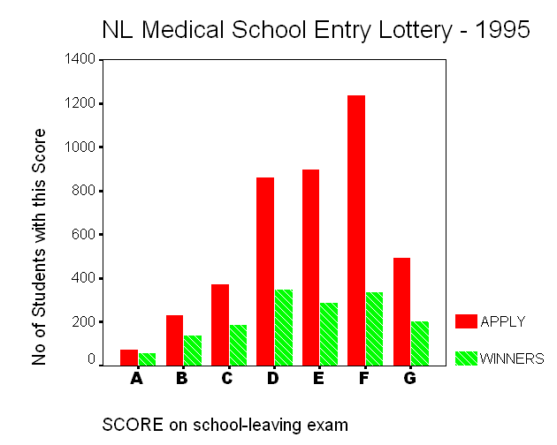

The graph on the left shows how the 1995 Dutch Medical School entry lottery worked. The ‘SCORE’ category relates to results on school-leaving examinations, combining both national tests and a teacher-based assessment. ‘A’ is the top category, ‘F’ the lowest, although this is relative: Only pupils from the top 10% are eligible to apply. The category ‘G’ relates to non-standard entries, such as those with non-Dutch qualifications. The second chart shows how the chances vary with the Score achieved:
Source: Report of the Drenth Commission, 1997

