
Anger at £10,000 beach huts lease
Plans to charge £10,000 for 10-year leases for huts at one of Wales' most popular beaches have led to claims some people will be priced out.
Swansea Council is aiming to raise around £200,000 to rebuild some of the 78 wooden huts at Langland on Gower.
Until now most have been allocated on an annual basis via a lottery with people paying around £230 for a season.
Opponents say it will create a two-tier system, but the council says it needs the money to cover rebuilding costs.
It is currently advertising the long-term leases and has built a "show hut" on the foreshore.
The authority said some of the structures, which date back over 80 years, were in desperate need of upgrading due to a combination of vandalism and the weather.
Not a lot of people can put their hands on that sort of money
Barbara Hynes, Labour councillor
About 20 long-term leases are being offered, with the rest of the huts still available for seasonal rental.
Opponents claim the proposed £10,000 fee will price many out of the market and reduce the number of huts available each year to the rest of the public.
Labour councillor Barbara Hynes said: "I used to take my boys down there when they were growing up, but I would not have been able to afford a 10-year lease.
"The huts and the beach are popular, but not a lot of people can put their hands on that sort of money.
"Many families use them as a chance to spend quality time with their children.
"I believe it is a two-tier system and why should some people be deprived of the chance [of leasing a hut]?"
The huts cannot be used as homes as there are no toilet or cooking facilities, but are used as a base for day-trips by people who regularly visit the beach.
Although not listed individually, they are protected by a conservation order.
Council cabinet member John Newbury: "The new leasing proposal represents a great opportunity to preserve our past while looking to the future.
"We're listening to the views of current hut users."
Story from BBC NEWS:
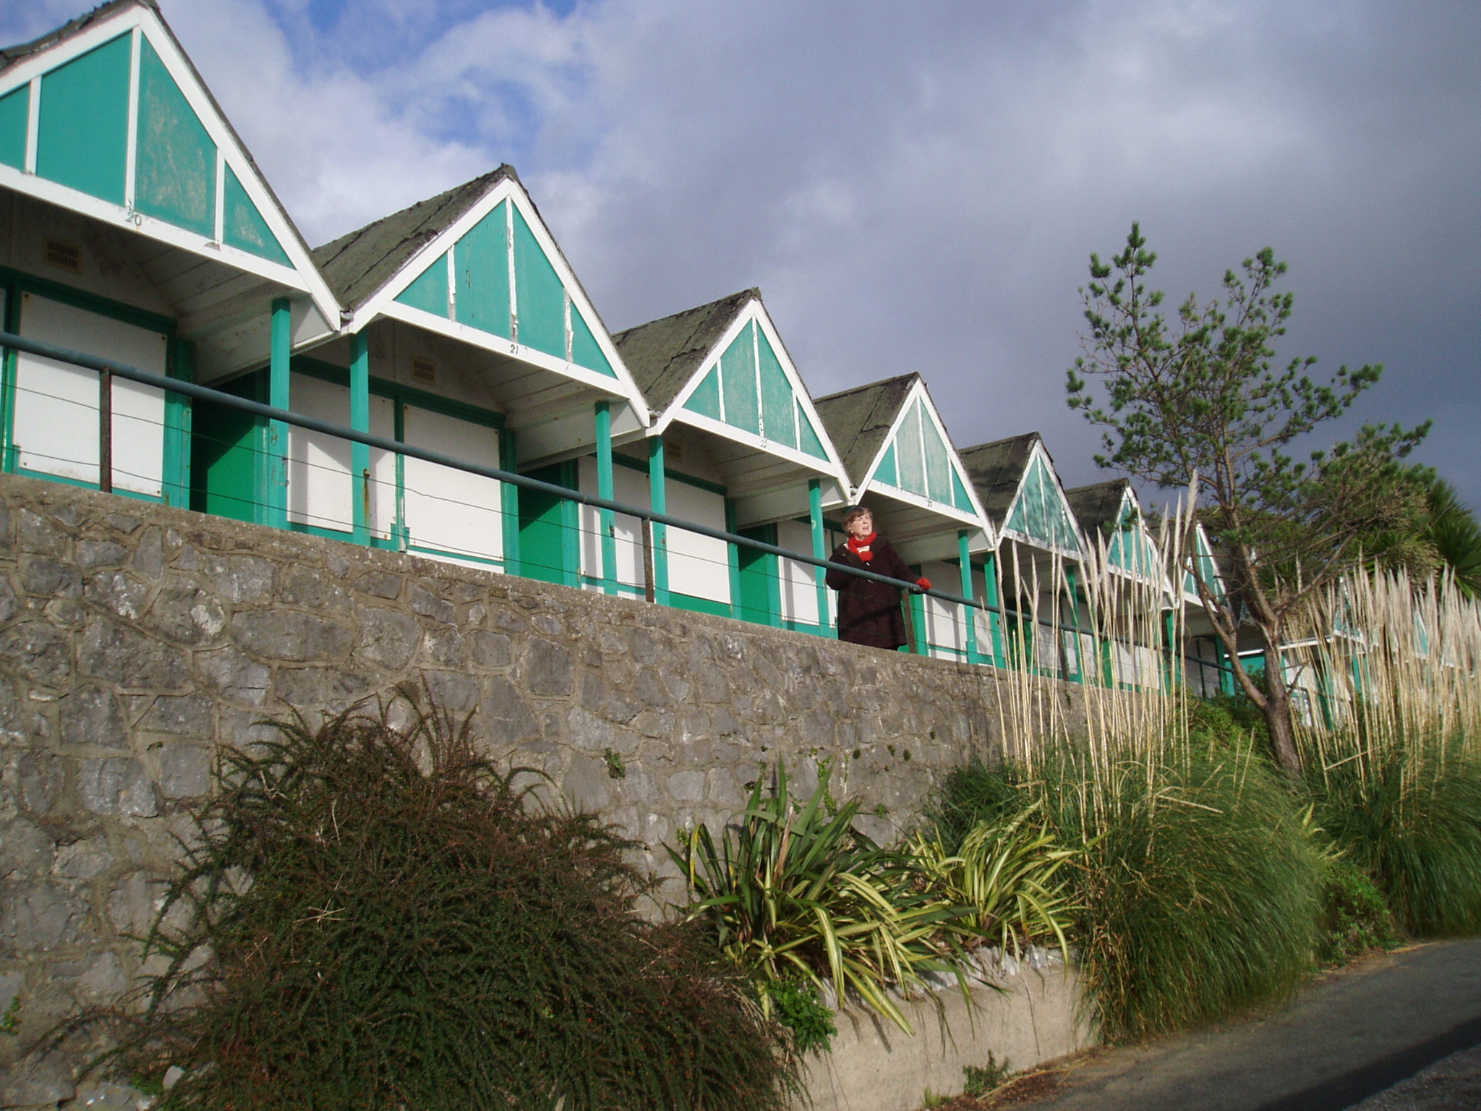
Published: 2007/11/19 16:59:52 GMT
© BBC MMVII

