108 SEED Boarding School, Baltimore Maryland
New York Times, May 25, 2008
OP-ED COLUMNIST
Hope in the Unseen
By THOMAS L. FRIEDMAN
Every once in a while as a journalist you see a scene that grips you and will not let go, a scene that is at once so uplifting and so cruel it’s difficult to even convey in words. I saw such a scene last weekend at the College of Notre Dame of Maryland in Baltimore. It was actually a lottery, but no ordinary lottery. The winners didn’t win cash, but a ticket to a better life. The losers left with their hopes and lottery tickets crumpled.
The event was a lottery to choose the first 80 students who will attend a new public boarding school — the SEED School of Maryland — based in Baltimore. I went along because my wife is on the SEED Foundation board. The foundation opened its first school 10 years ago in Washington, D.C., as the nation’s first college-prep, public, urban boarding school. Baltimore is its second campus. The vast majority of students are African-American, drawn from the most disadvantaged and violent school districts.
http://www.nytimes.com/2008/05/25/opinion/25friedman.html

SEED Maryland was admitting boys and girls beginning in sixth grade. They will live in a dormitory — insulated from the turmoil of their neighborhoods. In Washington, nearly all SEED graduates have gone on to four-year colleges, including Princeton and Georgetown.
Because its schools are financed by both private and public funds, SEED can offer this once-in-a-lifetime, small-class-size, prep-school education for free, but it can’t cherry-pick its students. It has to be open to anyone who applies. The problem is that too many people apply, so it has to choose them by public lottery. SEED Maryland got more than 300 applications for 80 places.
The families all crowded into the Notre Dame auditorium, clutching their lottery numbers like rosaries. On stage, there were two of those cages they use in church-sponsored bingo games. Each ping-pong ball bore the lottery number of a student applicant. One by one, a lottery volunteer would crank the bingo cage, a ping-pong ball would roll out, the number would be read and someone in the audience would shriek with joy, while everyone else slumped just a little bit lower. One fewer place left ...
It was impossible to watch all those balls tumbling around inside the cage and not see them as the people in that room tumbling around inside, waiting to see who would be the lucky one to slide out and be blessed. No wonder a portrait of hope and anxiety was on every face.
“I am so hopeful about the school and just so overwhelmingly anxious about what happens to the students who don’t get in,” said Dawn Lewis, the head of the SEED Maryland school. “During the six or seven months of recruiting, we heard all the stories of all the problems these kids are confronting in their schools, and each time [parents] would tell us, ‘This kind of school is the answer — the thing this child needs to be successful.’ When we were completing the applications, we received so many letters from guidance counselors and teachers and principals and even pastors saying, ‘Please, just exempt this kid from the lottery — because without this, there is no chance for this kid, there may not be another opportunity.’ ”
If you think that parents from the worst inner-city neighborhoods don’t aspire for something better for their kids, a lottery like this will dispel that illusion real fast.
Ms. Lewis said she’s seen people on crack walking their kids to school. “We had parents who came into our office who were clearly strung out,” she added. “They could not read or write, but they got themselves there and said, ‘I need help on this application’ for their son or daughter. Families do want the best for their children. If they have a chance, they don’t want their kids to inherit their problems. ... These aspirations are so underserved.”
Ms. Lewis said that she and her colleagues would meet with parents begging to get their kids in, help them fill out the applications and then, after the parents left, go into their offices, shut the door and cry.
Tony Cherry’s son Noah, an 11-year-old from Baltimore County, was one of the lucky ones whose number got pulled. “His teacher said if he got picked they’re going to have a party for him,” said Mr. Cherry. “This is a good opportunity. It’s going to give him a chance. ... Wish they could take all of them.”
Not everyone selected was in attendance, said Carol Beck, SEED’s director of new schools development. So, on Monday SEED notified those who had won. “We called one school counselor the next day and told her that so-and-so was chosen,” said Ms. Beck, “and she said: ‘Thank you. You have just saved this child’s life.’ ”
There are so many good reasons to finish our nation-building in Iraq and resume our nation-building in America, but none more than this: There’s something wrong when so much of an American child’s future is riding on the bounce of a ping-pong ball.

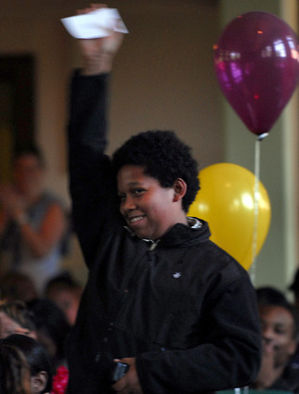
http://www.baltimoresun.com/news/education/bal-seed0517-pg,0,4749607.photogallery?index=2

Each SEED School of Maryland applicant was assigned a number, which was written on one of these balls. Eighty were picked for the public school, 40 for the wait list. (Sun photo by Chiaki Kawajiri / May 17, 2008)

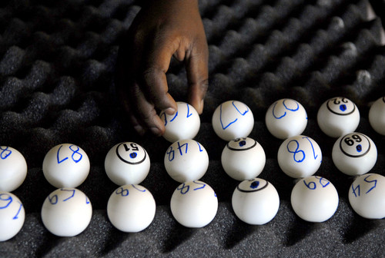www.baltimoresun.com/news/education/bal-md.seed18may18,0,5090069.story
baltimoresun.com

Eyes on the ball
Parents, kids pin their hopes on one white orb in boarding school lottery By Tanika White
Sun reporter May 18, 2008
The lucky ones heard their numbers called early.
Not only could those first-announced winners beam with pride about being one of the first 80 students who will attend the SEED School of Maryland, but they also did not have to agonize in their chairs any longer, watching the white lottery balls tumble in gilded cages - the numbered balls representing dreams for all and disappointment for many.Yesterday morning, the founders of the nation's first public boarding school, which opened 10 years ago in Washington, D.C., held the inaugural lottery to fill the slots for the Baltimore-based second location, which will open its doors in August to disadvantaged youths from all over the state.More than 300 students applied from the city, the suburbs of Baltimore and Washington, the Eastern Shore, and Western and Southern Maryland. Families traveled to the College of Notre Dame of Maryland to see if their child's number would be called.
Their reasons differed, but the underlying theme was the same: The SEED School - with its small class sizes, academically rigorous courses and impressive college admissions record - offered them a way out of the crowded schools and unforgiving neighborhoods they came from.
"This is the answer to a prayer," said a joyous Evelyn Collins of Randallstown, just after her grandson's number was called. His was the third number announced, but Nos. 1 and 2 were not in the audience to squeal the way Collins did or jump and wave like her grandson, Lucas Gutierrez, did.
The boarding school, funded mostly by the state, will offer a tuition-free, college preparatory education on the campus of the former Southwestern High School. It will open with a class of 80 sixth-graders, and add a grade each year through 12th. It is designed to serve students who live in "under-resourced" communities and are not performing to their potential. Organizers said many are likely to be low-income.
Jumping, yelping, cheering and hugging were in no short supply yesterday during the first few minutes of the lottery. But midway through, other activities became more prevalent: hand-holding, rocking, foot-tapping and, all throughout the too-warm auditorium, silent praying.
Carolyn Tenai of Lansdowne and her son Elijah Anthony Johnson Jr. clasped hands and put their heads together, willing the lottery ball with No. 91 to free itself from the pack. "If we get it," Tenai vowed, "I'll probably pass out on the floor."
When Maria Howard's son Deven's number was called, the medical biller from Columbia leaned back her head, covered her face with her program and let the tears fall.
"I work 40 hours and at least 20 hours I'm either in school or studying for school," Howard said. "It's hard on me because I can't help him, and when he gets bad grades, I feel as though it's my fault because I'm not there. This is such a good opportunity for him. And I know he's going to get a good education."
In Washington, 97 percent of SEED School graduates are accepted to four-year colleges, many with impressive names such as Georgetown, Princeton and Case Western.
Although the Maryland program is as yet untried, parents hear about the school's reputation and clamor to get in, said Head of School Dawn Lewis. A major draw is the school's size; the enrollment will grow to 400 students over seven grades and never get any larger, she said.
"We will know every child and their families," Lewis said.School leaders know, however, that for many students, the drastically different learning environment will be too much. Living away from family and friends during the week, without television or video games; mandatory study halls and extracurricular activities; intense personalized learning plans and unwavering pressure to succeed are SEED School hallmarks. Many will drop out in the first two years, officials said.
That is a good thing for Tenai and her son, Elijah Anthony. Their number was called third among 40 on the priority wait list. They were disappointed but not defeated, Tenai said, because she knows in her heart that he will make it in.
"He's my blessed child. I didn't know I was pregnant with him till I was 7Ã¯Â¿Â½ months pregnant and I was on drugs. So he's not even supposed to be here or be doing as well as he is," said Tenai, adding that Elijah Anthony's father is dead. "So I know he'll get in."
For many other families, the day ended less happily.Maurice Chandler of West Baltimore left his security guard's job at 7:30 a.m. and came home to pick up his son, Maurice Jr., his wife, Malinda, and their two other children so they all could be a part of the process. They sat together in a row, quietly, listening for No. 17.
But once the first class was selected and the priority wait list called, the auditorium seats began to empty without Maurice's number being uttered. The 11-year-old hid his face in his shirt, leaned against his father's arm and cried.
His mother tried to reassure everyone that Maurice's future still was bright. "I know whatever he does, he's going to succeed," she said.But Maurice was inconsolable.
"It was a long shot," said his father, his eyes heavy from lack of sleep. "But it was a chance we had to take."
tanika.white@baltsun.com
Copyright © 2008, The Baltimore Sun

