109 Nissan Figaro 1991
The Nissan Figaro is a small retro car manufactured by Nissan. The car was originally sold only in Japan. Despite this, the Nissan Figaro has become popular with celebrity owners in the UK, given the popularity of second-hand Japanese import cars
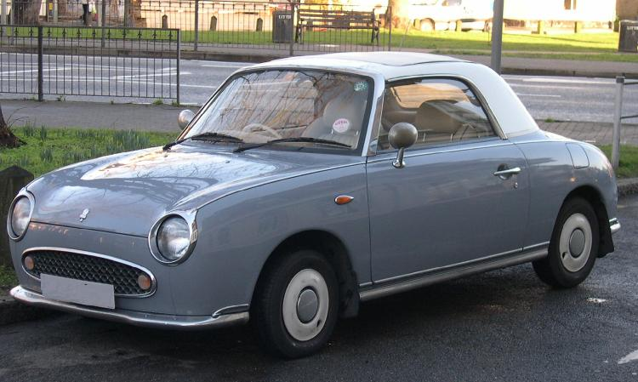
Only 8,000 were originally available with an additional 12,000 added to production numbers to meet demand. Prospective purchasers had to enter a lottery to be able to buy one of these cars. Limited edition cars came with passenger side baskets and cup holders. These now fetch hundreds on internet auction sites.

(from Wiki)

